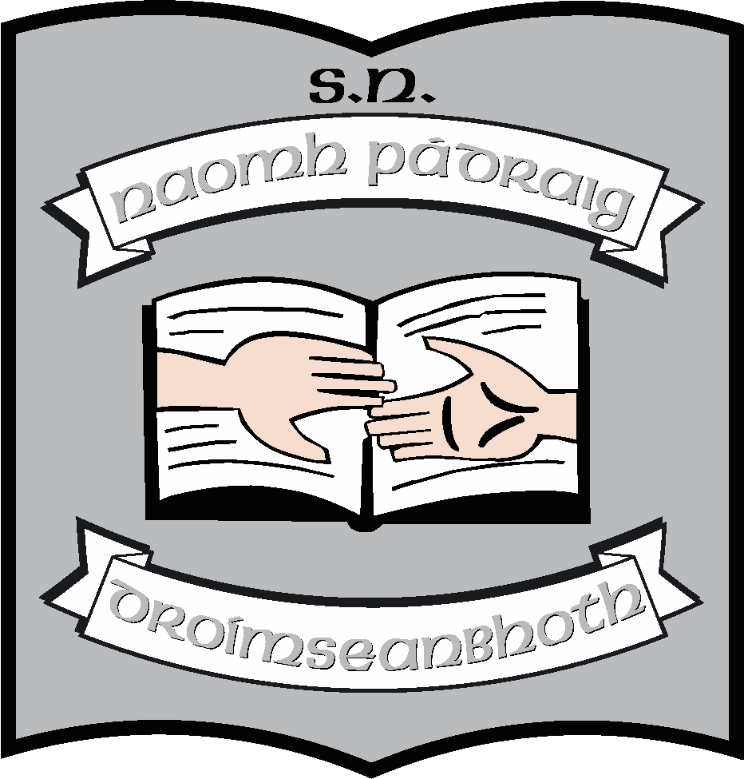

Annual Report of the Board of Management of St. Patrick’s NS
2020 - 2021
The Board of Management of St. Patrick’s NS consists of
- Martin McGowan (Chairperson & Bishop’s Representative)
- Fr. Frankie Murray (Bishop’s Representative)
- Aisling Fee (Parents’ Representative & Treasurer)
- Pascal Gillard (Parents’ Representative & Safety Officer)
- Stella Kehoe (Community Representative)
- Enda McGloin (Community representative)
- Louise Brennan (Teachers’ Representative & Recording Secretary) *
- Máirín O’Keeffe (Teachers’ Representative & Secretary)

Meetings
During this school year, the board had scheduled termly meetings in September, December January, March, April and June.
In addition, there were 6 exceptional meetings this year, mainly relating to the school building and to Covid.
Policy
The following organisational policies were reviewed during this school year and those in bold print have been uploaded onto the website.
- AUP policy (Acceptable Use Policy relates to Internet use)
- Mobile Phone Policy
- Child Safeguarding Statement 2020
- Anti-bullying 2020
- Appendix to Anti-Bullying Policy and Code of Behaviour – related to Covid
- Admissions Policy and Notice 2020
- Class Allocation Policy (relates to staff)
- Intimate Care Policy
- Remote learning Policy
- Covid Response Plan
- Assessment Policy
- Grievance Policy (relates to staff)
- Complaints Procedure
- Parental Status Communication Policy
- SNA Policy (relates to staff)

Statements and policies related to the Autism Classes were reviewed this year:
- Statement for parents
- Statement for staff
- Protocol for Bus Escorts
- Enrolment Policy for ASD classes

In terms of curricular planning
- The school is working to implement the new Oral Language Curriculum in Irish and English. We have changed the English scheme in use throughout the school.
- We have updated our Geography Plan.

Other
- Great work was done this year in upskilling pupils and teachers to facilitate remote teaching and learning.
- School Self Evaluation was replaced by planning and implementation of reopening schools after Covid and planning and implementation of remote learning.

Maintenance
- The extension of the school is now complete except for some outstanding paint work, plastering of exterior wall, new path and snag list.

Resources
- The board invested additional money in the build, mainly to provide for additional outdoor facilities and landscaping around the school.

Other
Our school reopened in September, having been closed since March 12th 2020. Unfortunately, schools were closed again after Christmas until a phased reopening beginning on February 22nd with the Cairde and Laochra classes, followed 2 weeks later by the Junior classes and finally the senior classes on March 15th. Despite an outbreak in the locality after Easter, our school has remained open.
To our great joy, when the pupils from Cairde and Laochra came back in February, the extension was completed and they were able to return to their new classrooms.
Much of the work of the Board this year lay in managing the build and also in preparing the school to reopen following the Covid outbreaks.
The Parents’ Association elected a new committee at the end of the school year. We also wish to acknowledge the outgoing committee Parents’ Association who have been such a support to the whole school community over the past few years. They have provided fun family events as well as raising much needed funds for the school.
They were instrumental in setting up the GoFundMe for the new building which raised over €19000. This allowed us to provide additional facilities for the children including a sensory garden, a kitchen, a basketball court and outdoor furniture (on order).
As always, the Board would like to thank the school community for its support during this school year, particularly during the extended school closure and again during the outbreak of Covid after Easter.
We wish to thank the staff for the work they did to ensure continued teaching and learning when the school was shut as well as for the way in which they upskilled themselves during the summer of 2020 in preparation for remote teaching.
We want to thank the parents who worked so hard, in challenging circumstances, to home-school their children.
It is our profound hope that the 2021 – 22 school year will see no further closures due to Covid.
June 2021

