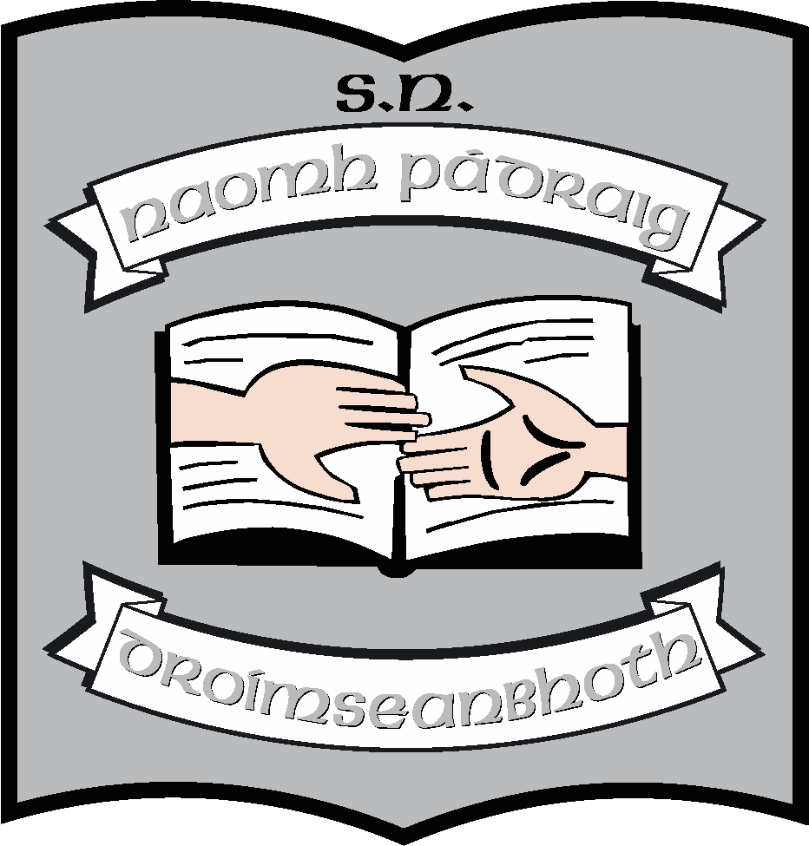

Annual Report of the Board of Management of St. Patrick’s NS
2021 - 2022
The Board of Management of St. Patrick’s NS consists of
- Martin McGowan (Chairperson & Bishop’s Representative)
- Fr. Frankie Murray (Bishop’s Representative)
- Aisling Fee (Parents’ Representative & Treasurer)
- Pascal Gillard (Parents’ Representative & Safety Officer)
- Stella Kehoe (Community Representative)
- Enda McGloin (Community representative)
- Louise Brennan (Teachers’ Representative & Recording Secretary) *
- Máirín O’Keeffe (Teachers’ Representative & Secretary)

Meetings
During this school year, the board had scheduled termly meetings in September, December February, March and May.
In addition, there were 3 exceptional meetings this year, one in November relating to the management of Covid in the school and two in April related to the enrolment of Ukrainian pupils.
Policy
The following policies were reviewed during this school year.
September
- Child Protection Policy
- Child Protection Statement
- Anti-Bullying Policy and Appendix (Covid-related)
- Extra Personal Vacation Policy
- Leave of Absence Policy
- Use of School Owned Assistive Technology
December
- SPHE
- SEN Policy
- Substance Abuse Policy
- Covid Response Plan
February
- RSE
- Health Promoting School Policy
March
- Visual Arts
- Droichead Induction Policy
- Covid Response review
May
- Music
- Drama
- English
- Gaeilge
- Appendix to COB; Action Plan for ASD Classes
The topic for School Self-evaluation was homework and the School Improvement Plan was presented to the Board of Management at the May meeting.

In terms of curricular planning
- The school is working to implement the new Oral Language Curriculum in Irish and English and the policies were updated accordingly
- We also carried out reviews of SPHE, Music, Drama and Visual Arts
- Maths will be the main area of for review in the next school year.
- We have updated our Geography Plan.

Maintenance
- The new building has been completed with only some items on the sang list to be resolved.
- The whole of the exterior of the school has been painted
- The heating in the older part of the building will be upgraded as part of a Summer Work Scheme, during the summer holiday
- We have a consultant’s report ready for submission when the next SWS opens up.

Resources
- The board has continued to invest in IT, replacing laptops and whiteboards where necessary
- A new English scheme was introduced in the school this year.

Other
There were no closures relating to Covid this year. However, attendance suffered greatly throughout the school because of the ongoing Covid outbreaks among the community.
The school was in receipt of additional CLASS hours which were used to ensure that children who missed out because of Covid were given extra support.
After Easter, 17 Ukrainian pupils joined the school. Additional EAL hours were allocated to support these pupils.
The school used the Droichead process for the first time and Áine Smith was successfully probated.
The Parents’ Association continued to support the school by fund-raising and providing support for school events and resources. This year they provided additional funding to pay for equipment used in an Artist scheme in 3rd and in 6th class. They funded celebrations in 2nd class, related to First Communion, and in 6th Class related to end of year.
The school received an unexpected gift to the school 0f $2500 which translated into approximately €2,200. We used this to but 4 table tennis tables and 4 badminton sets – some additional funding was provided by the PA to support this.
As always, the Board would like to thank the school community for its support during this school year, particularly in the management of Covid. They were very pro-active in adhering to the guidelines that kept outbreaks from spreading within the school.
We wish to thank the staff for the work they did to maintain a high standard of teaching and learning while also ensuring that, when as restrictions lifted, the children could resume the activities that did not take place during Covid, activities such as outings, tours, end of year plays etc.
We want to thank the parents who worked so hard, in challenging circumstances of the past year. We acknowledge the importance of the support that they give to their children and to the school.
Our school principal, Máirín O’Keeffe, has indicated her intention to retire on August 30th. We would like to thank her for her commitment to the school over the past 8 years and also to wish her health and happiness in her retirement. We look forward to working with a new principal in the next school year. Aisling Brenann and Stephen Keane have both decided to resign from the school following their 5 year career breaks. The Board would like to acknowledge the contribution that they made during the years that they taught here.
Finally, the Board has ratified the appointment of Ruth McLoughlin as the next principal of the school. She will take up the position on August 31st. The members of the board would like to congratulate Mrs. McLoughlin and we look forward to working with her in the years ahead.
May 2022

