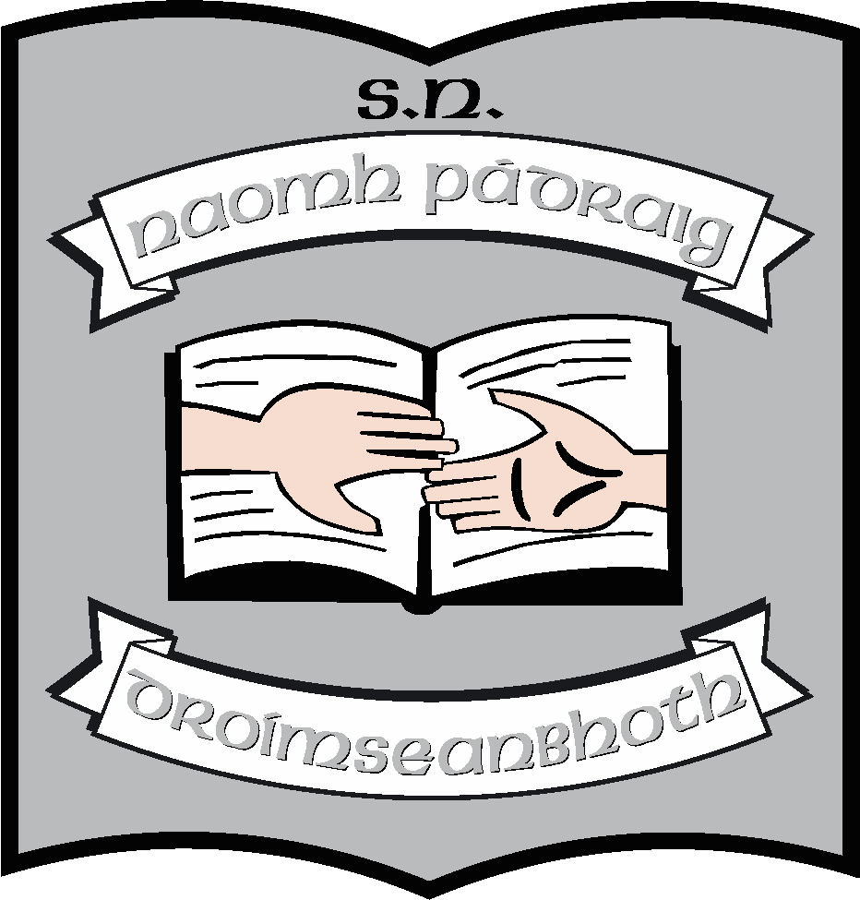St. Patrick’s N.S.
Drumshanbo,
Co. Leitrim.

Roll No: 19423J

Internet - Acceptable Use Policy

Reviewed: January 2023
Ratified: February 2023
Full review: 2027

St. Patrick’s National School
AUP 2023
The aim of this Acceptable Use Policy (AUP) is to ensure that pupils will benefit from learning opportunities offered by the school’s IT resources in a safe and effective manner. Teachers and pupils are encouraged to use these resources productively and safely to promote teaching and learning in the school. The policy is also being updated to reflect how we, as a school, can safely engage in remote learning when necessary.
This Acceptable Use Policy applies to:
- Pupils who have access to and are users of the internet in St. Patrick’s National School.
- Members of staff, volunteers, parents, carers, and others who access the internet in St. Patrick’s National School.
- To all school personnel who use digital tools in remote teaching and learning.
If the school’s AUP is not adhered to, access will be withdrawn and appropriate sanctions, as outlined in the AUP and the school’s Code of Behaviour, will be imposed.

School Strategies

The school will employ a number of strategies in order to maximise learning opportunities and reduce risks associated with the Internet. These strategies are as follows:
General
- Access to internet will always be supervised by a teacher.
- Filtering software and/or equivalent systems will be used in order to minimise the risk of exposure to inappropriate material. The school internet is protected by the firewall provided by the NCTE (National Centre for Technology in Education).
- The Irish School’s Broadband Programme provides an integrated set of services to schools which includes broadband connectivity and services including content filtering, webhosting and security services. These services are managed by the NCTE working closely with the Department of Education and Skills and are coordinated and supported by the NCTE Service Desk which is the single point of contact for schools for all broadband related issues, providing information, advice and support to schools.
- The school will regularly monitor pupil’s internet usage in school.
- IPads will be monitored by teachers using the Classroom App which allows the teacher to see what the children are working on.
- All pupil laptops will be wiped annually and cleared for the coming year.
- YouTube etc. has been disabled on all laptops.
- Pupils and teachers will be provided with training in the area of Internet safety.
- Uploading and downloading of non-approved software will not be permitted.
- Virus protection software will be used and updated on a regular basis.
- The use of personal USB keys/storage devices in school is only allowed with teacher supervision and permission.
- Pupils will observe good “netiquette” (i.e., etiquette on the Internet) at all times and will not undertake any actions that may bring the school into disrepute.
- It is important to note that the school’s Anti-Bullying Policy should be read in conjunction with this Policy. Parents/guardians and students should be aware that placing a once-off, offensive or hurtful internet message, image or statement on a social network site or other public forum where that message, image or statement can be viewed and/or repeated by other people will be regarded as bullying behaviour.

World Wide Web

- Pupils and teachers will use the Internet for educational purposes only.
- Teachers will be familiar with copyright issues relating to online learning. Teachers and students will not upload, download or otherwise transmit material that is copyrighted on school devices.
- Pupils will never disclose or publicise personal information.
- Pupils and teachers will be aware that any usage, including distributing or receiving information, school-related or personal, may be monitored for unusual activity, security and/or network management reasons.
- Pupils and teachers will not knowingly visit Internet sites that contain obscene, illegal, hateful or otherwise objectionable materials and the school will not be responsible for any attempts made in this regard.
- In the event of accidentally accessing any of the above sites, the student will be expected to immediately turn off the monitor and report the incident to a teacher or supervisor.
- Pupils will be taught appropriate use of the internet, using, for example, the www.webwise.ie teaching materials.
- Websites will be previewed / evaluated by a teacher using a filtering system, before being integrated into lessons conducted on school Devices.
- Students will not disclose or publicise personal or confidential information to others online. Examples of this are, but not limited to, their own or classmates’ home addresses, telephone numbers, email addresses, online profile information or name and location of their school.
- Students will not examine, change or use another person’s files, username or passwords.
- Students will be aware that any usage, including distributing or receiving any information, school-related or personal, may be monitored for unusual activity, security, and/or network management reasons.
- The school takes every reasonable precaution to provide for online safety, but it cannot be held responsible if students access unsuitable websites either deliberately or inadvertently.
- Downloading materials or images not relevant to their studies, is in direct breach of the school’s acceptable use policy.
- When using the internet pupils, parents and staff are expected:
- To treat others with respect at all times.
- Not to undertake any actions that may bring the school into disrepute.
- Respect the right to privacy of all other members of the school community.
- Misuse of the internet may result in disciplinary action, including written warnings, withdrawal of access, and in extreme cases, suspension or expulsion.
- The school also reserves the right to report any illegal activities to the appropriate authorities.

Email

- Pupils will not have access to personal email facilities at school. Any emails to other children/schools, will be sent through the school email address.
- When using Google Classroom and the G-suite Apps, students will use approved school student email accounts under supervision of a teacher or parent/guardian.
- Students will not send or receive any material that is illegal, obscene, defamatory, or that is intended to annoy or intimidate another person.
- Students will not reveal their own or other people’s personal details, such as addresses or telephone numbers or pictures.
- Students will never arrange a face-to-face meeting with someone they only know through emails or the Internet.
- Students will note that sending and receiving email attachments is subject to permission from their teacher.
- Teachers have set up individual school email addresses for the purposes of remote teaching and learning which the pupils in their class/group may use.
- Pupils may use school email addresses, with permission, to email work to school, but only if Google Classroom or SeeSaw are not operational.

Distance Learning

- In circumstances where teaching cannot be conducted on the school premises, teachers may use Google Classroom, Google Meet, Zoom, SeeSaw, Microsoft Teams, Padlet or other platforms approved by the Principal as platforms to assist with remote teaching where necessary.
- The school will sign up to the terms of service of the Online Platforms in use by the school and agreed by the staff.
- The school will enable the most up to date security and privacy features which these Online Platforms provide.
- In the case of Google Classroom, Zoom and Google Meet, parents/guardians must grant access to their child to have a school Gmail address, based on the school domain, such as pupilname.student@schoolname.ie
- Parents/guardians will be provided with the password and will be expected to monitor their child’s use of the Gmail address and online platforms.
- If teachers are using Zoom, parents/guardians must consent to their child having a school email address as above to allow their child access to the lessons. Where the child does not have a school email address, parents can consent by submitting their own email address for their child to access lessons on Zoom.
- Parents/guardians must also agree to monitor their child’s participation in any such lessons conducted on the Online Platforms.

Internet Chat (Very restricted use only)

- Pupils will only have access to chat rooms, discussion forums or other electronic communication forums that have been approved by the school for the purposes of teaching and learning.
- Chat rooms, discussion forums and other electronic communication forums will only be used for educational purposes and will always be supervised.
- Face-to-face meetings with someone organised via Internet chat is forbidden.

School Website/Blog

The school website is stpatricksnsdrumshanbo.ie
The school email address is stpatricksnsdrumshanbo@gmail.com.

- Students will be given the opportunity to have photos, projects, artwork and other work relating to curricular and extra-curricular school activities published on the school website as per the consent form. Teachers will coordinate the publication of this material.
- Personal information relating to the student including their name, home address and contact details will not be included on school social media or the school’s website.
- Digital photographs and audio or video clips of individual students will not be published on the school website and/or affiliated pages, without prior parental/guardian permission. Instead, photographs etc. will focus on group activities, where children will not be named.
- Photos/Videos may be used for the production of the Homework Journal or specific school events e.g. Communion etc. These photos/videos and the photos/videos on our website/App should not be copied or posted to any social media or other website or published in any way.
- Parent(s)/guardian(s) are requested not to ‘tag’ photographs or any other content which would identify any children or staff in the school.
- Parent(s)/guardian(s) are requested to ensure that online messages and/or comments to the school’s social media sites are respectful. Any messages written on social media are treated in the same way as written messages to the school.
- The Principal will review the content of the website and the social media sites regularly.
- If any parent or guardian has any concern about the appropriateness of the content of the website or social media sites, then the Board asks that the matter be brought to the attention of the Principal as a matter of urgency.

  - This Policy should be read in conjunction with our Data Protection Policy.

Staff Use of Email and the Internet

- Members of staff are encouraged to use various online resources in their teaching and learning activities, to conduct research, and for contact with others involved in education. Each member of staff has access to the school email address as part of his/her work.
- When using the Internet, all users must comply with all copyright, libel, fraud, discrimination and obscenity laws.
- School printers may be used to print downloaded materials associated with school activities.
- All users are expected to communicate in a professional manner.
- It will not be usual practice to read staff emails but the school reserves the right to do this in the case of a suspected breach of these policy guidelines. A serious breach may be treated as a disciplinary matter.
- No person will in any way alter the filtering preferences set for the school.

Personal devices

- Students may not use any personal device with recording or image taking capability while in school or on a school outing. Any such breach of the Acceptable Use Policy (AUP) will be seen serious misdemeanor and the pupil will be sanctioned accordingly.
- Any images or recordings taken by class teachers on smartphones or other personal devices must be downloaded onto the class laptop/school server and/or on to the school App/relevant school affiliated website and then immediately deleted from source.
- The use of E-readers may be permitted, under the supervision of the teacher.
- All personal devices are to be turned off during school hours. Some exceptions may be made for teachers. (See Mobile Phone Policy)
Legislation

The school will provide information, if requested, on the following legislation relating to use of the
Internet which teachers and parents should familiarise themselves with:
The following legislation relates to the use of the Internet.
- EU General Data Protection Regulations 2018 (See school policy and statement)
- Data Protection (Amendment) Act 2003
- Child Trafficking and Pornography Act 1998
- Interception Act 1993
- Video Recordings Act 1989
- The Data Protection Act 1988
- Anti-Bullying Guidelines for Primary Schools 2013
- The Data Protection Act 1988

Teachers and parents should familiarize themselves with relevant legislation. The school will help with this if requested.

Support Structures
Teachers will give instruction on appropriate use of the internet and how to use it safely.
We use the services of the NCTE , www.webwise.ie and www.safety.ie. We will also invite experts in this area to provide instruction to pupils, parents and teachers. This will normally take place every two years. We will cover internet safety in February annually around Internet Safety Day.

Use of Information Communication Technology (“ICT”) Resources

St. Patrick’s NS’ information and technology resources (e.g. e-mail, computers, computer applications, networks, internet, intranet, phone and other wireless communications devices, telephone and voice mail systems and the like) are school property and are provided solely for school related activities.

Inappropriate use including hacking, pirating software, using school resources for non-school commercial activities, soliciting, distributing literature for outside entities, disclosing confidential information of the school, sending inappropriate e-mail or accessing inappropriate web sites (such as those advocating hate or violence, containing sexually
explicit material promoting illegal activities), or using school resources in a way that violates the letter or spirit of the school’s policies or reflects negatively on the school is forbidden.

Users of the school’s information and technology resources must not share passwords. If you allow others to use your password or assigned resource, you will be held responsible for their use.

Consistent with national laws, the Board of Management reserves the right to monitor the use of its information and technology resources and to take appropriate disciplinary actions, or denying future access privileges in cases of misuse. Staff/student use of the school’s information and technology resources constitutes consent to such monitoring. All such monitoring will be conducted in accordance with law including, where applicable, the EU’s General Data Protection Regulation (“GDPR”).

Sanctions
Misuse of the Internet and devices will result in disciplinary action as per our Code of Discipline Policy, including written warnings, withdrawal of access privileges and, in extreme cases, suspension. The procedures outlined in the school Code of Behaviour will be used. The school also reserves the right to report any illegal activities to the appropriate authorities.

Implementation/Ratification/Review
This policy was reviewed in January 2023. It will be presented to the Board in February for ratification. It will be updated, as needs be, when developments in technology and new platforms for remote learning impact on teaching and learning in the school. Otherwise it is due for a full review in 2027

The AUP will be available in the school office for parents/guardians should they request to view or obtain a copy. The policy can be communicated by providing a written copy if requested, or by e-mail.
When it is ratified, it will be published on the school website/blog.

***************************************************************************

Ratification of policy for St. Patrick’s NS

Martin McGowan 28/02/23
Chairperson Date

Ruth McLoughlin 28/02/23
Principal Date

