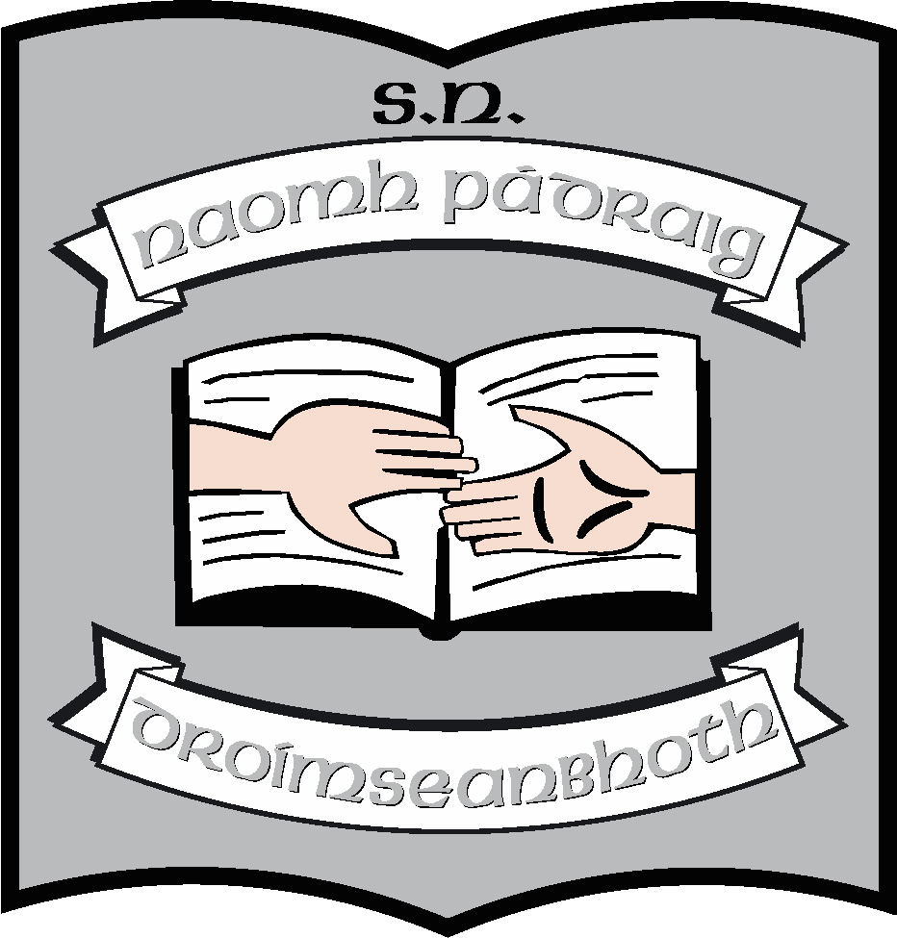St. Patrick’s N.S.
Drumshanbo,
Co. Leitrim.

Roll No: 19423J

Assessment policy

Reviewed: November 2020
Ratified: December 2020
Full review: 2022

St. Patrick’s National School

Assessment Policy 2020
Introduction
This policy is a complete review of assessment in our school. Our last Assessment Policy was created in 2015 and no longer reflects current practice in the school. This policy is being drawn up by the principal, SETs and ISM.
Reasons for review and rationale
- The 2015 policy needed to be updated to ensure that it reflects current practice in the school, particularly in light of the significant changes the we have made to our SEN policy and practice.
- A significant feature of the curriculum is the central position given to assessment in the teaching and learning process. We feel that we have to use assessment more effectively in our school and in our classrooms particularly in the area of assessment for learning (AFL)
- We are currently considering what standardised test we will use. We are using Drumcondra tests for numeracy and literacy but we may change to Micra and Sigma when the updated versions are available. We will continue to use Drumcondratest for Gaeilge.
- In 2020 – 2021, SETs expressed a wish to put a greater emphasis on assessment for learning.
- SETs also wanted to devote time to screening children for specific learning difficulties such as dyslexia.

Assessment activities used in our school will contribute to pupil learning and development by gathering relevant information to guide each pupil’s further learning (assessment for learning) and by providing information on each pupil’s achievement at a particular point in time (assessment of learning).
Aims of assessment
A principal function of assessment is to provide the teacher with an accurate picture of the child’s development. This will enable him/her to create the learning contexts and design the teaching strategies most appropriate to the needs of individual pupils.
Another function is to help the teacher to assess the curricular needs of the class – what needs to be taught in any strand/strand unit, what needs to be revisited.
Our aims are:
- To monitor the learning processes of teaching and to ascertain achievement in each area of the curriculum.
- To monitor strengths and weaknesses of the teaching of the curriculum at a school, class and individual level.
- Through assessment, the teacher will be able to construct a comprehensive picture of the short-term and long-term learning needs of the children. The teacher can plan work accordingly and give support in curricular areas where needs have been identified.
- Through assessment, the teacher will be able to identify, at a class level, what curricular content concepts need to be taught or re-taught.
- Through assessment the school will be able to prioritise areas of the curriculum that need attention and areas in which we need to be upskilled.
- Assessment will be used to identify children with specific learning difficulties so that the nature of the support and assistance they need can be ascertained, and appropriate strategies and programmes put in place to enable them to cope with the particular difficulties they are encountering.
- Assessment will assist communication about the child’s progress and development between teacher and parents and between teacher and teacher.
- It will enable the child to become more self-aware as a learner and to develop powers of self-assessment
- It is a diagnostic tool enabling teachers to identify the strengths and weaknesses of pupils and to take the appropriate next step such as looking for psychological assessment

Areas to be assessed
Assessment is integral to all areas of the curriculum. In addition to the products of learning, the strategies, procedures and stages in the process of learning are assessed.
- In our school we focus on the assessment of literacy and numeracy. For these subjects we use standardised tests, published tests (E.g. Mathemagic Assessment tests) as well as teacher designed tests.
- Published test are also used in areas such as comprehension and listening skills.
- Teacher designed tests are used to assess content learned in SESE.
- Tables and spelling tests, including test based on the DOLCH list are used regularly from first class upwards.

To take into account the breadth and variety of the curriculum, we will use a wide range of assessment tools. These range from informal tools such as
- teacher observation – a great proportion of the teacher’s assessment will involve the use of less structured methods and will be an integral part of the teaching process
- classwork
- homework
- teacher designed test and tasks
- discussion with pupils
- projects
- portfolios
- self-assessment by children, especially in the writing process

to more formal testing such as
- screening tests
- diagnostic tests* - generally admininstered by a member of the LS/SEN team
- standardised test**
- published tests
- psychological assessments (usually carried out through NEPS)
- speech and language assessments (usually carried out through the HSE)

Each teacher will select those that best meet their needs at the time. Teacher will keep records of non-standardised test results.
Assessment of/for learning
Teachers will use tests to assess what has been learned and to ensure that children have understood the topic at a level appropriate to their level and ability.
Such tests will include
- spelling tests
- comprehension tests
- cloze procedures
- Mental Maths tests
- teacher designed tests following the teaching of topics in History, Geography, Science tests
- Projects and assignments
- Reports on topics covered

Teachers will use tests to assess to inform their planning and timetabling and to decide when topics need to be revisited
Such tests will include
- Pre-tests and post test, particularly in Maths – including Mathemagic assessment tests
- Assessments which accompany the Reading Zone scheme
- Comprehension assessment tests from Prim-Ed series
- Projects and assignments

Informing parents (Non-standardised tests)
Results of teacher designed tests and tasks will be communicated to parents throughout the school year using
- homework notebooks
- as part of face to face consultations
- in end of year reports
- at informal meetings

Standardised Testing
- Children in first class are tested prior to the PT meetings to establish their level
- In the summer term all children from first class to sixth class will be assessed in English and Maths using the revised standardised test. (End of May)
- In the spring term, all children in Senior infants will be administered the MIST test (February/March)
- Children in fifth class will be assessed annually in Gaeilge using the revised Drumcondra tests
- The following results are recorded – raw score, standard score, percentile rank, STEN and Reading age, using a uniform approach across all classes.
- NRIT tests are administered annually to 2nd and 4th.
- If we are not using Micra-T as our school standardised test, teacher in Sixth Class will test with Micra-T in autumn to establish reading ages prior to PT meetings.
- From 2021, Drumcondra Spelling test will be given to Third Class, possibly in September but definitely prior to mid-term.

Responsibilities in regard to standardised testing

- The SETs will order all the necessary tests before the Easter holidays.
- The tests may be administered by a teacher other than the class but corrected by the class teacher. SETs may support the administration of tests, especially in lower classes.
- In the case of the MIST tests the SETs will administer and correct the tests.
- In the case of the NRIT tests for 2nd and 4th, the SETs will administer and correct the tests.

Recording of results
The teacher who corrects the test will record the results on the appropriate form and put it into the Aladdin system where the records will be held. The booklet will be retained only while it is current.
Each class teacher will be responsible for updating the record for standardised tests and assessments. Teachers will be asked to include all data for the purposes of analysis.
SETs will update the records for diagnostic tests – these are part of support plans.
The SETs will collate the results of standardised tests and analyse them using the SET policy, as part of the continuum of support.
The principal will be responsible for sending returns to the DES using the online system. The school bell curve will be communicated to the Board of Management at the first meeting of each school year.
Reporting of results of standardised tests
The results of all tests will be shared with
- Parents in end of year reports
- The appropriate class teacher
- The SET
- The principal will have access to the results and her attention should be drawn to any particular areas of concern

The results of all standardised tests will be included in end of year reports. These reports will be issued 2 weeks before the school closes for summer holidays and parents will be offered the opportunity to meet with teachers to collect results. Where a teacher has concerns about the results, he/she may initiate such meetings.
Percentiles and standard scores will be used as indicators for support. Parents will be given STen scores.

Screening and diagnostic testing
With regard to screening parents are consulted in advance and permission is sought before screening is carried out. Results are communicated to parents and they are consulted if diagnostic testing is considered necessary. Permission is part of the school enrolment form.
Diagnostic Assessment:
The following formal diagnostic tests may be used to determine the appropriate learning support for individual pupils who present with learning difficulties:
- Aston Index
- Jackson Phonics Reading Test
- Yarc Reading for Comprehension Test
- GL Dyslexia screener & GL follow-on test
- Drumcondra Spelling
The Class teacher and SETs are involved in selecting children for diagnostic assessment. The SETs teacher administers the diagnostic tests and interprets the results in consultation with the class teacher.
Following diagnostic testing
- Support plans are put in place or targets are updated for each child who is shown to have learning difficulties.
- Following testing, consultation takes place between Class teacher, SETs, parents and if necessary Psychologist, to share information gained from testing.
Psychological Assessment:
In the school, we are allocated hours from NEPS which is the psychological service provider to schools. The time we are allocated – usually about 3 days in total – is to cover support for staff as well as psychological assessments. Normally our allocation covers 2 assessments per year. The need in the school greatly exceeds this. Therefore, we have to prioritise children with more complex needs, based on our continuum of support approach.
- Class teacher, in consultation with the SETs and principal, is responsible for requesting and arranging an assessment from specialist(s), (Psychologist, Speech & Language Therapist, Audiologist, other…)
- Results of standardised and diagnostic assessment are used in drafting support plan for a pupil
- Reports are stored in each child’s file, in a secure cabinet in the classroom. Access is available to relevant professionals as needed
End of year reports
From June 2015 the new format of reports based on the templates provided by the NCCA have been used. They are stored electronically, using the Aladdin system. A hard copy will be filed in each pupil’s file.
Communication of assessment results within the school
- Meetings among staff members are used as a means to transfer information on pupils. These happen regularly throughout the year. They generally involve SETs meeting with class teachers.
- Before commencement of the school year meetings take place between teachers to facilitate the smooth transition of pupils from one class to another. Pupil files are passed on to following teacher at the end of each school year. This will include report sheets, standardised and diagnostic test results, any assessments by outside agencies.
- Liaison also takes place between the Principal/Sixth class teacher and Secondary school. Passports are provided to Secondary Schools.

Roles and responsibility for assessment
- The principal will be responsible for overseeing the implementation of this policy.
- The teachers will adhere to the policy and will update and vary the tools of assessment.
- The SETs will be responsible for carrying out diagnostic tests. (See also Learning Support SET Policy)
- The B.O.M. will support and fund materials and tests required to implement the policy using the grant provided by the DES.
- Parents will support the policy by ensuring that children are present for tests and by attending subsequent meetings, as far as possible.

***************************************************************************

Implementation/Ratification and Review
This policy will be presented to the Board of Management at the next meeting (December 2020). If ratified, it will become school policy and will be published on the school website. It is due for full review in 2025. However, changes in practice and to curricular policies may necessitate an earlier review or amendment. Review of the assessment areas of subjects of the curriculum may also necessitate an update to the policy.
Circulation:

The Assessment Policy will be available in the school office for parents/guardians should they request to view or obtain a copy. The policy can be communicated by providing a written copy if requested, or by e-mail.
When it is ratified, it will be published on the school website/blog.

***************************************************************************
Ratification of policy for St. Patrick’s NS

Martin McGowan 03/12/2020
Chairperson Date

Máirín O’Keeffe 03/12/2020
Principal Date

