St. Patrick’s National School. Roll No. 19423J
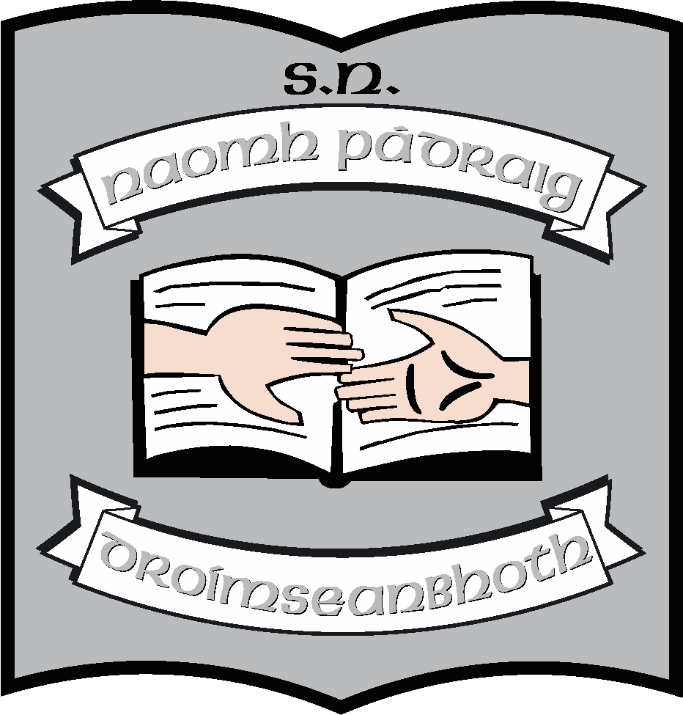
Drumshanbo, Co. Leitrim. N41 PY61.
Tel: 071 96 41755
Email: stpatricksnsdrumshanbo@gmail.com
Website: stpatricksnsdrumshanbo.ie

Calendar 2023 – 2024

Re-opening: Thursday 31st August, 2023.

The school will be closed on the following dates for the school year 2023 – 2024.

October 2023 mid-term break:

- School will be closed from Monday 30th October, 2023 to Friday 3rd November, 2023 inclusive.

Christmas 2023:

Closing on Friday 22nd December, 2023 (last day of term). All schools re-open on Monday 8th January,2024.

February 2024:

- School will be closed on Monday 5th February, 2024 – (Public Holiday).

Mid-term break:

- School will be closed on Thursday 15th and Friday 16th February, 2024.

March 2024:

- School will be closed on Monday 18th March, 2024 - (Bank Holiday for St. Patrick’s Day).

Easter 2024:

- Closing on Friday 22nd March, 2024 (last day of term) and re-opening on Monday 8th April, 2024.

May 2024:

- School will be closed on Monday 6th May, 2024 - (Public Holiday) and Tuesday 7th May, 2024.

June 2024:

- School will be closed on Monday 3rd June, 2024 - (Public Holiday).

School will close for summer holidays on Tuesday 25th June, 2024.

