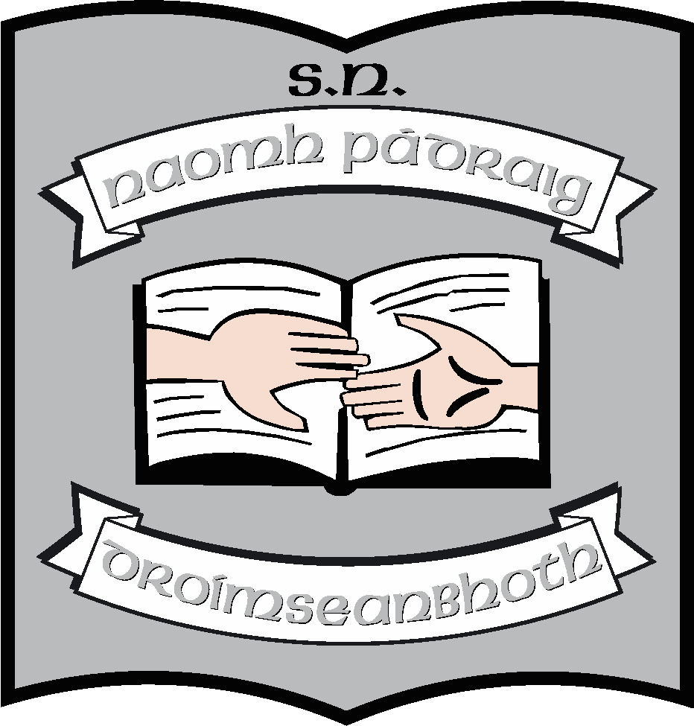St. Patrick’s N.S.
Drumshanbo,
Co. Leitrim.

Roll No: 19423J

Communication Policy

Created: January 2023
Ratified: February 2023
Due for Review: 2027

Communication Policy
Introduction
This policy was written in consultation with the staff, Board of Management and Parents Association. It was created in order to provide information and guidelines regarding communication between teachers and parents in the context of St. Patrick’ N.S Drumshanbo. It also outlines the Complaints’ Procedures at the end of this document for parents.

Aims
- Develop close links between home and school.
- Enable parents to collaborate with the school in developing the full potential of their children.
- Outline the various forms of home school communication.
- Share the responsibility of maintaining the school’s ethos, values and distinctive vision.
- Encourage positive and respectful participation in Parent/Teacher Meetings.
- Affirm the professional role of all staff members in the school.
- Encourage active involvement in the school/parents’ association.
- Encourage participation in policy development and decision-making processes.

Forms of Communication:
- School telephone for calls to and from parents
- School mobile for calls and messages to and from parents
- Aladdin Connect for notices, absences, Parent/Teacher notifications etc.
- WhatsApp messages for staff
- Emails to staff when necessary
- Staff notice board
- Meeting for parents of new Junior Infants – Term 3 prior to starting in the school
- Individual Parent/teacher meetings in Term 1 (Junior Infants – 6th Class)
- Staff meetings for staff
- Croke Park Hours for staff
- Student council will have monthly meetings with Ms. Reynolds
- Parents receive a school report at the end of each school year for each of their children.
- Meetings with parents whose children have special educational or behavioural needs
- Parent/Teacher consultation throughout the year, as needed
- Written communication – through Aladdin/emails/texts/Homework diaries
- Parents Association AGM
- Through the Parents’ Association, parents are invited to discuss and contribute to the drafting and review of all school policies. Decisions taken to change current policies and procedures or to introduce new ones will be made known to all parents in written format via the school blog
- School Calendar which keeps parents up-to-date with school events, holidays and other important dates
- Homework diaries can be used to relay messages which are written/signed between parents and teachers. Parents are requested to sign the diary each night to certify that homework has been completed.
- SeeSaw is used as a platform for communication with parents of children from Junior Infants to Second Classes, Laochra and Cairde also.
- Google Classroom is the platform used to communicate for homework with the senior classes.
- Parents are invited to events throughout the year school plays etc.
- All parents are welcome to make an appointment any time throughout the year. If a parent wishes to contact a teacher, he/she can contact the school secretary to arrange a suitable time. It is vital that the school is immediately informed of family events/situations that occur which may cause anxiety to the child and therefore may adversely affect his/her education.
- In all matters pertaining to the well-being and education of pupils, only the parents/legal guardians will be consulted by staff.
- In the case of separated parents, they shall both be contacted when the child starts in the school or when the school is informed of the separation to identify the most appropriate communication arrangements for their particular situation. Both parents will be sent a copy of the end of year report.

Guidelines for Parents and Guardians
In general, please remember that our learning platforms and video calls are to the children ( if we are directed by the Department of education to use Remote Teaching and Learning). You are encouraged supervise and welcome to be in the vicinity but, as in school, the interactions will be between the teacher and the pupil.

For Remote Learning
- It is the responsibility of parents and guardians to ensure that pupils are supervised while they work online.
- Check over the work which pupils send to their teacher, ensuring it is appropriate. This may not be necessary in all classes.
- Continue to revise online safety measures with pupils – check out our Acceptable Use Policy (AUP)

For video calls/Zoom
- Under no circumstances should pictures or recordings be taken of video calls.
- Ensure that the school has the correct email address for inviting you to join apps and meetings.
- The main purpose of a video call is to engage in online learning activities while maintaining a social connection between the school staff and pupils. Encourage pupils to listen and enjoy the experience.
- Be aware that when participating in group video calls, children can be seen and heard unless you are muted or have disabled your camera.
- Follow the Zoom invitation link you have been sent to join the meeting via your school network email address. Please note that the link to the meeting will not work unless you are an invited guest.
- Please ensure your child is on time for the scheduled Zoom call. Open the link approximately five minutes before the scheduled meeting time. Please wait for the host to start the meeting.
- Make sure to familiarise your child with the software in advance. For video in particular, show them how to mute/unmute and turn the camera on/off.
- Participants in the call should be dressed appropriately.
- An appropriate background/room should be chosen for the video call.

Any breach of the above guidelines will result in a discontinuation of this method of communication. It may also result in a person being immediately removed from a meeting or a meeting being terminated.
Remote Teaching and Learning Protocols for Pupils
- Check assigned work each school day
- Communication may only take place during normal school hours
- The normal school calendar will apply
- The following school policies apply to remote teaching and learning:
  - Code of Behaviour
  - Anti- Bullying Policy
  - Acceptable Use Policy
- Teaching and Learning best practice will continue to apply, with students expected to present all assignments to the best of their ability and on time.

Remote Teaching and Learning Protocols for Parents
- We ask parents/guardians to ensure protocols for students are adhered to.
- Check-in on their child’s school work on a daily basis if necessary and talk to their child about the work being assigned.
- The health and wellbeing of all is paramount. Circumstances may change for any of us unexpectedly, teachers or parents, so please keep schooling in perspective and do not allow anything school related to impinge on your child negatively. You are the primary educator of your child and you make those calls. We encourage your children to engage with the school. We provide work and guidance and ask parents and pupils to do their best and that is all.
- If Remote teaching and learning is happening, remember that we are continuing with the work of the school at this time especially in the areas of Literacy and Numeracy so it is important that children keep up.

Remote Teaching and Learning Protocols for Teachers/SNAs
- Check uploaded work daily
- Communication may only take place during normal school hours
- The normal school calendar will apply
- The following school policies apply to remote teaching and learning:
  - Child Protection Policy
  - Data Protection Policy
- Teaching and Learning best practice will continue to apply with students expected to present all assignments to the best of their ability and on time, where possible. Relevant feedback and support will be provided by the class teacher and the Special Education Teacher on an ongoing basis.
Parent/Teacher Meetings
Formal Parent/Teacher meetings will be held once a year for all classes in November.
The Special Education Teacher (SET) will arrange a meeting with parents of children who are in receipt of School Support Plus in Term One prior to the regular parent/teacher meetings. The SET, Class teacher and SNA (if appropriate) will meet with the parent to discuss targets for the support plan for the school year. A second meeting will be arranged with parents/guardians for a review of the support plan in February of Term 2.
Children who are in receipt of School Support and Classroom Support will meet the class teacher and Special Education Teacher at the yearly Parent/Teacher meetings. Teachers are available to meet outside of this meeting if a parent wishes to discuss any issues. If a parent wishes to arrange a meeting at any stage during the year to discuss their child, regarding any issues, they may do so by prior appointment through the office.
The school will attempt to co-ordinate times where siblings are concerned, through Aladdin. Meetings may take place in classrooms or support rooms. Parents can enrich teachers’ knowledge of their child’s progress by providing further information about his/her learning at home.
The purpose of the Parent/Teacher meeting is:
• To establish and maintain good communication between the school and parents
• To inform parents how their children are progressing in school
• To help teachers/parents get to know the children better as individuals
• To help children realise that parents and teachers are working together
• To inform parents of problems and difficulties the child may have in school
• To discuss with the parent the child’s experience of schooling
• To learn more about the child from the parent’s perspective
• To learn more about parental opinions on what the school is doing
• To identify areas of tension and disagreement
• To identify ways in which parents can help their children
• To make joint decisions about the child’s education
• To inform teachers on how children are coping outside school
• Parents can enrich teacher’s knowledge of their students’ progress through providing further information about the students’ learning at home.
Reporting to Parents/Guardians
Parents have the primary responsibility for their children’s learning and development. Schools can strengthen the capacity of parents to support their children by sharing useful information with parents about the progress that children are achieving in the education system. Teachers draw on the following sources of evidence:
• conversations with the child
• teacher’s observations on the child’s progress in reaching objectives laid down in the teacher’s short-term and long-term planning
• examination of students’ own self-assessment data
• teacher’s observations of the child’s engagement with tasks
• outcomes of assessments, tests and other tasks
• examples of students’ work.

End of Year Reports
End of year reports are sent home each June to inform parent of their child’s progress during the year. The school uses the template laid down by the NCCA.
Parents are given the opportunity to discuss the report if they are concerned about any element of it, before the school year ends. If a child has deteriorated or improved substantially the class teacher will always make a phone call to the parent prior to the report being issued.
Informal Meetings with Parents/Guardians
The school encourages communication between parents and staff. However, meetings with the teacher cannot be arranged for during teaching time. Meetings with the teacher at the class door to discuss a child’s concern/progress are discouraged on a number of grounds:
a) Teachers cannot adequately supervise their class while at the same time speaking to a parent
b) It is difficult to be discreet when so many children are standing close by
c) It can be embarrassing for a child when his/her parent is talking to staff at a classroom door.
d) Keeping in mind that schools are very busy places, parents are asked, whenever possible, to contact the secretary to arrange an appointment to see the class teacher or principal. e) The class teacher can phone a parent for the meeting at an agreed time, once the appointment is made through the office. (Parents should reveal the theme of the meeting to the secretary so as the school can prepare adequately.)
Occasions occur where a parent needs to speak to a staff member urgently. Sometimes these meetings need to take place without prior notice. Parents are urged to inform the office first and the Principal will aim to facilitate such meetings, making every effort to ensure that the children in the class do not lose out on any of the teaching/learning time.
If parents wish to drop in lunch boxes, sports gear etc, this can be done through the secretary’s office as it is important to keep class interruptions to a minimum.
Complaints Procedure
Complaints are infrequent but the school would wish that they be dealt with informally, fairly and quickly. Our Complaints’ Procedures outline the agreed complaints procedure to be followed in St. Patrick’s National School. The steps which are followed when dealing with any form of complaint between adults in our school are set out in our Complaints Procedures Policy and our Grievance Procedures Policy.
Roles and Responsibilities
Positive and respectful communication is of great importance to our school. This not only extends to the children but to all of the partners in education e.g. the staff, parents, board members and the wider community. While the behaviour of children in our school is of vital importance, adults in the school community also have a responsibility to ensure their own behaviour models the types of behaviour expected of children.
It is important that all partners in education are responsible for their own behaviour in the school.
For example:
• All stakeholders are expected to speak to each other with respect. Shouting or other aggressive tones are not acceptable. If a stakeholder displays anger or aggression to another member of the school community, they may be asked to remove themselves from the building. In certain cases, the Gardaí must be called
• All stakeholders will treat all children attending our school with the utmost respect while on the premises
• Staff will only discuss school matters relating to the parent/guardian’s own child. The school staff will respect the child’s right to privacy so it is asked that parents respect other children’s rights to privacy
• When meetings are arranged, it is recommended to agree a reasonable duration for the meeting. Every effort should be made not to exceed the agreed duration
Health, Safety and Welfare at Work
The Safety, Health and Welfare at Work Act (2005) is an important piece of legislation for Boards of Managements and for those who work in schools. It is recognised that school staff may be at risk from violence in the form of verbal abuse, threats, assaults or other forms of intimidation. This behaviour may come from pupils, parents, guardians, other staff members or intruders. In this respect, all staff should be aware of DES Circular 40/97 and Health & Safety Policy and Dignity at Work Policy which deal with the procedures to follow if they feel they have been subjected to any of the above behaviours.
Success Criteria
• Record the number and nature of complaints and how they were resolved
• Feedback from the school community/visitors to the school that a positive, welcoming atmosphere can be felt in the school
• Feedback from school staff, parents, pupils, etc on how the policy is working
• Good relationships and good open communication between parents and school staff
Review
This policy will be reviewed in 2027
Exceptional Closures:
In the event of exceptional closures e.g. no heating, water, electricity, inclement weather or Covid we will be guided by the Government guidelines and the most up to date advise. Remote learning may be necessary depending on the advice given to us.
This plan has been agreed on by the school staff in conjunction with the BOM

Martin McGowan 28/02/23
Chairperson Date

Ruth McLoughlin 28/02/23
Principal Date

