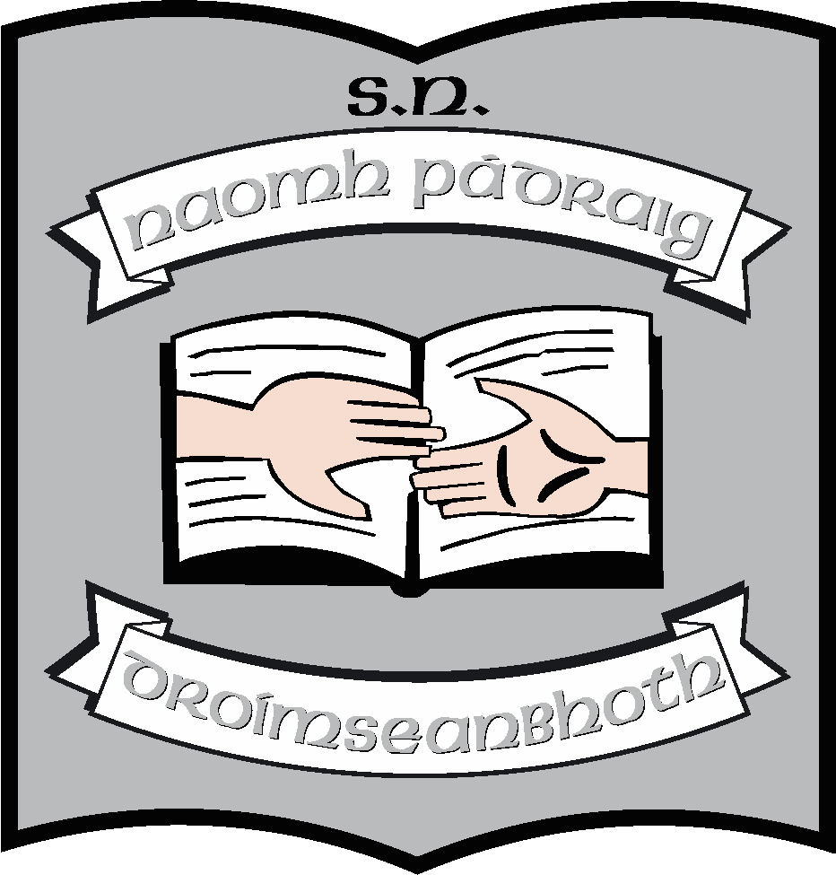St. Patrick’s N.S.
Drumshanbo,
Co. Leitrim.

Roll No: 19423J

Critical Incident Policy

Reviewed: January 2023
Ratified: February 2023
Due for review: 2027

St. Patrick’s National School

Critical Incident Policy 2023

St. Patrick’s National School aims to protect the wellbeing of its students by providing a safe and nurturing environment at all times. We have taken a number of measures to create a coping, supportive and caring ethos in the school. We have formulated a policy and procedures to be followed with a view to ensuring the physical and psychological safety of staff and students, both in ordinary time and in the event of a critical incident.

What is a “Critical Incident”?

St. Patrick’s N.S. recognises a critical incident to be “an incident or sequence of events that overwhelms the normal coping mechanism of the school and disrupts the running of the school”. Critical incidents may involve one or more pupils, staff, the school or our local community.

Types of incidents might include:

- The death of a member of the school community through sudden death, accident, violent death, terminal illness or unexpected death.
- An intrusion into the school.
- An accident/tragedy in the wider school community.
- Serious damage to the school building through fire, flood, vandalism etc.
- The disappearance of a member of the school community
- An accident involving members of the school community.

Aim:

At St. Patrick’s N.S. we recognise that the key of managing critical incidents is planning. We have developed a Critical Incident Management Policy and an accompanying plan. Our hope is that in the event of an incident these will help staff to react quickly and effectively maintain a sense of control. We have aimed to compile a policy and to return to normality as soon as possible after a potential critical incident and ensure that the effects on the students and staff would be limited.

Creation of a Coping, Supportive and Caring ethos in the school:

We have put systems in place to lessen the probability of the occurrence of an incident. These systems are in place to provide support to staff, students and the wider community which should help to cope with a range of life events. These include measures to address both the physical and psychological safety of both staff and students.

Physical Safety:

We have included into our Health and Safety Policy:-
- Evacuation plan in the event of a fire. (see fire drill)
- Regular fire drills occur (termly)
- Fire exits and extinguishers are regularly checked.
- Annual Risk assessment and annual safety statement.

Also
- Child protection and anti-bullying policies are in place.
- Rules of the playground and expectation of general pupil behaviour, as laid out in the school Code of Behaviour, encourage good behaviour, positive relations and prohibit bullying in any form.
- Pre-opening morning time supervision starts at 9:10 am.
- Children cannot be taken from school during school hours without informing the teacher, principal or secretary.

Psychological Safety:

We have created an open and encouraging environment in the school where students can talk about their difficulties and seek help.

- The school has a Child Protection Policy in place and the staff is familiar with Child Protection Guidelines and Procedures and how to proceed with suspicions or disclosures of abuse. The Designated Liaison Person (DLP) is Ruth McLoughlin and the Deputy Designated Liaison Person (DDLP) is Orla Walsh.
- Students who are identified as being at risk are referred to the DLP. Concerns are explored and the appropriate level of support and assistance is provided. Parents are informed and where appropriate a referral is made to an appropriate agency.
- Our Discipline Policy includes an approach to bullying.
- Our Mission Statement specifies that all children are given equal hearing.
- Social, Personal and Health Education (SPHE) programmes are included in the curriculum to address issues such as grief and loss, communication skills, stress and anger management, conflict management, problem solving, help seeking, decision making and alcohol and drug prevention.
- All staff are informed of difficulties affecting individual students and are aware and vigilant to their needs.
- All staff have access to books and resources on difficulties affecting the Primary School Child.
- The school has developed links with outside agencies such as the clergy, N.E.P.s., H.S.E., school nurse, cigire, the gardaí, the local surgery and the I.N.T.O.
- The staff will be cognisant of the differing needs of international pupils and pipils with special educational needs.
- Staff members accept the role in the pastoral care of pupils and colleagues.

Critical Incident Management Team:

A critical incident management team has been established in line with best practice. The members of the teams were selected on a voluntary basis and consist of staff who know the community, the students and each other well enough to make necessary decisions for when an incident occurs. They will retain their roles for at least two school years. The members of the teams will meet once a year to review and update the plan. Materials relevant to the role of each team member are attached to this policy.

Roles:

Key roles have been identified and assigned. The team includes:-

- Team Leader: Ruth McLoughlin
- Staff Liaison: Louise Brennan
- Student Liaison: Each Class Teacher
- Community Liaison: Clare McCabe/Jeannette Reynolds
- Parent Liaison: Orla Walsh
- Media Liaison: Ruth McLoughlin
- Admin./Records: Secretary (Caroline Flynn)

In the event of a critical incident the responsibilities of each role-holder will be as follows:-

Team Leader:

- Alerts the team members to the crisis and convenes a meeting.
- Co-ordinates tasks of the team.
- Liaises with the Board of Management and Department of Education and Science.
- Liaises with the affected family/staff member.
- Liaises with Garda Síochána.

Staff Liaison:

- Leads meetings to brief staff on the facts known, gives staff members an opportunity to express their feelings and outlines the routine of the day.
- Advises staff on the identification of vulnerable students.
- Is alert to vulnerable staff members and makes contact with them individually.
- Providing relevant materials to staff and students.
- Setting up of a “quiet room” where necessary.

Student Liaison:

- Liaises with other team members to keep them up-dated with information and progress.
- Alerts staff to vulnerable students.
- Setting up and supervision of “quiet room” where agreed.

Community Liaison:

- Liaises with agencies in the community for support and onward referral.
- Updates team members on the involvement of external agencies.
- Co-ordinates the involvement of these agencies. Key parents such as members of the Parent’s Association to be involved. Emergency support services and other external contacts and resources to be liaised with.

Parent Liaison:

- Facilitates “questions and answers” meeting.
- Meets with individual parents.
- Visits the affected families with the Team Leader.
- Ensuring that credentials of individuals offering support are verified.
- Providing appropriate materials for parents.

Media Liaison:

- Drawing up a press statement giving media briefings and interviews.
- Ensuring that all information about details of critical incident is checked for accuracy before being shared.
- Responsibility for considering issues that may arise and how they might be responded to (eg students being interviewed, photographers and journalists on premises).
- Communication with other groups/stakeholders.
- In the event of an incident, will liaise where necessary with the Communications Section in the DES.

Admin/Records:

- Maintain up to date lists of contact numbers of:-
(a) Parents or Guardians
(b) Teachers
(c) Emergency Support Services
- Telephone calls need to be responded to, letters sent and materials photocopied.
- Maintaining appropriate and necessary records.

To do List:
Contact Principal or Deputy Principal
Contact Class Teacher and staff
Contact accident and emergency services
Contact Parents/Guardians
Contact Fr. Frankie (if a life or death situation)
Contact First Aid Person/Health and Safety officer
Contact NEPS
Contact the I.N.T.O.

Record Keeping:

In the event of an incident each member of the team will keep detailed records of phone calls made and received, letters sent and received, meetings held, persons met, interventions used, materials used etc. The school secretary will have a key role in receiving and logging telephone calls, sending letters, photocopying materials etc.

Confidentiality and Good Name Considerations:

The school has a responsibility to protect the privacy and good name of the people involved in any incident and will be sensitive to the consequences of any public statements. The members of the school staff will bear this in mind and will see to ensure that pupils do the same. (For instance, the term “suicide” will not be used without the consent of the family involved or until it has been established categorically that the persons death was a result of suicide. The phrases “tragic death” or “sudden death” may be used instead).

Critical Incident Rooms:

In the event of a critical incident, the staff room and office will be the main room used to meet the staff, students, parents and visitors involved.

Group | Children in School | Children Absent
Meetings with Staff | Staff Room | Staff Room
Meetings with Students | Hall | Hall
Meetings with Parents | Resource Rooms | Resource Rooms
Media | Resource Rooms / Outside
Individual Sessions with Students | Resource Room
Other Visitors | Office

Development and Communication of this Policy and Plan:

All staff were consulted and their views canvassed in the preparation of the draft plan. Parent representatives were also consulted and asked for their comments. Our school’s final policy and procedures in relation to responding to a critical incident has been presented to all staff and to the Board of Management.

Review and ratification

This policy has been in operation in St. Patrick’s N.S. since October 2013. It was updated in December 2022 to reflect changes in personnel. It will be fully reviewed in 2026 unless changes of personnel/guidelines/procedures cause an earlier review.

***************************************************************************
Ratification of policy for St. Patrick’s NS

Martin McGowan 28/02/23
Chairperson Date

Ruth McLoughlin 28/02/23
Principal Date

