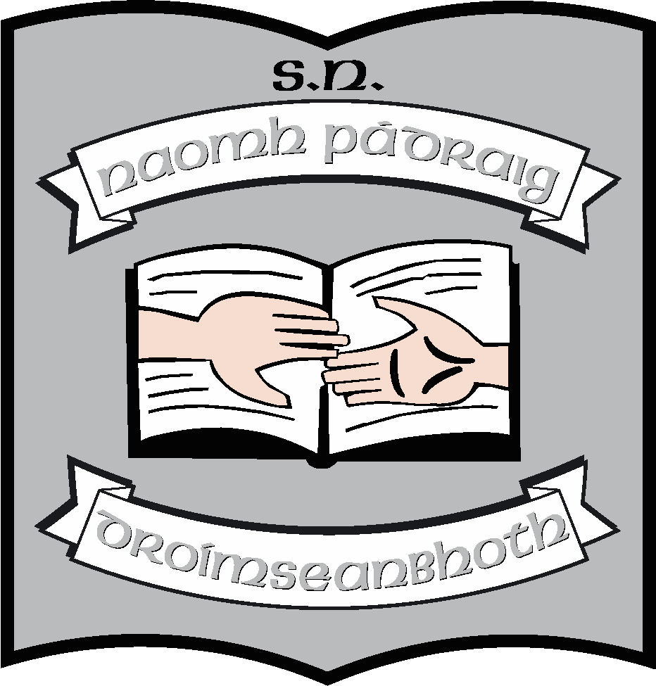St. Patrick’s N.S.
Drumshanbo,
Co. Leitrim.

Roll No: 19423J

Droichead Induction Policy

Reviewed: February 2022
Ratified: March 2022
Due for review: 2024

St. Patrick’s National School

Droichead Induction Policy

- Introduction

The Droichead process is an integrated professional induction framework for Newly-Qualified Teachers (NQTs). It builds on Céim taking as its starting point the areas for further learning that have been identified by the NQT in collaboration with the HEI as part of the school placement experience. At the same time, it recognises that induction is a distinct phase of the continuum of teacher education, a socialisation process into the teaching profession.

The main objective of the Droichead process is to support the professional learning of NQTs during the induction phase, thus laying the foundations for subsequent professional growth and learning for the next phase of their career. (Droichead: The Integrated Professional Induction Framework, Teaching Council, March 2017, p.3)

- Rationale

To provide a common understanding of the Droichead process for all school stakeholders.

- Aims

The main aims of this policy are:

- To guide the whole school implementation of Droichead and to support the induction of NQTs
- To outline the roles and clarify the responsibilities across the school community in support of Droichead
- To highlight protocols underpinning the Droichead process in the school
- To identify key documents which support the Droichead process

Roles and Responsibilities

- Roles and Responsibilities

  - Professional Support Team (PST) Suggested Roles and Responsibilities

A PST is a team of experienced, fully-registered teachers who have been trained by the National Induction Programme for Teachers (NIPT) to support the Droichead process. The PST works collaboratively to support and guide a newly-qualified teacher through his/her induction phase. The PST, comprising of a minimum of three members will be entirely school-based.
The current PST team is made up of Máirín O’Keeffe, Ruth McLoughlin and Orla Walsh. In the event that there is a vacancy in the team, it will be filled by a post-holder in the school.

Supporting an NQT through Droichead is always a collaborative process. The dual role of the PST is to:

- guide and advise the NQT during school-based induction, in the first stages of their professional journey
- form a joint declaration with the NQT that they have participated in a quality teaching and learning process (Droichead: Policy Teaching Council, March 2017).

The roles and responsibilities of PST members may vary and are therefore agreed before the Droichead process commences (Droichead Policy 1.1.4.2). To guide a PST in its roles, some suggested responsibilities are identified in Appendix 2. The list is neither exhaustive nor prescriptive and is open to customisation by a PST. While the responsibilities of mentoring are common to all team members, a PST may designate some of the other responsibilities to identified individuals within the team.

The PST will share its roles and agreed responsibilities with the NQT at their initial meeting.

- Appendix 1 details the names of each trained PST member in the school
- Appendix 2 outlines suggested roles and responsibilities for all PST members and suggested responsibilities that may be assigned to a named PST member.

  - Newly Qualified Teacher (NQT) Roles and Responsibililties

As previously stated, the main objective of the Droichead process is to support the professional learning of NQTs during the induction phase, thus laying the foundations for subsequent professional growth and learning for the next phase of their career (Droichead Policy Teaching Council, March 2017).
NQT Role

Supporting an NQT through Droichead is always a collaborative process. Droichead is fundamentally about the NQT’s professional journey and the process of their induction. A key part of this process is an NQT’s engagement with more experienced colleagues, and reflection on the professional conversations that take place on their own professional learning and practice.

Through their engagement in the Droichead process, the NQT will, in line with the Droichead standards

- have engaged professionally with school-based induction and additional professional learning activities
- have shown their professional commitment to quality teaching and learning for their pupils/students
- have engaged in reflective practice that supports their professional learning and practice, both individually and collaboratively

Based on above, the NQT will sign a joint declaration with the PST, that they have participated in a quality teaching and learning process (Droichead: Policy Teaching Council, March 2017).

Appendix 2 also outlines suggested roles and responsibilities for the NQT.

  - Principal – Roles and Responsibilities

“As a leader of learning in the school, the principal, while not necessarily involved in the Droichead process, fosters a learning culture in which Droichead can flourish, and supports the PST in facilitating a quality induction process (p.7 Droichead Policy 2017).

The Principal of St. Patrick’s N.S. has opted to engage as a member of the school’s PST, but may also opt solely for an oversight role - choosing to support the NQT and PST as they undertake the Droichead process, but are not part of the PST and do not sign Form D.

Appendix 3 outlines suggested roles and responsibilities for a principal in an oversight role.

- Protocols

This Induction Policy advocates adherence to the protocols identified in Droichead – The Integrated Induction Framework, Teaching Council, March 2017. This policy is specifically supported by the protocols referenced in the following sections:

- Professional Conversations: p. 5
- Observation: p. 5
- Maintaining records of the Droichead process: p. 6
- Concluding the Droichead process: p. 7

- Supporting Documentation

This policy is part of a suite of documents to support Droichead in the school.

These documents include:

- Droichead: The Integrated Induction Framework, Teaching Council, March 2017
- Teaching Council Standards (accompanied by customisable Indicators and School Context Examples)
- PST and NQT Roles and Responsibilities
- Droichead Outline Plan (to be drafted by the PST and finalised with NQT input)
- Droichead Standards and Induction Plan (to be updated regularly in collaboration with the NQT)
- Code of Professional Conduct for Teachers Updated Second Edition 2016
- Post-qualification Professional Practice Procedures and Criteria Registration Handbook
- Transitionary Arrangements Post-qualification Professional Practice Conditions available at Cosán: Framework for Teachers Learning, March 2016
- Looking at Our School 2016 -A Quality Framework for Primary Schools

- Timeframe for Review

This policy will be subject to biannual review which will be informed by ongoing experiences. The review of the policy will be led by the principal in collaboration with members of the PST and NQT and the in-school management team.

Timeframe for Implementation

This policy will be presented to the board at the next meeting for formal ratification. The policy will then be ratified.

Implementation/Ratification and Review

This policy will be presented to the Board of Management at the next meeting. If ratified, it will become school policy and will be published on the school website. It is due for full review in February 2024. The responsibility for the review will lie with the principal.

**************************************************************************

Ratification of policy for St. Patrick’s NS

Martin McGowan 28/03/2022

Chairperson Date

Máirín O’Keeffe 28/03/2022

Principal Date

Appendix 1 – PST Member Names

PST Member Details

Name | Class/Role | NIPT Link Person
Máirín O’Keeffe | Principal
Ruth McLoughlin | Deputy Principal  Cairde teacher | N NIPT Link Person  NIPT Link Person
Orla Walsh | SET

Appendix 2 – PST and NQT Roles and Suggested Responsibililties

Droichead – Roles & Suggested Responsibilities
for Professional Support Team (PST) Members and Newly Qualified Teachers (NQTs)
Droichead

The main objective of the Droichead process is to support the professional learning of NQTs during the induction phase, thus laying the foundations for subsequent professional growth and learning for the next phase of their career.
Droichead Policy Teaching Council, March 2017

Droichead and the PST-Role and Suggested Responsibilities
Supporting an NQT through Droichead is always a collaborative process. The dual role of the PST is to:

- guide and advise the NQT during school-based induction, in the first stages of their professional journey
- form a joint declaration with the NQT that they have participated in a quality teaching and learning process.
Droichead: Policy Teaching Council, March 2017
PST Suggested Responsibilities

Supporting a Newly Qualified Teacher during Droichead is always a collaborative process, although the roles and responsibilities of PST members may vary in different school contexts, and are therefore agreed before the Droichead process commences. (Droichead Policy 1.1.4.2)

To guide a PST in its roles, some suggested responsibilities are identified below. The list is neither exhaustive nor prescriptive and is open to customisation by a PST. While responsibilities relating to support and mentoring relate to all team members, a PST may designate some of the other responsibilities to identified individuals within the team.

The PST will share its roles and agreed responsibilities with the NQT at their initial meeting.

Suggested responsibilities for all PST members:

- Ensure that relevant Droichead materials are agreed before engaging in the process
- PST members to agree on protocols around observations, ensuring that observations by and of the NQT are conducted as per NIPT’s training recommendations (e.g.: an NQT should be observed by different PST members during the process)
- Agree Droichead Outline Plan with each NQT, ensuring opportunities for timely professional conversations and quarterly reviews are included
- Contact NIPT if there are concerns around the successful completion of the process. (It is recommended that this is done promptly, thus allowing the PST and NQT time to work together to ensure adequate supports and opportunities are provided to the NQT to successfully complete the process)
- Enable the NQT to be proactive when identifying emerging professional needs and supports required
- To provide support for planning and preparation for teaching and learning by NQTs
- To clarify school policies and procedures for the NQT
- Co-ordinate working with the NQT using the Droichead Standards and Induction Plan
- Liaise with Principal regarding organising Droichead Release Time for induction activities
- Professional and pedagogical support for the NQT
- Liaise with other experienced teachers/other relevant staff members/other schools in relation to opportunities for the NQT to visit/observe in classrooms and work alongside them
- Maintain records of the Droichead process in line with schools Data Protection Policy (GDPR) and confidentiality procedures
- Form a consensus in relation to the joint declaration and sign Form D, if appropriate
- Review the process when it is concluded with an NQT and update the school’s induction policy when necessary.
- Be mindful of the wellbeing of all involved in the Droichead process

Suggested responsibilities that may be assigned to a named PST member:

- Co-ordinate the overall Droichead process in collaboration with the PST members and the NQT including communicating meeting schedules and agendas and the co-ordination of Droichead Release Time
- Brief school staff and Board of Management on the nature and purpose of the school’s involvement in Droichead
- Share the termly Droichead updates with the rest of the PST (email sent by NIPT to the link person nominated at training)
- Arrange and lead the initial meeting with NQT
- Share the Droichead Outline Plan with the principal (if in oversight role)
- Attend Droichead professional development (one person invited from every school) and update relevant school personnel as necessary
- Liaise with Droichead associate/NIPT
- Keep a copy of the Approval to Commence the Droichead Process email and other relevant records
- Other...

Droichead and the NQT-Role and Suggested Responsibilities
Droichead

The main objective of the Droichead process is to support the professional learning of NQTs during the induction phase, thus laying the foundations for subsequent professional growth and learning for the next phase of their career.
Droichead Policy Teaching Council, March 2017

NQT Role

Supporting an NQT through Droichead is always a collaborative process. Droichead is fundamentally about the NQT’s professional journey and the process of their induction. A key part of this process is an NQT’s engagement with more experienced colleagues, and reflection on the professional conversations that take place on their own professional learning and practice.

Through their engagement in the Droichead process, the NQT will:

1. have engaged professionally with school-based induction and additional professional learning activities
2. have shown their professional commitment to quality teaching and learning for their pupils/students
3. have engaged in reflective practice that supports their professional learning and practice, both individually and collaboratively.

Based on above, the NQT will sign a joint declaration with the PST, that they have participated in a quality teaching and learning process. (Droichead: Policy Teaching Council, March 2017)

NQT Suggested Responsibilities

To guide the NQT in their role, some suggested responsibilities are identified below. The list is neither exhaustive nor prescriptive and is open to customisation.

- Apply to commence the Droichead process on the My Registration Portal of the Teaching Council website
- Retain a copy of the Approval to Commence the Droichead Process email and give a copy of same to the PST
- Register with an Education Centre for Cluster Meetings and bring Form D to each Cluster Meeting to be stamped
- Plan weekly and termly
- Be aware of relevant school policies and procedures
- Be familiar with relevant Droichead documentation including the Droichead Policy, Droichead Outline Plan, and the Droichead Standards and Induction Plan etc.
- Working with the PST, identify and agree indicative timeframes for induction activities and quarterly reviews which will be included on the Droichead Outline Plan
- Engage professionally with school-based induction activities, including, but not limited to, observations.
- Engage professionally with additional professional learning activities
- Observations: complete at least two observations of experienced teachers. The NQT will also be observed, on at least two occasions, by members of the PST. Engage in the 3 step process: pre-observation meetings, the observations, and the post-observation conversations.
- Be proactive in identifying emerging needs, and also work with the PST to identify these needs
- Engage in reflective practice that supports professional learning and practice, both individually and collaboratively. “As a self-directed learner, and to support reflective practice, NQTs will maintain a Taisce, (arising from the Gaeilge translation treasure trove)”.
- Update and maintain Droichead records as appropriate, for example: the Droichead Standards and Induction Plan document, post-observation records, Taisce etc.
- Reflect on professional learning and identify an area(s) of interest for future professional learning
- At the end of the Droichead process, complete Form D with the PST and post the original to the Teaching Council, retaining a photocopy
- Other…...

Appendix 3 – Principal’s Oversight Role

The Principal’s Oversight Role… Some Suggestions

“As a leader of learning in the school, the principal, while not necessarily involved in the Droichead process, fosters a learning culture in which Droichead can flourish, and supports the PST in facilitating a quality induction process.” (Droichead Policy, 2017, p.7)

From a practical perspective, the Principal’s Oversight Role might include some of the following activities: (this is not an exhaustive list - just some samples):
The Principal’s Oversight Role at Different Stages of the Droichead Process
Some suggestions…*
Before… | During… | After…
- Read the Droichead policy  - Identify suitable members for the PST:  - fully registered  - variety of expertise/competencies  - credibility  - Give ownership to PST (distributed leadership)  - Think about class allocations – so NQTs could be supported by others around them  - Logistics/support - ensure NQT is located where support can be easily provided by PST | · Talk to staff about Droichead, create an awareness & understanding of Droichead at whole-school level  · Attend part of PST meeting(s). Suggest value in attending the initial meeting – sets the climate – shows the value that the principal places on Droichead  · Affirm the PST – value placed on the work they do and the broader benefits for NQT and school  · Request a copy of the Droichead Outline Plan (indicative timeframe of the process). | · Celebrate and affirm the achievements and successes of the NQT, the work of the PST and the whole staff  · Records of the process:  - securely kept for a min. of one year  - also subject to your school’s own data retention policy  - supports a quality assurance process (Droichead Quality Assurance)
*Further examples are explored at NIPT’s Principal Oversight Role Day

