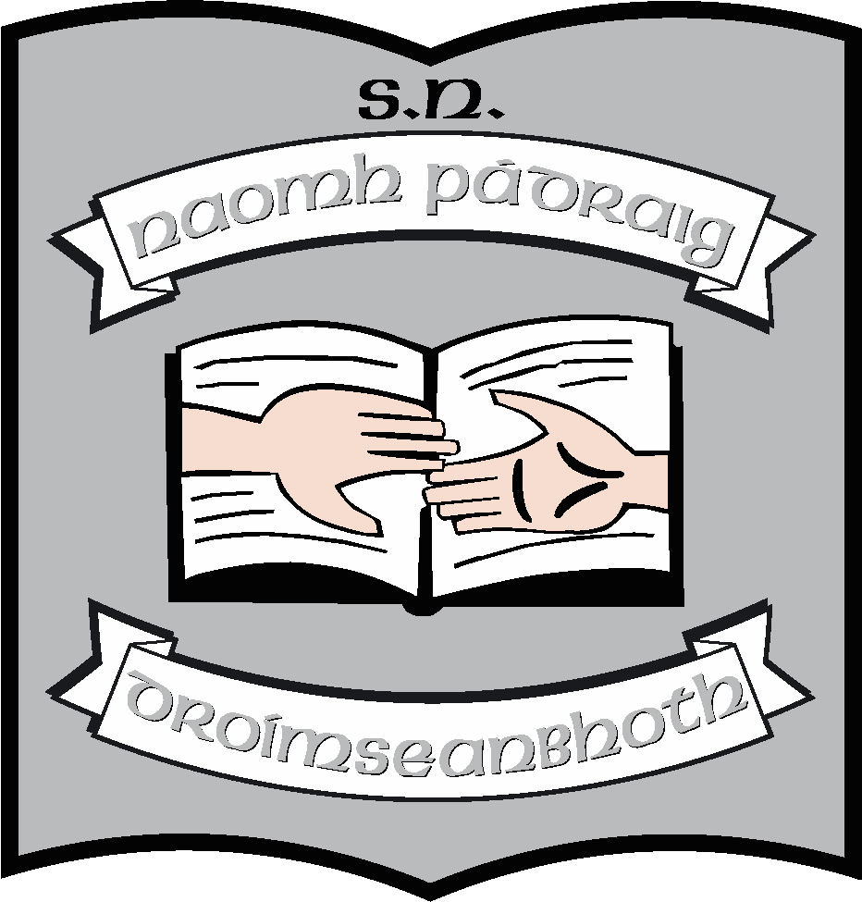St. Patrick’s N.S.
Drumshanbo,
Co. Leitrim.

Roll No: 19423J

SESE: Geography Policy

Reviewed: May 2021
Ratified:
Due for Review: 2026
Appendix 1: Curriculum glance cards
Appendix 2: Skills Development glance cards
Appendix 3: 3rd – 6th Counties and countries outline
Appendix 4: Whole school thematic plan
Appendix 5: Class resources & IT

St. Patrick’s National School

Geography Policy

Introductory Statement and Rationale

- Introductory Statement

The plan was originally formulated by the staff of St. Patrick’s National School in 2013 – 2014. It was reviewed in January and February 2020 during Croke Park hours and at ISM. This policy update was completed in May 2021 following the Covid closures.

It policy is grounded on the principles of the Geography curriculum and, as such, the content essentially remains the same. However, we need to update the policy to reflect increased thematic planning and a greater variety of methodologies and resources that are currently being used in the school

- Rationale of 2020 review

To improve the way in which Geography is taught in the school by
- Using cross curricular and whole school planning
- Using a greater variety of methodologies
- Incorporating the use of IT in the teaching of Geography

Rationale
We teach Geography
- to give children an understanding of place, space and environment
- to increase their awareness of their local place and environment and then progress to national and world-wide environments
- We also aim to develop children’s geographical skills.

Curriculum Planning

1. Strands and Strand Units

- Teachers are familiar with the strands/strand units/content objectives for the relevant class levels as well as being familiar with the core curriculum as included below.
- Continuity and progression are ensured through each teacher following the core curriculum as well as having the freedom to include other areas which may be particularly suitable to their class, interests or other activities
- Teachers will follow the recommended sequence for geography – local, regional, national, European and global and then reflect it back to their own location. A plan from 3rd class to 6th class outlining this is included as an appendix to this policy.
- Glance cards with an overview of the curriculum are included as an appendix to this policy

2. Skills Development

Teachers will ensure that there is a balance between skills development and the acquisition of knowledge throughout the programme
The strategies used by each class to develop the child’s skills and concepts development under the three headings are as outlined in the geography primary school curriculum. (See Curriculum pp. 22-23 Junior & Senior Infants; pp. 34-37 First & Second; pp. 50-53 Third & Fourth, pp. 68-71 Fifth & Sixth)
Glance cards with an overview of the skills development in the Geography Curriculum are included as an appendix to this policy.
4. Approaches and Methodologies

The key methodologies of the Primary Curriculum as follows are used as part of the geography programme:

- Active learning
- Problem solving,
- Developing skills through content,
- Talk and discussion
- Co-operative learning
- Use of the environment

- Examples of approaches and methodologies used in learning about places are use of photographs, maps, Google Maps, etc.
- Examples of approaches and methodologies used in learning about the environment are fieldwork, exploratory trails, photographs, virtual trails etc.
- Examples of approaches and methodologies used to investigate human environments are surveys, photographs, artefacts, interviews.
- Examples of approaches and methodologies used to investigate natural environments are vi trails and photographs etc
- Examples of approaches and methodologies used in learning about other places are artefacts, atlases, globes, interviews, photographs, IWB
- Examples of mapping skills and mapping concepts developed as part of the geography programme are local maps, plans, photographs, internet
- There are a number of maps, globes, atlases throughout the school and map work and mapping skills are taught as an integral part of the school curriculum.

5. Linkage and Integration

Teachers will link areas within the Geography curriculum. They will endeavour to make meaningful integration with other subjects in the curriculum, particularly in SESE.

A key part of this will be the implementation of whole school thematic planning. This will take place in November and in March. The themes will be

Year 1: Homes and Houses; My Locality
Year 2: Food; A contrasting country

Whole school thematic planning is included as an appendix to this policy.

6. Assessment and Record Keeping

Teachers will assess children’s knowledge and understanding of environmental matters as well as the acquisition of geographical skills and the development of attitudes. Tools of assessment tools used to gather information about a child’s progress are:
- Teacher observation
- Teacher-designed tasks and tests
- Work samples and projects
- Information gained from the assessments will influence teachers on how they plan for future lessons
- Records are kept by the class teacher for the year and results of all end of year tests are passed on to next teacher
- End of year results are shared with parents on the report cards where applicable

7. Children with Different Needs

Teaching is differentiated for all the children in the class by the class teacher. Classes and activities are organised and adapted for all children.

8. Equality of Participation and Access

Equal opportunities given to boys and girls to participate in classes/activities as all pupils are included in all aspects of the subject. Geography class is used as an opportunity to integrate the culture of all pupils

Organisational Planning

9. Timetable

- Time is allocated at each class level for Geography as per the curriculum guidelines i.e. 1 hour per week from 1st-6th and 45 minutes per week in the infant classrooms.
- Teachers have the opportunity to block time on occasions for Geography
- Discretionary curriculum time can be used occasionally for SESE if needed and at the discretion of each individual teacher.

10. Resources and ICT

• Appropriate resources are displayed in classrooms during lessons. Additional resources are stored centrally.
• Resources can be purchased centrally at the request of individual and groups of teachers.

ICT

- There is a selection of technologies available in the school including laptops, Ipads and cameras as well as interactive whiteboards in all classrooms.
- The code of practice to ensure safe Internet usage is recorded in the school’s AUP policy documents

11. Health and Safety

Teachers are aware of health and safety issues when participating in the Geography programme e.g. fieldtrips, handling equipment. The same health and safety policy and tours policy apply both in school and out of school and teachers always do their utmost to ensure the safety of the children in their care.

12. Individual Teachers’ Planning and Reporting

- Each teacher is aware of the school plan and core curriculum which informs their long and short-term planning.
- Teachers can plan using the strands and strand units or use a thematic approach depending on which is most appropriate to the lesson content and time frame needed.
- Teachers will record their content of work and assessment in the area of Geography in the Cúntas Miosúil. This will serve as a starting point in reviewing and developing individual preparation for following years.

13. Staff Development

- Teachers have access to reference books, resource materials, and websites dealing with geography.
- If there are appropriate geography courses available teachers are encouraged to attend.
- Teachers are encouraged to share the expertise acquired at these courses during staff meetings.
- Time is allocated if necessary at staff meetings or at Croke Park hours to discuss aspects of the primary school curriculum including geography.
- Teachers avail of internal and/or external expertise to inform and up-skill the school community in these areas where appropriate.

14. Parental Involvement

Parents can be involved in supporting the geography plan through supporting children with homework.

15. Community Links
Members of organisations / individuals in the community are available to support the school’s Geography programme as the need arises. This is particularly the case when classes are engaged in local studies such as when the whole school theme of ‘My Locality’ is being explored.

Success Criteria

We will know that the plan has been implemented if:
- Teachers preparation is based on this plan.
- Procedures outlined in this plan are consistently followed.

Means of assessing the outcomes of the plan include:
- Teacher/parent feedback
- Children’s feedback
- If the plan has promoted the key considerations when implementing the Geography curriculum.
- That there is a balance between the process (how the child learns) and content (what the child learns)
- That the curriculum is spiral and developmental in its structure.
- That the child engages in studies ranging from local to national and international Geography.
- That Geography is integrated across the curriculum from Infants to Sixth Class.

Implementation

The plan will be supported and implemented by the Principal and staff of the school.
The plan will be monitored and evaluated as necessary at whole staff meetings.

Review

This plan will be reviewed in 2025 unless there are curricular changes in the meanwhile. It will be presented to the Board of Management in the last meeting of the 2021 – 2022 school year.

Ratification and Communication

The plan can be communicated by providing a written copy if requested or by e-mail.
Geography plan will be available in the school office and available for parents/ guardians, should they request to view or obtain a copy.

************************************************************************
Ratification of policy for St. Patrick’s NS

Chairperson Date

Principal Date

