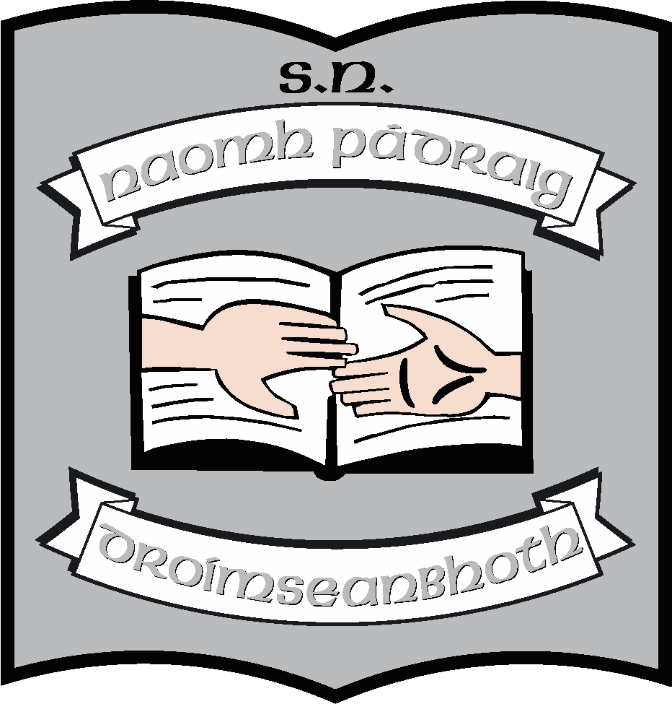 St. Patrick’s NS;
Geography & layout

Location of the school

St Patrick’s National School is situated on the outskirts of Drumshanbo, Co Leitrim, on the Ballinamore road. The land on which it was built belonged to the local parish of Murhaun and the school is linked to the church by a very scenic path which runs alongside the school, past the Poor Clare Convent wall and the graveyard, and into the church grounds.

St Patrick’s National School (then known as Drumshanbo Central School) first opened its doors to pupils and teachers in November 1974. It represented an amalgamation of Drumshanbo NS ( now called Áras Pádraig), Aughagrania NS, Corderey NS and Cormongan NS. Drumkeelan NS joined a year later in 1975.

Layout of the school

The school opened in 1974 with six classrooms, a general purpose room and attendant facilities. Very quickly this proved inadequate for the needs of a growing school population and a number of extensions followed leaving the school with nine permanent classrooms, a resource room, a general purpose room, a school office and principal’s office, staff room and kitchen as well as toilet facilities throughout the school including a disabled toilet.
At the back of the school, there is a separate building for learning support, which is divided with a sound-proof partition to form two classrooms. There is also a small building for storage. The school has two portacabins (used previously as learning support classrooms) and a storage unit. They will be used as resource rooms and PE stores respectively.

In 2021 an extension to the school has been completed, which includes an Autism unit comprising of 2 classrooms, with kitchen, sensory rooms, storage rooms and bathrooms. A large multipurpose room is also part of the extension. Some changes were also made to the layout of the existing building, including the provision of offices for the secretary and principal and the extension of the existing classroom. A lobby area was created at the main entrance to the school.

Access to the school

The main access to the school is via an entrance near the middle of the school building, as viewed from the road. Access is controlled from the secretary’s office. There are exits at either end of the building. There is disabled access throughout the school
Parking is across the road from the school and there is a pedestrian crossing for ease of access.
There are three gates providing access to the school. The furthest gate from the town provides disabled access whereby a car can drive directly to the main entrance of the school.

Outdoor areas

The school grounds consist of a large yard at the side of the school which is marked for games. This is used for PE when weather permits. There is a smaller yard directly in front of the school. There are three more play spaces, two at either side and another behind the school. The children use these spaces for recreation. Each class has a designated area.

A small garden is located inside the main gate of the school. This is dedicated to the memory of Mary Doyle. (Mary was a long-time secretary in the school as well as being the wife of the previous principal.) There is a sensory garden at one side of the school.

There is a field behind the school which is used as a football pitch and play area when weather permits.

The school car park is on the other side of the road and a crossing is provided for the safety of pupils, parents and staff. There is limited parking in front of the school, mainly for disabled parking and for school buses.

