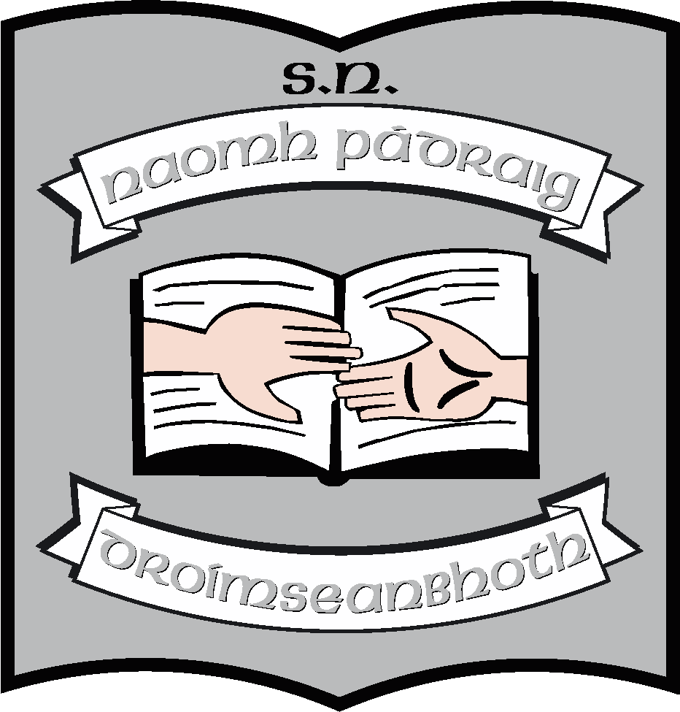
St. Patrick’s N.S.
Drumshanbo,
Co. Leitrim.

Roll No: 19423J

Health Promoting Policy

Reviewed: November 2021
Ratified: February 2022
Due for review: 2028/2029

St. Patrick’s National School

Health Promoting Policy

Introduction
This policy is a statement of the aims and objectives, principles and strategies for the promotion of health and healthy eating at St. Patrick’s National School.

Introductory Statement
St Patrick’s National School wishes to enable all children to develop and maintain a shared philosophy of all aspects of food and drink.

Rationale
We hope that the application of this policy will help us to
- Develop consistent messages about healthy eating across the curriculum
- Ensure food provision at school is in line with healthy eating guidelines e.g. water consumption
- Create a positive eating environment, both social and physical, at mealtimes.
- Ensure that the school environment is conducive to promoting healthy eating choices through the adaption of food programmes and fitness activities undertaken within the school.
- Create an environment that promotes healthy eating choices, rather than on the focusing of the banning of foods.
- Establish that the wellbeing of the whole school community is central to the school’s ethos/mission statement and school leaders and management actively promote wellbeing.
- Provide opportunities for children, staff and parents to have an active voice in decisions relating to school improvement.
- Use opportunities to promote wellbeing across the curriculum
- Ensure drinking water is freely available and rewards other than food are used to motivate children and young people.

Aims
We take our aims from the SPHE curriculum and they are:
- to promote the personal development and well-being of the child
- to foster in the child a sense of care and respect for himself/herself and others and an appreciation of the dignity of every human being
- to enable the child to make informed decisions and choices about the social, personal and health dimensions of life, both now and in the future
- To take a whole school approach to healthy and wellbeing in school, in relation to: the Culture and Environment, Curriculum (Teaching and Learning), Policy and Planning, Relationships and Partnerships.
- To promote healthy eating across school life, consistent with national healthy eating guidelines and school curriculum

Implementation of the school aims listed above:
The aims will be addressed through the following, using the key areas of the SPHE curriculum alongside other curricular areas, including SESE and PE.
- Packed lunches, availability of drinking water, where food is eaten (for staff and students).
- Time allowed for eating – balance of eating time and social time.
- Promotion of non-food rewards.
- Culture of healthy eating encouraged and positive modelling by adults in school
- Each class undertakes a variety of activities to promote and encourage movement, physical health and positive wellbeing of the students.

Junior Infants | Senior Infants | First Class | Second Class
Food Dudes  Fundamental Movement Skills  Outdoor coaches - GAA, skipping, gymnastics | Food Dudes  Fundamental Movement Skills | Go Noodle  Fundamental Movement Skills | Go Noodle  Fundamental Movement Skills

Third Class | Fourth Class | Fifth Class | Sixth Class
Futsol  Cumann na mBunscoil  Basketball League  Outdoor coaches - rugby, tennis, hurling, GAA  Laya Super Troopers  School Gaelic League  Gymnastics  Dance - Séan Ós Dancing | Cross Country  Couch to 5km  Cumann na mBunscoil  Outdoor coaches - rugby, tennis, hurling, GAA  Laya Super Troopers  Basketball League  School Gaelic League  Dance - Séan Ós Dancing | Cycling Programme  Couch to 5km  Cumann na mBunscoil  Outdoor coaches - rugby, tennis, hurling, GAA  Laya Super Troopers  Basketball League  School Gaelic League  Dance - Séan Ós Dancing  Volleyball | Cross Country  Couch to 5km  Cumann na mBunscoil  Outdoor coaches - rugby, tennis, hurling, GAA  Laya Super Troopers  Basketball League  School Gaelic League  Dance - Séan Ós Dancing  Volleyball  Online Videos - The Body Coach hiit

Laochra | Cairde | Whole School
In addition to the activities they complete with their classes:  Swimming | In addition to the activities they complete with their classes:  Horse riding  Swimming | Treat Friday  Sports Day  Movement breaks  Regulation breaks  Football Free Friday  Sensory Path  10 @ 10  Conor’s Path  Garden boxes for growing  vegetables  Theme month - Bia  Active Schools Week - May

Curriculum (Teaching and Learning)

• SPHE: As part of the Social, Personal and Health Education (S.P.H.E.) Programme we encourage the children to become more aware of the need for healthy food in their lunch boxes.
• PE: Physical Education programme supports the physical development and fitness of the children.
• SCIENCE: Science curriculum also looks at the development of the body and deepens the children’s understanding of how the body grows and develops. In addition, the curriculum looks at the effect of heating and cooling food.

Student Well-Being:
• As part of health promotion, we as a school look at the importance of promoting personal development and student wellbeing across the curriculum using The Weaving Well-Being Programme. This is undertaken from second to sixth class and is delivered by the class teacher.
• Each class explores a different strand under the framework of the Programme:
- Second class focus on character strengths
- Third class focus on positive emotions
- Fourth class focus on Resilience
- Fifth class focus on Positive Relationships
- Sixth class focus on Empowering Beliefs
• Each month the children engage in a different well-being theme whereby they complete a diary entry once a week into their personal Well- Being journal. The children can write or draw a picture to express themselves during this time. Playing relaxing music in the background during this activity is also encouraged school wide. Examples of themes we explore are Living Life to the Full, Forgiveness, Kindness, Thankfulness and Being a Good Friend.
• The theme for Well- Being is referred to each month in our school assembly. The children decorate a template to add to our wellbeing wall at the top of the main hall and this is often referred to during the assembly.

Attitudes to Food

• To coincide with our health promoting, we endeavour to encourage a healthy diet among children. We ensure to promote healthy eating guidelines for all school lunches with the use of a healthy eating policy. This includes a strict ‘nut free lunch’ to cater for any allergen needs across the school.
• Healthy packed lunches are encouraged with the exception of ‘Treat Friday’ whereby students can bring a small, funsize treat to enjoy.
• Teachers are encouraged to give healthy, active rewards as an alternative to food rewards. This includes: extra play/pe time, class activity, listening to music, free play, dance, extra golden time.

Review and Ratification

This policy has been created to coincide with our SPHE and Healthy Eating Policy. It was created in 2021/2022 to outline how the school promotes and what is undertaken to develop the physical and mental wellbeing of the students. It will be successful with the good-will and full cooperation of the whole school community.

It will be fully reviewed in 2028/29 unless changes to guidelines or procedures cause an earlier review. When adopted by the Board of Management, it will be published on the school website.

***************************************************************************

Ratification of policy for St. Patrick’s NS

Martin McGowan February 2022
___________________________________________________________________________
Chairperson Date

Máirín O’Keeffe February 2022
___________________________________________________________________________
Principal Date

