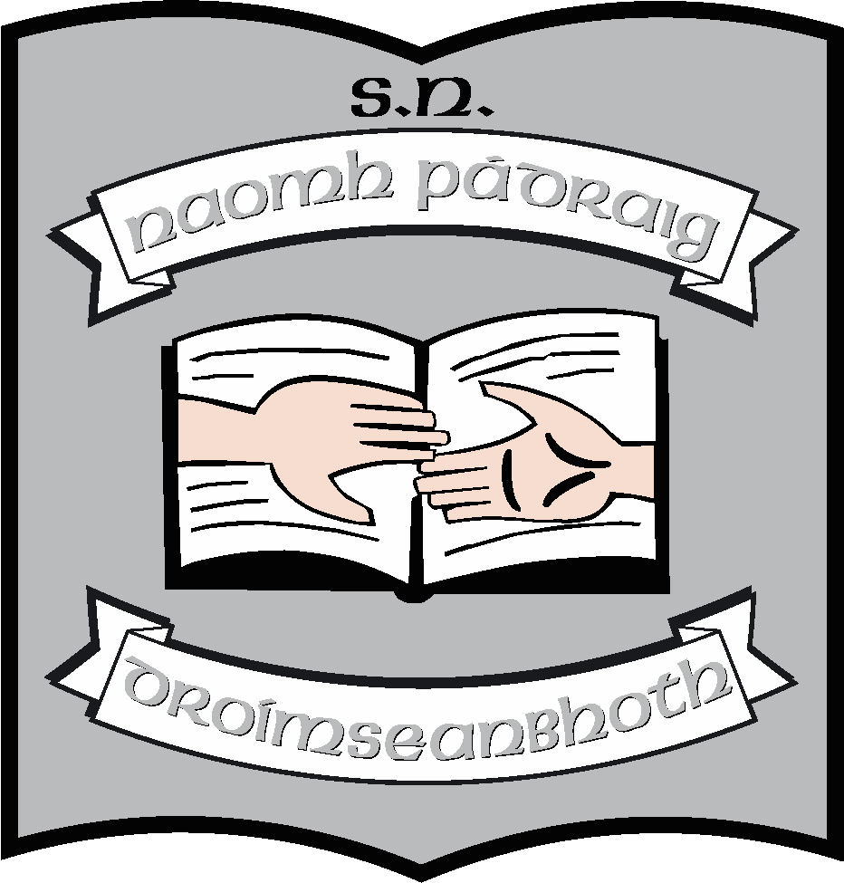St. Patrick’s N.S.
Drumshanbo,
Co. Leitrim.

Roll No: 19423J

Healthy Eating Policy

Reviewed: January 2023
Ratified: February 2023
Full Review: 2027

St. Patrick’s National School

Healthy Eating Policy

Introduction: This policy was reviewed by the school staff during the last term of the 2019/2020 school year.

Rationale: To promote healthy living, healthy lifestyle and to create awareness of the importance of a healthy balanced diet.
Aims:
The aims of the policy are to:-
- Eradicate junk food from lunches.
- Foster an awareness of healthy alternatives to junk food.
- Support parents in their efforts to provide a well balanced diet.
- Foster a positive attitude towards healthy eating.
- Nurture an interest in the preparation of healthy food and enjoyment of eating.

The following food items are not allowed:-
- All crisps and crisp related food e.g. Pringles
- All chocolate products e.g. bars, chocolate coated products, including biscuits and chocolate spreads. Yogurt with chocolate additives
- All sweets and sweet biscuits
- Chewing and bubble gum
- Pastries, buns, doughnuts, cakes and cake bars.
- All cereal bars due to high sugar content
- All hot foods e.g. chips, wedges etc.#
- Fizzy drinks

The following food items are suitable suggestions:-
- All bread and crackers
- All fruit and raw vegetables
- Cheese
- Scones, fruit scones, plain biscuits and brack.
- Unsweetened popcorn.
- Suitable sandwich fillings – roast beef, turkey, peanut butter, chicken, jam, marmalade, egg and onion etc.
- Drinks – Milk, water, flavoured milk, fruit juice.
- Yogurts and yogurt drinks

The Food Dudes Programme was introduced in the 2013/2014 school year to encourage children to eat more fruit and vegetables. All children took part in this programme.

- Exceptions will be made for children with special dietary requirements i.e. coelaic disease or diabetes.

- Children who bring a banned product into school will have the product confiscated.

- On special occasions, pupils may be rewarded with treats and we may allow the children to bring a little treat on Fridays.

This policy will only be successful with the good-will, common sense and full co-operation with the whole school community.

Please find attached information sheet.

Healthy lunchbox tips
A healthy lunch box should include a wide variety of foods
The lunch box should include at least one portion each of:-
- Bread and Cereal
- Fruit and Vegetable food groups
- Dairy Products
- Meat or an alternative (see examples below)
- Try not to offer the same foods on consecutive days
Make an effort to add interest to the lunchbox e.g. different types of bread – pitta bread, bagels, wholemeal rolls.
Fluids are important for children – up to 6 cups of fluid should be encouraged daily. Remember to avoid sugary and fizzy drinks.

Fun ideas
- Use biscuit cutters to cut sandwiches into fun shapes
- Put juice drinks in the freezer overnight and as the day goes on it will thaw out and be cold and slushy.
- Theme a lunchbox on a different country e.g. Italian – add a pizza slice, Mexican – fill flour tortilla with a filling of your choice.
- In the winter or on cold days you could make some home-made soup for your child
- In the summer, salads are light and refreshing and full of essential vitamins and minerals.

To help you get the correct portion size here is a list of examples for all the food groups:-
- 1 portion of fruit or vegetable
- 2 small fruit e.g. plums or satsuma
- 1 banana or apple
- 1 bunch of grapes
- A handful of dried fruit e.g. raisins or sultanas
- Celery or carrot stick

1 Portion of starchy foods such as bread and cereals
- A slice of bread, a bread roll, tortilla wrap, pitta bread
- A couple of handfuls of popcorn (plain, unsalted), a scone
- Slice of deep pan pizza – avoid pepperoni, sausage, spicy meat and double cheese
- 3 – 4 tablespoons of rice or pasta

1 Portion of dairy
- A pot of custard or yogurt
- A carton/glass of milk
- A triangle of spreadable cheese or 2 cheese slices

1 Portion of meat or alternatives
- One slice of meat or cheese in sandwich filling
- One hard-boiled egg, half a small can of tuna or salmon
- 1 – 2 tablespoons of chickpea spread, e.g. hummus – try as a dip with carrots/celery

Sometimes it is very difficult to think of an alternative to snacks high in sugar or fat. Here are some other options:-

Healthier options to crisps:-
- Washed, cut-up, raw vegetables. e.g. sticks of carrot, celery, pepper, cucumber.
- Whole raw veg. e.g cherry tomatoes
- Fruit e.g. 1 apple, 1 banana, 2 kiwis, handful of grapes, small box of raisins
- Plain popcorn
- Dried mixed fruit (no added sugar)
- Breadsticks
Healthier options to confectionery
- Mini tin of fruit in juice
- Fromage frais or yogurt with crunchy bits
- Currant buns, scones, fruit breads
- Semi-sweet biscuits e.g. Digestives
Healthier options to fizzy drinks
- Unsweetened fruit juice
- Fizzy water or flavoured bottled water
- Milk, flavoured milk or low-fat milkshake

St. Patrick’s National School

Healthy Eating Policy

***************************************************************************
Ratification of policy for St. Patrick’s NS

Martin McGowan 28/02/23
Chairperson Date

Ruth McLoughlin 28/02/23
Principal Date

