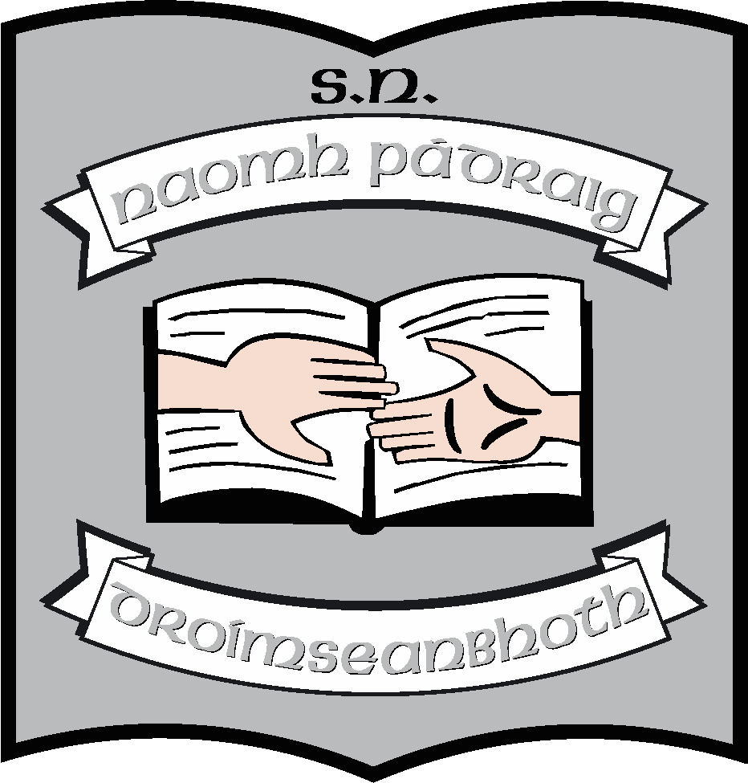St. Patrick’s N.S.
Drumshanbo,
Co. Leitrim.

Roll No: 19423J

SESE: History Policy

Reviewed: January 2022
Ratified:
Full review: 2027
Appendix 1: Strands and strand units
Appendix 2: Class by class scheme based on History Quest
Appendix 3: Unit of work: 1916
Appendix 4: Whole school planning for theme months

St. Patrick’s National School

History Policy

Introductory Statement and Rationale

- Introductory Statement

The plan was formulated by the staff of St. Patrick’s National School, Drumshanbo at a series of staff meetings during the school year 2012-2013 using a variety of methods including group review of existing policy, individual planning and preparation of particular sections by staff members, group discussions and use of ICT. It was updated in 2016 to reflect the work taking place in the school in preparation for 1916 centenaries and the changes in methodologies that was involved in this work. This review is being undertaken to reflect the theme months which take place in November and March of each year and also to reflect the integrated SESE scheme (Folens) which has been introduced in the Junior Classes in the school.

- Rationale of 2022 review

To improve the way in which History is taught in the school by
- Using cross curricular and whole school planning for 2 theme months each year
- Using a greater variety of methodologies
- Incorporating the use of IT in the teaching of History

Vision and Aims

(a) Vision:

Our history curriculum provides opportunities for the child to acquire a broad and balanced understanding of local, national and international history through the study of a range of peoples, events and periods.
It is our vision that history in our school will enable children to better understand the present by exploring the past before they look towards the future. We believe that history can help them to respect and empathise with people from all kinds of traditions and cultures.
We view history as having a distinct but complimentary role with geography and science within SESE with links to all areas of the curriculum.
We endorse the importance of local history.

(b) Aims:

We endorse the aims of Social, Environmental and Scientific Education as outlined on page 4 of the SESE History Curriculum Statement. We endorse the aims of the SESE History Curriculum:

- To develop an interest in and curiosity about the past
- To make the child aware of the lives of women, men and children in the past and how people and events had an impact on each other.
- To develop an understanding of the concepts of change and continuity.
- To provide for the acquisition of concepts and skills associated with sequence, time and chronology, appropriate to the developmental stages of the child.
- To allow the child to encounter and use a range of historical evidence systematically and critically.
- To provide opportunities for the child to communicate historical findings and interpretations in a variety of ways.
- To foster sensitivity to the impact of conservation and change within local and wider environments.
- To help the child recognise and examine the influences of the past on the attitudes and behaviour of people today.
- To encourage children to recognise how past and present actions, events and materials may become historically significant. (SESE History Curriculum Statement P. 12 )

We have made the following decisions to promote and develop the teaching and learning of history in our school:

Resources:

- We have a limited collection of resources relevant to topics, selected by class teachers
- We will revisit appropriate catalogues with a view to building up a collection of artefacts.
- We have bought a time-line which is permanently displayed in the hall. We also have a picture timeline based on Drumshanbo on display in the hall. We will better incorporate the use of timelines in our classrooms.
- We will encourage children to bring in artefacts and set up class museums.
- We will use IT resources to research, report and make presentations for history.

Local Studies:

- Since introducing the whole school themes of Homes and Houses and My Locality we have sourced appropriate buildings etc that can be studied by the senior classes
- As part of the above named themes, senior classes will visit and study a local building/graveyard/school/ruin.
- We will invite local people with knowledge of particular aspects of Drumshanbo in the past such as farmers, teachers, craftspeople, local historians etc. (when Guidelines permit)

Planning

- As part of our annual tours, we try to incorporate a visit to an historical site in line with the topics being studied that year with particular reference to any centenaries/celebrations taking place
- We will plan at least two units of work annually, based on a theme from the History curriculum which can be studied cross-curricularly:
Year 1: Homes and Houses; My Locality
Year 2; Food; A Contrasting Country
- Through all of the above, we will try to place less emphasis on text books and more on the themes and methodologies suggested in the curriculum.

Curriculum Planning

Strands and Strand Units:
(See Appendix 1 – Strands and Strand Units)

Each teacher is familiar with the strands, strand units and content objectives for his/her relevant class level. In our yearly planning we have taken into account the following:

- All strands and strand units will be covered on a yearly basis from infants to second.
- We are aware of the requirements of the “menu curriculum” as outlined in the Curriculum Statement regarding the number of Strand Units from each Strand that must be covered in each school year for the middle and senior classes.
- We recognise that the curriculum recommends that in each year one strand unit in local history and one strand unit in national or world history is studied in more depth over a longer period by the middle and senior classes.
- Equal emphasis is given to each strand and strand unit.
- There is continuity and progression in the History curriculum from class to class. This is shown in the individual class content schemes (included in the Appendix of this plan). Textbooks and resources which are applicable to the class level are used.
- Content is selected based on the strands and strand units in the curriculum. Teachers choose local, national and international contexts appropriate to the class level and try to ensure that there is a balance in their schemes between same.
- Many of the strands selected are relevant to the local environment and the locality of the school, in particular ‘Local Studies’ – homes, schools and buildings/ruins in the locality and ‘Story’ – stories from the lives of people in the locality in the past.

Skills and Concepts Development:

Each teacher is aware that the curriculum provides for the development of a growing range of historical skills and concepts. Each teacher is aware of the aspects of Working as a Historian that apply to each class level.

Skills of working as a historian are:

Infants:

- Time and Chronology
- Using Evidence
- Communication

First – Sixth Class

- Time and Chronology
- Change and Continuity
- Cause and Effect
- Using Evidence
- Synthesis and Communication
- Empathy

Approaches and Methodologies:

Our History Curriculum asserts that one of the keys to successful history teaching is the use of a broad range of classroom approaches and methodologies outlined as particularly suited to history and will endeavour to employ as many as we can as appropriate to our individual circumstance. The range will include:

- Story (P. 65 – 71, TG)
- Personal and family history (P. 72 -75. TG)
- Using Artefacts (P. 81 – 86, TG)
- Drama and Role Play (P. 109 – 113, TG)
- Using pictures and photographs (P. 87 – 98, TG)
- Use of the environment (P. 99 – 103, TG)
- Oral evidence (P. 77 – 80, TG)
- Documentary Evidence (P. 104 – 108, TG)
- Use of ICT (P. 114, TG)

Linkage and Integration:

We acknowledge that linkage and integration are recommended within the SESE curriculum and endeavour to make a link between our history topics in so far as possible. Teachers will explore possibilities for linkage across the History curriculum and will consider and note such opportunities in their classroom planning.

Linkage:

In order to make learning more meaningful for the child and to ensure the simultaneous development of historical skills and to provide for the application of these skills teachers will explore possibilities for linkage across the History curriculum and will consider and note such opportunities in their classroom planning e.g. Story will link with many other strand units. Some of the topics in Continuity and Change will also link with other strand units.

Integration:

We agree with the assertion made in the Curriculum Statement, (Page 9), that while history makes an important and distinctive contribution to the development of the child, historical education complements the growth of the child’s geographical and scientific learning. With this in mind, we will ensure to explore all possibilities to integrate the SESE subjects. Using integrated themes or topics will be one way to do this. We will also exploit all meaningful possibilities where History could be integrated with other curricular areas.

- We will endeavour not only to integrate content but also skills throughout the SESE subjects.
- Topics in History will be integrated with Geography using setting and location; this will be especially true during theme months
- History themes will provide the fictional lens in Drama; drama and drama strategies will also be used as methodologies for the teaching of History,
- Use of historical novels will be part of English and History education.
- Oral language, process writing and poetry will also be enhanced through history.
- Work on time and chronology will integrate with maths throughout the school.
- Visual Arts will be integrated with History especially in the area of looking and responding and will be tied in with the methodology which uses pictures and photographs.
- SPHE will be integrated under all of its strands, in areas such as personal and family history, citizenship, development education, as well as in the development of the skill of empathy.
- Irish culture, music, poetry etc. will be promoted through the History curriculum.
- Traditional games will be taught as part of the History curriculum.

Assessment and record-keeping

The primary purpose underlying assessment in history is to enhance the learning experiences of the child while ensuring that he/she is accessing all areas of the History curriculum.

Teachers assess

- Progress in children’s knowledge of the past
- Ability to use historical skills
- Development of attitudes

through:

- Teacher observation (P. 79, 80 C.S.)
- Teacher designed tasks and tests (P. 80, 81 C.S.)
- Work samples, portfolios and projects (P. 82, 83 C.S.), including pupils’ drawings and displays
- Pupil feedback

Information gained from the assessments is used to guide future learning and reinforcement where necessary. End of year results are passed on to the next teacher and to parents. A written report is given to parents of all children in the summer.

Children with Different Needs

We aim to ensure that all children have the opportunity to experience a rounded historical education. We will strive to make the history curriculum accessible to as many children as possible. In order to do this we will consider:

- Using a mixture of whole class teaching, paired, group and individual work
- Planning topics so that opportunities are provided for further investigation work for the more able or less able
- Using a range of questions and providing a range of tasks.
- Using a variety of teaching methodologies
- Offering a variety of recording methods e.g. drawing, photographs, use of ICT etc.
- Providing opportunities for co-operative learning
- Facilitating individual research and project work for the more able pupils
- Utilising skills of SNAs where appropriate

We endorse the emphasis this curriculum places on the exploration of personal and family history at all levels but we are conscious of the sensitivities some aspects of these topics may require. In cases where it would be insensitive to explore a child’s own personal and family history we will consider the substitution of the personal and family history of another person.

Equality and Access

History is for all pupils regardless of age, gender, background or ability. In planning our history curriculum, we will endeavour to ensure that the children encounter a broad and balanced curriculum that:

- Includes studies from local, national and international contexts
- Explores the past from a range of perspectives
- Explores the contribution of different ethnic and cultural groups, social classes and religious traditions with particular reference to and sensitivity towards the diverse groups within our school
- Includes a range of historical periods
- Allows for the use of wide of evidence
- Includes a balance between the broad sweep of history and more intensive study of limited periods
- Fosters the child’s sense of local, national and European identity

Organisational Planning

Timetable

In keeping with the recommendations in the Primary School Curriculum Introduction (P. 70) a minimum of three hours will be allocated to SESE per week from First to Sixth Classes and 2 ¼ hours for infant classes. Normally 1/3 of this time is allocated to History.
On occasion, time will be blocked as appropriate. This might occur when:

- Using a thematic approach
- Working on a project
- Exploring the local environment

Teachers will consider the use of discretionary curriculum time for SESE when appropriate

Resources

The school has a small amount of History resources which are stored centrally in the porta-cabin.
Each teacher will be responsible for his/her own resources for class specific topics and will try to build up a bank of History resources which can be used, including
- Pictures and photographs
- Artefacts
- Documents
- Maps
- Packs for topics
- IT resources

For whole school themes, staff will develop resource packs together which can be retained centrally for future use.

IT

IT will be used extensively to provide History resources. We will make extensive use of:

- Ask About Ireland
- Scoilnet – including archives
- Census Ireland
- Timeline websites
- Topic specific websites
- BBC educational websites
- Google Maps ( historial content)

When using the Internet to supplement the teaching of history in our school, teachers will adhere to the school’s Acceptable Use Policy.
Digital cameras, visualiser, Ipads will be used for field-work. Lap-tops will be used for project work.

Health and Safety

See school’s Health and Safety Policy.

Teachers act in locus parentis and as in any school trip teachers will take the upmost care to ensure the safety of all children visiting areas of historical significance e.g. handling artefacts, going on trails, visits to museums, ruins, archaeological sites.
The following Health and Safety guidelines will be adhered to in preparing for fieldwork:

- explore and get to know the environment thoroughly
- identify and note potential hazards
- consult with Principal
- choose and prepare for activities in which children will engage - prepare work directives
- consult safety guidelines for science which are relevant in relation to handling artefacts/field trips
- prepare the pupils: discuss forthcoming work with children and their behaviour at such places e.g. Archaeological sites
- ensure adequate supervision
- organize what the teacher and pupils should bring in relation to ‘Health & Safety’ e.g. teacher – mobile phone, first aid kit, contact numbers for doctors, gardaí school, parents
- check list of pupils’ names and safety instructions for helpers.

Individual Teachers’ Planning and Reporting

- As far as possible, planning for History will form part of a thematic approach.
- Teachers will use the History curriculum strands and strand units when planning.
- Skills development will form a key part of planning.
- Teachers will report on work completed on a Monthly Report template – Cúntas Míosúil.
- Teachers will use the Whole School Plan and Yearly Plans to inform their classroom planning.

Staff Development

Teachers have access to reference books, resource materials, and websites dealing with history. Each teacher is responsible for this during preparation.
They are made aware of and encouraged to attend local history courses when the opportunity arises. Opportunities are given for the sharing of information and expertise from these courses with the rest of the staff, both formally and informally.

Parental Involvement

- Parents will be informed, through parent/teacher meetings and through newsletters, of how they can support their child’s learning in history by fostering an interest in personal, local, national and international history.
- Parents will be asked to engage in the collection of personal photographs and artefacts in support of the strand on Myself and My Family.
- Parents and grandparents will be invited to speak or be interviewed by the children from time to time.

Community Links

We have identified the following people and agencies who may be able to support the implementation of our history programme:

- Heritage Officer with Leitrim Co. Council
- Leitrim Tourist Office
- Glimpses of the Past, Drumshanbo
- Carrick On Shannon Education Centre
- Archaeology Pack
- Local libraries
- School Folklore Collection UCD
- Local people with a particular expertise in the field of local history –Noel McPartland, Eugene O’Connell

Places of historic interest

The school has embarked on tours to places of historical interest. These include both local and national places of interest e.g. yearly visits to Ballintubber Abbey, Knock Folk Museum. We have also visited Ulster American Folk Park, Belvedere House, Turlough House, Arigna Mining museum. We try to visit places which are relevant to themes being studied in classes or to topical themes and events.

We have identified the following local places as being suitable to support the teaching of local and national history:

- Our school & The old primary school
- Local churches – Catholic, Methodist & Protestant
- Graveyards
- Local heritage centre
- Buildings associated with the Laird family
- Buildings associated with the railway
- The High Street
- Sites and monuments linking Drumshanbo with 1798

Success Criteria

We will use the following criteria to assess the success of this plan:

- Evidence that pupils are engaging in studies from personal to local, national and international history.
- Improved methodologies and resources
- Our yearly and classroom planning is based on the Whole School Plan
- There is a balance between skills and content
- Development of historical skills throughout the classes
- Use of timelines throughout the school
- Classes engaging in outdoor observation and trails of the local environment
- Photographs, displays, use of artefacts and evidence in classes
- Children’s feedback/Teacher/Parent feedback/Inspectors’ suggestions / feedback

Roles and Responsibilities:

All classes are responsible for the implementation of the history curriculum in their own classrooms. Teachers will be encouraged to present feedback during staff meetings on a review of history.

Implementation/Ratification and Review
This plan is already being implemented in part but when ratified by the Board of Management, it will become school policy in the 2021/22 school year and will be included in the Plean Scoile. The whole policy is due for review in 2026. However, changes to the curriculum or to classroom organisation may precipitate an earlier review.

************************************************************************
Ratification of policy for St. Patrick’s NS

Chairperson Date

Principal Date

