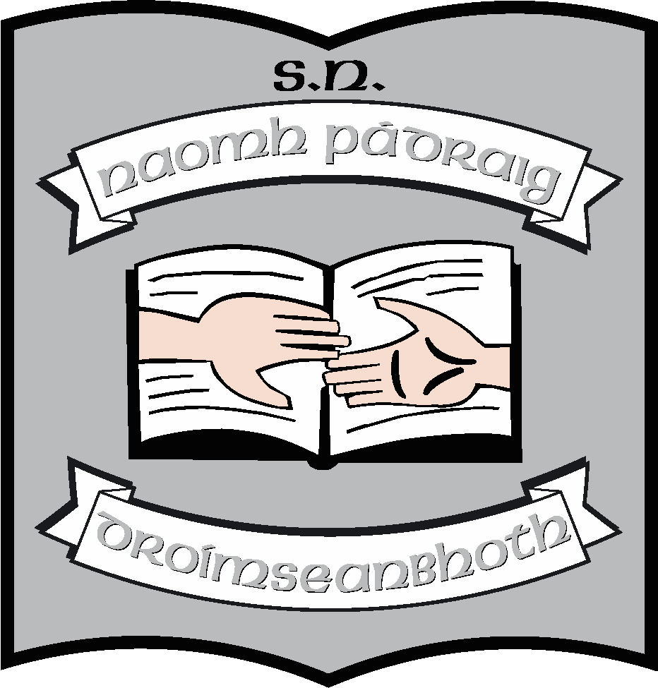St. Patrick’s N.S.
Drumshanbo,
Co. Leitrim.

Roll No: 19423J

Induction of New/Substitute Teachers

Reviewed: January 2023
Ratified: February 2023
Full Review: 2027

St. Patrick’s NS, Drumshanbo
Induction of New / Substitute Staff Members
School day
Morning
- School officially opens to receive pupils at 9:10am.
- Children must remain in their seats once they enter the classroom.
- Class begins at 9:30. Children are allowed to eat a snack at their desks at 10:55. Bell rings for small break at 11:00

Small break
- Break is from 11:00am to 11:10am.
- Junior infants - 2nd class go to the yard outside the main door and behind the school. 3rd – 6th class go to the big yard using the exit near the office. If it is raining, the children remain in their seats in their classroom.
- When bell rings for the end of break, children line up with their class groups at the appropriate door and return to the classroom.
- Class resumes at 11:10
Lunch break
- Children are allowed to eat their lunch at their desk. Some children get milk using the school scheme. Generally a child has been appointed to collect this from the fridge in the hall. Procedure is as for small break.
Afternoon
- Junior and senior infants finish at 2pm. They are collected, one at a time, from their classroom door.
- 1st – 6th finish at 3pm. Those going home by bus go to the infant classrooms to get into their queues. Others are collected, some walk or cycle. There is also a collection by the afterschool team.
**********
Child Protection
- Substitute teachers should leave copy of Garda vetting and form of undertaking in the office.
- A copy of the school policy regarding child protection is kept in each teacher’s table along with a copy to record any concerns. In the event of any questions in this regard, please check in the office.

Information in classroom for substitute teacher
- Each teacher has a copy of the names, addresses and phone numbers of pupils. This is displayed in each room.
- Some children attend Learning Support/Resource teachers. The timetable is displayed in each classroom and in the small office.
- The children may attend coaching/choir etc. Appropriate lists/timetables are kept in each classroom.
- Each teacher has a timetable and a day’s work for emergency absences kept in the classroom.
- See also Child Protection Policy

Other Information
- The First Aid box is located at the top of the hall near the second class classroom. Accident report forms are also kept there. Teachers should use these to record and accidents which occur in class or while they are on duty in the yard. Parents should be informed of any fall/injuries/illness.
- We do not administer any medication in this school.
- It is the policy of the school to give homework from Monday to Thursday. Homework and classwork must be corrected.
- Rolls are called daily at 10:30 and absences and latecomers are recorded electronically – check with the office. Roll books are also maintained. Children are required to provide a note following an absence.
- No child is allowed to leave the school grounds at any time, unless they have written permission from their parents. Likewise, a child may not leave early without written permission.
- Junior classes must be collected by a designated adult.
- If children are returning forms/money etc. to the teacher, these should be collected, recorded and returned to the office. Letters to parents/guardians should be given to the oldest in families.
- All electrical equipment must be plugged out each evening. Please let the principal know if any item is not working.
- Children are not allowed to have mobile phones. Teachers are asked not to answer/use their mobile phones during class time.
- Children go singly to the bathroom
- It is the policy of the school that all children wear school uniform or school track-suit.

Other important information
- The office is straight through the main hall, second last door on the right.
- Staffroom is the last door on the right, next to the office.
- Supervision rota is displayed in the staffroom and in the office
- Staff bathroom is the second door on the left, inside the main school door.
- Telephone number 071-9641755

Principal | Ruth McLoughlin
Deputy principal & SET | Orla Walsh
6th Class | Kathy Keegan
5th class | Maria McGolderick & Emma Earley
4th class | Ciara McTigue
3rd class | Áine Smith
2nd class | Maureen McNamara
1st class | Martina Duignan
Senior infants | Michelle Kelly
Junior infants | Sinéad Rogers
Autism class Cairde | Rachel Noone
Autism class Laochra | Louise Brennan AP2
SET | Regina McLoughlin
SET | John Molloy
SET | Clare McCabe AP2
SET | Jeannette Reynolds AP2
Secretary | Caroline Flynn
SNA Mainstream | Donna Flynn
SNA Mainstream | Sinéad Dolan
SNA Mainstream | Olive Murphy
SNA Cairde | Deborah Kehoe
SNA Cairde | Davinya Sheehan
SNA Cairde | Samantha Cullen & Sharon McGovern
SNA Laochra | Julie Durkin
SNA Laochra | Ann Flood

St. Patrick’s National School

Induction of New / Substitute Teachers

***************************************************************************
Ratification of policy for St. Patrick’s NS

Martin McGowan 28/02/2022
Chairperson Date

Ruth McLoughlin 28/02/2022
Principal Date

