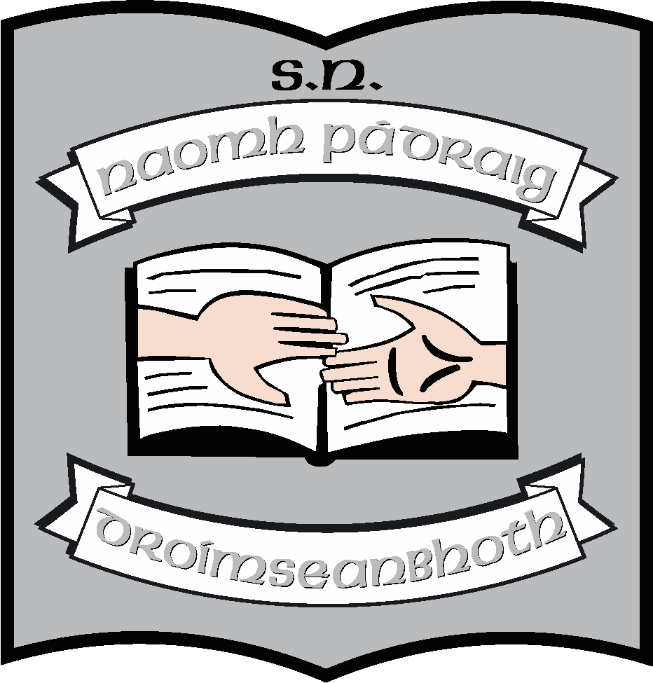 St. Patrick’s NS;
School Mission Statement

Pupils’ Mission Statement:

St. Patrick’s N.S. is a Catholic school where all children are welcome.

It is a happy, safe place where friendship and learning are very important.

Our School Motto:

Friendship and learning

Cairdeas agus foghlaim

