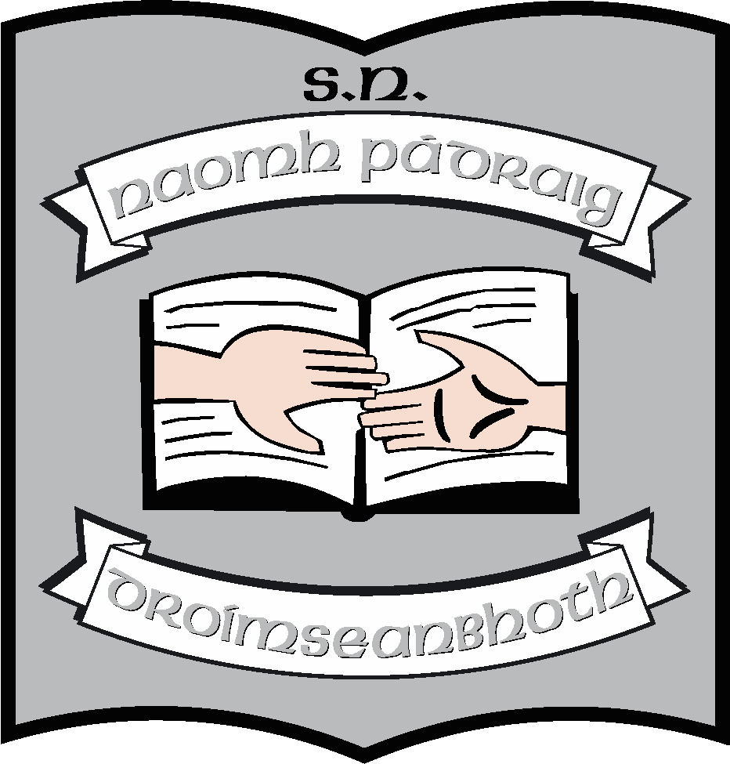St. Patrick’s N.S.
Drumshanbo,
Co. Leitrim.

Roll No: 19423J

Arts: Music Policy

Reviewed: August 2021
Ratified:
Full review: 2026
Appendix 1: Tin Whistle and Literacy

St. Patrick’s National School

Music Policy

Introductory Statement and Rationale.

Introductory Statement

The plan was formulated and reviewed in October 2012 by Mr. Reynolds and Ms. Mc Morrow in conjunction with all members of staff. This review (2021) has been undertaken by staff to update the policy in regard to current practice in the school although the fundamental curriculum and methodologies remain the same.

Rationale

Music provides an opportunity for children to enjoy and express themselves and to have fun. We hope that the music education provided in our school will be the beginning of a life-long love of music for many of the children.
Music can also teach children about being part of a team, about performing and about creativity.
Therefore we must teach music to provide children with opportunities to engage with a wide range of musical styles and traditions, to become involved in moving, dancing, illustrating, story-telling and making drama.
Our music curriculum introduces children to music reading and writing, to song singing and to playing classroom instructions.

Vision and Aims

Vision

We seek to assist the children in our school in achieving their potential through developing his/her talents in the area of music.

Aims

We endorse the aims of the Primary School Curriculum for Music:-
- To enable the child to enjoy and understand music and to appreciate it critically.
- To develop the child’s openness to, awareness of and response to a wide range of musical genres.
- To develop the child’s capacity to express ideas, feelings and experiences through music as an individual and in collaboration with others.
- To enable the child to develop his/her musical potential and to experience the excitement and satisfaction of being actively engaged in musical creativity.
- To nurture the child’s self-esteem and self-confidence through participation in musical performance.
- To foster higher-order thinking skills and lifelong learning through the acquisition of musical knowledge skills, concepts and values.
- To enhance the quality of the child’s life through aesthetic musical experience.
- To provide children with opportunities to perform using their musical talents.

The Music Plan will be addressed under the following headings:-

Curriculum Planning:

- Strands and strand units
- Approaches and methodologies
- Linkage and integration
- Assessment and record keeping
- Equality of participation and access
- Organisational planning

- Timetable
- Resources and ICT
- Health and Safety
- Individual teachers’ planning and reporting
- Staff development
- Parental involvement

- Strands and Strand Units

- Teachers are familiar with the strand/strand units/content objectives for their class level as well as the core curriculum for St. Patrick’s N.S. as stated in the curriculum
- Familiarity of the music programme is maintained when teachers change class or if new teachers join the staff through the core curriculum and school plan.
- Continuity, progression and consistency from class to class is ensured through following the curriculum, core curriculum and school plan.
- Teachers are familiar with the musical concepts and the three strands including Listening and Responding, Performing and Composing, ensuring that they are comprehensively covered and afforded equal importance.

Listening and Responding
- Children are provided with opportunities to listen and respond to music in the classroom. Teachers ensure that children experience a wide range of musical styles, traditions and cultures.
- The teacher provides opportunities for active listening and responding through eg. questioning, prompting suggestions, listening to shot examples repeatedly, responding in some of the following ways:-
Moving, talking about, listening for specific instruments and/or specific features, drawing and painting, following/creating a pictorial score of music, writing in response to music, composing, singing or playing along with music, musical games and/or action songs.
- Children are provided with opportunities to work in different groupings eg. whole group, small groups, pairs individually.
- Children are provided with opportunities to work collaboratively/co-operatively.
- A broad range of materials is provided for listening and responding eg.
- recorded music.
- Tuned and unturned percussion instruments.
- Environmental objects such as assortments of metals, wood or fibres.
- Melodic instruments – tin whistle, key board, ukulele, piano
- We encourage musicians to come to the school to perform live

Performing
In the performing strand all the following are emphasised:
- Active enjoyable participation
- Developing of skills, understanding, knowledge.
- Fostering of children’s attitude and interests.
- Developing of creativity:-
- Effective singing skills are developed through: encouraging the following – part singing, teaching rounds, partner songs (duet) and part songs
- Approaches to music literacy include pictorial representation of rhythm, stick notation, tonic sulpha and reading music for tin whistles.
- Children are provided with opportunities to play unturned and tuned percussion instruments in all classes.
- Children have many opportunities to perform for an audience within class, for other classes and for parents and the wider community
- Opportunities provided for live performances include Christmas/Easter Concerts, Choir performances, Sacraments
- The school takes part in the National Children’s Choir
- Performance of a group, ensemble, band, choir, orchestra visiting the school or at another venue.
- Tin whistle is taught from 2nd class to 6th
- Ukulele is taught in 3rd and 6th classes
- There is a literacy scheme in use to accompany tin whistle in 3rd – 6th classes
- Two Irish songs annually are stipulated for each class as part of our Gaeilge Neamhfhoirmiúil
Composing

Children are encouraged to compose music as part of the Composing Strand through:-
- Children from Juniors to 6th compose short rhythmic pieces
- Children compose by putting a melody to rhythm
- Some children compose melodic tunes on a melodic instrument.
- Children are given opportunities to compose a rhythmic piece by using vocal sounds, body sounds and percussion instruments.

- Approaches and Methodologies

- All children are actively engaged in music education in our school.
- A variety of approaches and methodologies are used to foster active enjoyable participation in the music curriculum.
- Opportunities are provided to enhance children’s lives through various class and school performances throughout the year.

- Linkage and Integration.

- There is natural linkage across the strands of the curriculum – Listening and Responding, Performing and Composing – particularly if the main emphasis of the lesson is song singing.
- Music is a subject that lends itself to integration across the curriculum but especially with Visual Art and SESE.

- Assessment and Record Keeping

- Assessment informs the teaching and learning of music by determining the skills the children already have and enabling teachers to identify what needs to be reinforced, consolidated or the next skill to be taught.
- Children’s overall musical ability, interest and participation level is assessed as well as individual aspects of each strand.
- Teacher observation is the main assessment tool.
- Other assessment tools used are:
Teacher-designed tasks, Recording of the children’s work.
Assessment based on the music literacy scheme
- Assessment is recorded in teachers’ notes and in the end of year report.
- This is communicated to parents in the end of year report.

- Equality of participation and access.

- All children participate in classroom music. Teachers adapt and differentiate the curriculum according to the needs and talents of the children and a special needs assistant provides support to some children if necessary/allocated.
- All children are given equal access to the curriculum
- The music class can be used as an opportunity to integrate the culture of all pupils eg. international pupils.

- Organisational Planning

- Time is allocated as per the Primary School Curriculum. In this curriculum, music is included in the time allowance for arts education.

- Resources and IT

An inventory of resources, including equipment and instruments available for music are listed below. Music CD’s and the internet are also used as key resources for teachers.

- A variety of instruments is stored in two storage boxes, blue in the resource cabin. These contain a wide selection of instruments including tuned, percussion and wooded instruments. Please see below:-
- Teachers choose from a variety of books and resources which are store in the resource cabin.
- Teachers have access to active listening and responding resources via Internet and whiteboards.
- Music Box/Teachers Resource Book (used by classes 1st to 6th)

- Health and Safety

Teachers always do their utmost to provide safe learning environments across all areas of the curriculum. Consideration is given to the following when planning for music:-
- Safety of children moving around the classroom
- Storage facilities
- Access to, and transport of equipment/instruments
- Ventilation of the classrooms
- Amount of space for children to sit or stand when doing choral or instrument work
- Appropriate volume levels when doing audio equipment and instruments
- During Covid, singing and tin whistle will not take place indoors until guidance permits

- Individual Teachers’ Planning and Reporting

- The whole school plan, core curriculum and the curriculum documents for music provide information and guidance to individual teachers for their long and short term planning.
- Teachers plan using the objectives as laid out in the strands and strand units.
- Each teacher will record their month’s work in their Cúntas Miosúil which will serve in reviewing and developing the whole school plan/individual preparation for following years.

- Staff Development

- Teachers have access to reference books, resource materials, instruments, equipment and websites dealing with music.
- Staff are consulted about the purchasing of instruments and materials for music. Suggestions are made at staff meetings regarding the purchase of additional musical equipment if deemed necessary.
- Information about in-service courses, school visits, musical events are communicated to all by the principal via the staff notice board.

- Parental Involvement

- Parents can and do support their children in fostering an interest in music through attendance at concerts/performances/choir, encouragement of tin-whistle practice, giving permission to attend out-of-school music days (eg pantomine) and general encouragement of their child’s talent.
- Parents are involved and encouraged to view the children’s performances in music wherever possible.

Success Criteria

This plan will make a difference to the teaching and learning of music in our school because teachers will use it to inform their planning and teaching. The following criteria will indicate success in terms of teacher engagement with the plan:-

- Teachers’ planning and preparation for music is evident
- Procedures outlined in this plan are consistently followed
- Means of assessing the outcomes of the plan includ :- teacher/parent/pupil/community feedback.
- Cúntas Miosúil
- Inspectors suggestions/report

We will know if the plan has enhanced pupil learning if:-

- Children have a positive attitude and appreciation of music
- Children have an interest in expression through music.
- Children engage in listening and responding, performing and composing music.
- Children have explored sound including vocal sound, body percussion, instruments and environmental sounds.
- Children have listened and responded to music from a wide variety of genres and cultures in a variety of ways.
- Children sing songs appropriate to their vocal range from a wide variety of genres and cultures.
- Children play a variety of instruments.
- Children experience a variety of ways of recording music which may include graphic, pictorial and traditional music notation.
- Children improvise and create music using a variety of sound sources.
- Children talk about, evaluate and record their work.

And we will hear music in our school.

Implementation

Roles and Responsibilities:

Class teachers together with the principal will co-ordinate the progress of the plan, through the Cúntas Miosúil and will encourage and accept feedback on its implementation and report on findings during staff meetings.

The plan will be monitored and evaluated on an ongoing basis by the whole staff.

Review and ratification

This policy has been in operation in St. Patrick’s N.S. since October 2013. The current review (2021) has taken place suring Covid which has curtailed teaching and learning of Music. This has been a great deficit in our school. We look forward to teaching Music with renewed vigour when it is safe to do so.

This review will be presented to the Board of Management at the next meeting and, following ratification, will become school policy. It will be reviewed in 2026 unless changes to the curriculum occur in the meanwhile.

***************************************************************************
Ratification of policy for St. Patrick’s NS

Chairperson Date

Principal Date

