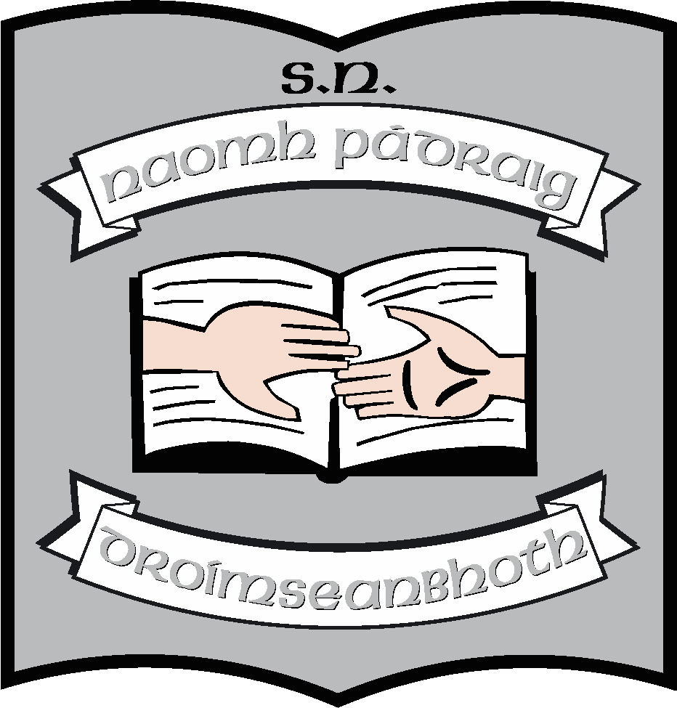St. Patrick’s N.S.
Drumshanbo,
Co. Leitrim.

Roll No: 19423J

PE Policy

Reviewed: May 2016
Ratified: 2016
Full review: 2021
Appendix 1: Strands and strand units; glance cards – electronic copy only
Appendix 2: Active Schools – electronic copy only
Appendix 3: Whole School Timetable for PE
Appendix 4: Resources
Appendix 5: PE for pupils with special needs; suggestions
Appendix 6: Local clubs/organisations
Appendix 7: Aquatics Plan
Appendix 8: Visiting teachers

St. Patrick’s National School

Physical Education Policy

Introductory Statement

Physical education provides children with learning opportunities through the medium of movement and contributes to their overall development by helping them to lead full, active and healthy lives. We aim to provide these learning opportunities to the children in our school to maximise active learning experiences and approaches to the benefit of each individual child.

This PE policy (2016) is a review of the plan created in 2013, in consultation with the staff and BOM at that time.

Rationale

We are reviewing the PE policy at this time

- As part of the ongoing timetable of review in the strategic plan
- In line with our application for Active School status and our application for our fourth Green Flag
- Having audited and updated PE resources in 2015/16

Vision

We seek to assist the children in our school in achieving their potential by the promotion of physical activity throughout the school. We promote a spirit of friendship and learning in PE
as in all areas of the curriculum.
We want to encourage children to participate in local clubs and community initiatives which seek to raise levels of activity, skills and teamwork.

Key Principles

The key principles underlying the PE curriculum are

- the importance of enjoyment and play
- maximum participation by all children
- the development of skills and understanding
- a balance between competitive and non-competitive activities
- providing opportunities for achievement of each child
- providing activities equally suitable for boys and girls

Aims

We endorse the aims of the primary school curriculum for physical education. The aims of physical education in St. Patrick’s N.S. are

- To promote the physical, social, emotional and intellectual development of the child
- To develop positive personal qualities
- To help in the acquisition of an appropriate range of movement skills in a variety of contexts
- To promote understanding and knowledge of the various aspects of movement
- To develop an appreciation of movement and the use of the body as an instrument of expression and creativity.
- To promote enjoyment of, and positive attitudes towards, physical activity and its contribution to lifelong health-related fitness, thus preparing the child for the active and purposeful use of leisure time.

Broad Objectives

When due account is taken of intrinsic abilities and varying circumstances, the physical education curriculum should enable the child to:-

Social and personal development

- Experience enjoyment and achievement through movement
- Interact and co-operate sensitively with others, regardless of cultural or social background or special needs.
- Develop qualities of self-esteem, self-awareness, confidence, initiative and leadership through movement.
- Develop an understanding of fair play and team spirit through participation and competition.
- Develop positive attitudes towards participation in movement activities.
- Experience adventure and challenge

Physical and motor development

- Develop strength, speed, endurance and flexibility through engaging in a wide range of activities.
- Develop agility, alertness, control, balance and co-ordination through movement.
- Develop personal competence in the athletic skills of running, jumping and throwing.
- Perform dances with confidence and competence, including simple folk and Irish dances.
- Develop personal competence in a range of gymnastic movements.
- Develop personal competence in the games skills of sending, receiving and travelling using a wide variety of equipment, and to apply these skills in games situations.
- Apply the skills needed to live and move with confidence in the environment.
- Build water confidence near, in, on and under water.*
- Develop personal competence in a variety of strokes and water agility.*

(Limited to second class because of financial constraints)*

Curricular Content

Strands and Strand Units
The strands/strand units/content objectives for the relevant class level(s) are found in the curriculum handbook on the following pages:

- Infant classes pp. 16-23
- First and Second classes pp. 24-34
- Third and Fourth classes pp. 38-46
- Fifth and Sixth classes pp. 48-59
- Aquatics: Junior Infants-Sixth pp.62-64 (See Appendix 7: Aquatics plan)

- The school will also use the PE lesson plans prepared by the Primary School Sports Initiative.
- Teachers will choose a range of activities for all strands for each class. Where possible children will have access to the following five strands each year – Athletics, Dance, Gymnastics, Games, Outdoor and Adventure Activities.
- Aquatics will be undertaken by Second Class and the Autism Class each year.
- We will endeavour to create a PE rich environment in the school by introducing a range of games and activities in the course of physical education lessons.
- Team activities are an important feature of this school across a variety of sports including basketball and Gaelic games inclusive of boys and girls.
- Pictures of sporting teams and events are displayed on the walls around the school.
- We will ensure there is continuity and progression from class to class by:
- Developing appropriate warm-up activities for indoor and outdoor work at each level – with strand specific mobility, strengthening and flexibility exercises appropriate to each class level.
- We will record the content covered at each level which will briefly detail the level of engagement with each strand (Cúntas Miosúil)

(See Appendix 1: PE Strands & Strand Units; glance cards)

Approaches and Methodologies

We will use a combination of the following approaches:

- Direct teaching approach e.g. teaching a specific skill such as “the dig” in volleyball
- Guided discovery approach e.g. children creating their own sequence in dance
- Integration e.g. Geography and Outdoor and Adventure Activities – directional and spatial awareness.
We will endeavour to use methods that encourage maximum participation by the child through group work:

- Individual, pair, group and team play - younger children and special needs children will need more individual attention
- Station teaching - groups moving around different stations and having one teaching station
- Using a play area divided into grids - groups of children stay in grids and the activities within the grids are differentiated to suit the particular group of children

Structure of a PE lesson

Each PE will be comprised of some or all of the following:

- Warm Up
- Main Activities: Running, jumping, throwing, rolling, striking an object, kicking, playing small sided games orienteering, dancing etc; these main activities will take place at individual, pair and small group levels
- Station teaching will be used to teach a specific skill and to enable the children experience a variety of activities in the PE lesson
- We will divide our hall/play area into Grids to allow for small group activity and yet all children will be involved
- Cool Down

Linkage and Integration

Linkage can take place within physical education in that many activities transcend strands and are of benefit to the child irrespective of the strands or subjects being covered. This is true of Dance/Gymnastics, Athletics/Games, Gymnastics/Games, Athletics/Outdoor pursuits.

PE can readily be integrated into other areas of the curriculum:
- Déanaimid iarracht Gaeilge a labhairt sna ranganna Corpoideachas, go mór mór treoracha a thabhairt agus áiseanna a ainmniú as Gaeilge
- Playground games, GAA games etc. can be integrated with the History curriculum
- Dance can be integrated with the Music curriculum; déanaimid damhsaí traidisiúnta i rang a 5 agus rang a 6 agus bíónn ceilí againn uair amháin sa bhlian, i rith Seachtain na ghaeilge, de ghnáth.
- PE and Science can be integrated particularly in the strands, Human Life ( How people move, effects of fitness on the processes of the body etc) and Forces – pushes, pulls, trajectory etc.
- Teachers are encouraged to check the many readily available resources linking Maths and PE. (A good example is available on www.gaa.ie) Maths trails and Outdoor activities can be integrated to form part of Active Schools’ Week.
- In SPHE the Strand Unit: Taking care of My Body reinforces the value of exercise and fitness for children.

Assessment

Assessment is used to provide information on individual children, assist the teacher in planning a programme and facilitates communication with other teachers, parents and other professionals.
Assessment will be as outlined in the Curriculum P68-74 and Teacher Guidelines P98-100. The teachers in the St. Patrick’s N.S. will assess the P.E. lessons delivered as we identify progress and difficulties.

We will assess

- Willingness to participate in activities
- Readiness to engage with a certain activity
- The level of competence of a child in carrying out an activity
- Interest in and attitude to activity
- Willingness to cooperate in individual, pair and group activities

Our assessment tools are:

- Teacher observation
- Teacher-designed tasks based on the skills being taught.

Participation and access

All children will be encouraged to participate in all P.E. activities through the use of cooperative fun activities. We will also give encouragement and acknowledge good effort wherever possible. Our main aim is to set activities close to each child’s ability level but at the same time challenging them to improve their performance. Reasonable targets will be set for all children at individual, pair and small group levels.

Children with Special Needs
Teachers will endeavour to support and ensure the participation of children with special needs by planning to include all children in P.E. activities. This will mean we have to focus on the abilities of each child. Children with special education needs in mainstream classes who have been allocated a Special Needs Assistant will have the benefit of this assistance while engaged in physical education activities when the SNA is present in the class at that particular time.
We will also plan to include children who may have physical disabilities by planning to include them in all PE activities and by adapting the activities as necessary.
*See Appendix 5

Children with exceptional ability

Children with exceptional ability/talent for P.E. will be encouraged and supported by acknowledging their talents and creating additional challenges for these children within the strands of the P.E. curriculum in which they excel. These challenges will be based on the activity being pursued by the rest of the class. In addition, the children will be encouraged to maximise their talent by forging links with local clubs (if links have not been established already) so the child(ren) can bring their talent to a higher level. The children with exceptional ability will, on occasion, be encouraged to assist their classmates in achieving proficiency in the activities they are undertaking.

Equality of Participation and Access

In planning for P.E. St. Patrick’s N.S. will pay attention to the following areas in order to promote equity throughout the PE curriculum.

- All children from infants to sixth class will partake in all six strands of the curriculum. However, due to time constraints and financial considerations, all classes do not partake in all strand units of aquatics annually.
- We will provide equal access for all children to physical education equipment and facilities and the use of the playground during breaks will be incorporated as an integral part of the school’s programme.
- When grouping children for physical education the school will endeavour not to group children solely on the basis of gender whenever possible.
- As a staff we will help children to build positive attitudes towards all activities.
- We will take into account the needs of girls and boys when promoting the health related fitness of children.
- We will enter both boys and girls teams in inter-school competitions.
- Due to the increased enrolment of children from other countries in St. Patrick’s N.S, it is vital to help these children integrate. P.E. provides great opportunities for this integration.
- The Dance strand of the curriculum will be used to introduce dances from other cultures in the area of folk dance. The children from other countries will also appreciate the folk dances which are an integral part of our Irish culture.
- Large sporting events such as the Olympics, World Cup, Special Olympics etc will be used to look at the customs and sporting culture of some of the participating countries.
- Introduction of games from different traditions i.e. boules, tennis to children in the school, yet at the same time acknowledging the special place that Gaelic Games hold in our culture. Gaelic Games will be given particular consideration as part of the Games programme
- Every child will have access to all PE activities provided by the school and lack of financial resources on behalf of the child will not hinder their participation.

In line with Department of Education and Science recommendations, it is the policy of Saint Patrick’s N.S. not to charge for in-school curricular activities. However, when organising the aquatics strand, this school is unable to meet the cost of running an adequate aquatics programme. As a result, the B.O.M. has given permission to charge a fee to each child. No child will be denied access to swimming lessons due to lack of financial resources and the school has made provision for such children to attend classes.

School Initiatives/Sporting events

St. Patrick’s NS is involved in a number of school initiatives and takes part in many events which promote different sports and disciplines:

- This year (2016) we are taking part in the Active Schools’ initiative.
- In 2014/15 and again in 2015/16 senior classes took part in a fitness initiative, with the support of the Leitrim Sports Partnership.
- The school competes annually in Cumann na mBunscol.
- As part of the Green Flag (Travel) we encourage children to walk/cycle to school and we hold regular events to promote this.
- Children’s teams from 3rd – 6th take part in the Primary Schools’ Indoor Athletics.
- The school is represented in Primary Schools’ Sports, Cross-country, Swimming events.
- We take part in Mini-sevens (3rd – 6th)
- We take part in events associated with Bicycle Week.
- We hold in-school football and basket-ball leagues annually.

These activities will adhere to the general principles of the PE curriculum of the school as follows:

- The importance of enjoyment and play
- Maximum participation by all children
- The development of skills and understanding
- A balance between competitive and non-competitive activities
- A balance between contact and non-contact activities
- Providing opportunities for achievement for each child
- Providing activities equally suitable for boys and girls.

Organisational Planning:

Timetable

In St. Patrick’s N.S. classes will have one hour of P.E. per week. Second class and the Autism Unit attend swimming lessons in the Lough Allen Hotel, Drumshanbo each year. Each class will receive a minimum of six swimming lessons in the school year.
The Games, Outdoor and Adventure activities and Athletics strands are done at a time when it is hoped the weather will be fine and will allow the PE lessons to be based outside in the schoolyard or field.
Over the past two school years, Gymnastics coaching has been provided to all children in the junior classes. In 2015/16, Hip-hop classes were provided to all children in the senior classes. These sessions took place in the hall during the winter months to ensure regular activity for the children whatever the weather. We hope to continue with these classes while funding allows it.

Procedures

- If coaches from a local or a national sporting organisation are invited into the school to work with the children as part of their PE class, they will be used to support the class teacher in the implementation of some of the PE curriculum strands in the school. They will not replace the class teacher and ultimate responsibility for the class lies with the class teacher. The class teacher will in turn support the coach on certain occasions when this will lead to maximum benefit for the children in the class.
- Any coaches working with children must have Garda Vetting.
- Any coaches working in the school context will be expected to adhere to the Code of Ethics of Irish Sport, produced by the Irish Sports Council. ‘Adults interacting with children in sport (referred to as Sports Leaders in this Code) are in a position of trust and influence. They should always ensure that they treat children with integrity and respect and that the self-esteem of children is enhanced. All adult actions in sport should be guided by what is best for the child and carried out in the context of respectful and open relationships. Verbal, physical, emotional or sexual abuse of any kind or threat of such abuse is totally unacceptable within sport, as in society in general.
- If there is a suspected case of child abuse in the class (even if it becomes apparent in the context of a PE class), all teachers will adhere to the Department of Education and Science Child Protection Guidelines to be used with the ‘Children First Guidelines’ produced for all personnel working with children.

PE Equipment and ICT

A thorough inventory of PE equipment, followed by an investment in updating and expanding the resources, was undertaken by Mrs. Brennan in 2015/16. ( See Appendix 4)
It is stored in a container behind the school, the key for which is retained in the office. It is the responsibility of each class teacher to ensure that all equipment is returned to the room after each lesson. Any breakages have to be reported to the Principal as soon as possible. Each teacher will be given a copy of the equipment list.
The Principal and the staff will have the responsibility to purchase the P.E. equipment for the school.

ICT

The use of the school’s digital cameras will be vital in recording P.E. activities and events such as Sports’ Day and Leagues, Bicycle Day etc. The display of these pictures will give an opportunity to children to see themselves and others in action. Pictures will regularly be displayed on the school website also. Each classroom is equipped with an interactive whiteboard to enable teachers to deliver certain aspects of the P.E. curriculum where necessary.

Health and Safety

We have a school Health and Safety Policy which will be adhered to at all times in PE activities. Issues identified as being health and safety issues in a P.E. context include warm up at the start of all physical activity, practising in confined spaces, use of equipment, accidents, supervision, activities involving the whole school yard, procedures for dealing with accidents etc. It is important to acknowledge from the beginning that while the following procedures will eliminate unnecessary hazards they cannot remove all risks due to the physical nature of the subject. When engaging children in P.E. all members of St. Patrick’s N.S. staff will ensure that the following safety aspects will be taken into consideration

- All children have to wear suitable footwear and clothing during a P.E. lesson. Children will not be allowed wear any jewellery during a P.E. lesson.
- The equipment used will be suitable in size, weight and design to the age, strength and ability of the child and be of good quality and in good repair.
- Children will be taught how to lift and carry all P.E. equipment safely.
- In all P.E. lessons, children will warm up and cool down. This develops good practice and the children will return to class relaxed after activity.
- Should an accident occur in the P.E. lesson we will follow the procedures outlined for other accidents in our Health and Safety policy.
- Running activities will not finish at a wall or pole.
- Best practice is safe practice and the teacher should ensure that the children understand that the rules and procedures are there for their safety.
- We will endeavour to have an appropriate surface for the activities in the P.E. lesson.
- Children will not be forced to do activities for which they are not physically or mentally ready.
- When running outside of the school grounds, teachers will man stations at regular intervals on the designated route.

The First Aid Kit is kept in the shop and is restocked regularly with items only recommended by First Aid personnel. A second portable kit is also available when children are participating in after school sports. The medical conditions of all children are detailed by their parents/guardians on the school enrolment form

Individual Teachers’ Planning and Reporting

Each teacher will include PE in their long-term and short-term plans. The whole school plan and the curriculum documents for P.E. will lay out the structure and format that teachers will follow in addition to the aims and objectives of the primary school curriculum.

Staff Development

We are fortunate to have a number of staff with particular skills and strengths in different areas of the PE curriculum. This helps the development of all teachers in the school. Some teachers undertake regular CPD in areas such as dance/aquatics as well as Gaelic football. Staff are involved in training school teams, outside of the regular PE lessons.

Community Links

We are very much aware of the school’s role in the community and we are also conscious of the fact that the expertise of people in the community is an invaluable resource to any school.
We have benefitted greatly from the support of
- Allen Gaels GAA club
- Drumshanbo Athletics Club
- Drumshanbo Gymnastics club – who donated equipment and funding to the school when they ceased to function
- The community, in the form of a very active Parents Association, has also been involved in fundraising for P.E. equipment for the school and for after school activities.
Events during Active Schools Week and also as part of the Green Flag initiative have brought a greater awareness to the community of the physical activities going on in the school.

Parental Involvement

Parents are invited to participate in the sporting life of the school. They are encouraged to support the various school teams and to help with swimming lessons in the Lough Allen Hotel where they can view the progress of their child (ren). The Parents Association, as outlined above, is willing to fundraise to allow additional equipment to be purchased. Parents are requested to inculcate in their children a positive attitude towards P.E. and sport. Parents have given of their time and skills to help with training of GAA teams and to promote athletics in the school. We are very grateful for their support.

Implementation of School Plan

This plan will be implemented from September 2016. Teachers’ preparation will be based on this plan and the planning of individual teachers will feed into the overall school plan. Teachers will also be acquainted with the content and methodologies outlined in the plan. There should be clear progression as children move from class to class.

Success Criteria - Key Principles

- The importance of enjoyment and play
- Maximum participation by all children
- The development of skills and understanding
- A balance between competitive and non-competitive activities
- A balance between contact and non-contact activities
- Providing opportunities for achievement for each child
- Providing activities equally suitable for boys and girls.

Means of assessing the outcomes of the plan include

- Teacher/parent/community feedback
- Children’s feedback regarding the activity level, enjoyment and skill development of the classes
- Inspectors’ suggestions/report
- Second level feedback
- Feedback from external coaches

Roles and Responsibilities:

All class teachers are responsible for the implementation of the PE curriculum in their own classrooms. Teachers will be encouraged to present feedback during staff meetings on a review of PE
Mrs. Kelly, along with Mrs. McLoughlin and Ms. Keegan has been responsible for drawing up the plan for Active Schools. Mrs. Brennan did the inventory and purchasing for the audit of the PE equipment.

Implementation/Ratification and Review
This plan is already being implemented in part but if passed by the Board of Management, it will become school policy in September 2016 and will be included in the Plean Scoile. We are seeking our first Active School Flag in 2016 also. (See Appendices 2 & 3)
The whole policy is due for review in 2020/21.
However, changes to the curriculum or to classroom organisation may precipitate an earlier review.

************************************************************************
Ratification of policy for St. Patrick’s NS

Chairperson Date

Principal Date

