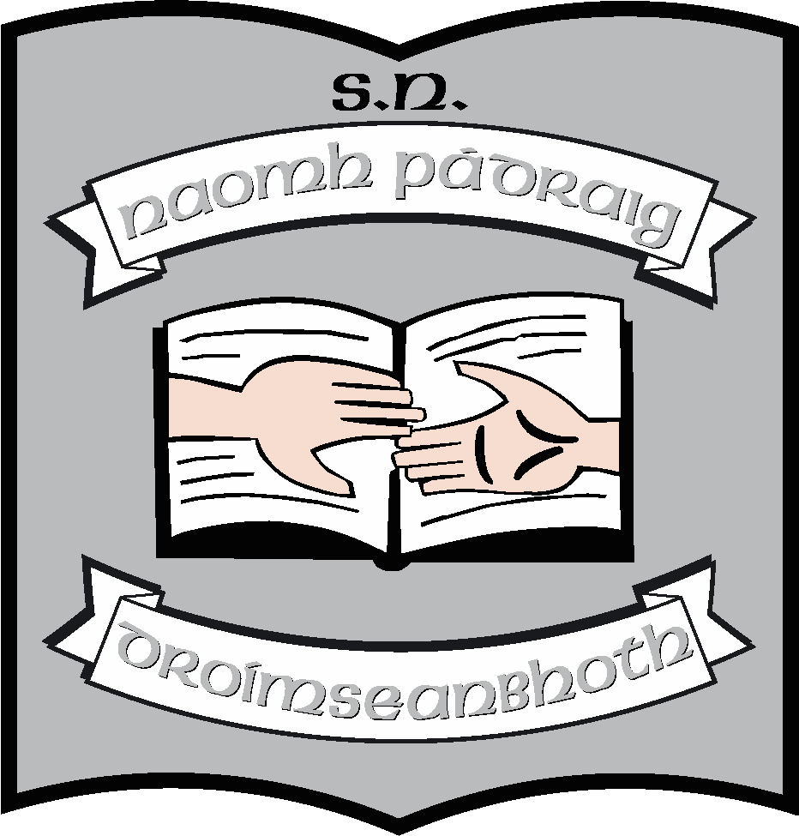St. Patrick’s N.S.
Drumshanbo,
Co. Leitrim.

Roll No: 19423J

Parental Status and School Communication Policy

Created: May 2021
Ratified: June 2021
Due for review: 2026
Appendix: Information to which parents are entitled depending on status

St. Patrick’s National School

Parental Status and School Communication Policy
Introduction and Rationale
This policy was formulated to provide the school community of St. Patrick’s NS, Drumshanbo with guidelines regarding situations of parental separation and custody matters. It was written based on guidelines outlined by the Irish Primary Principal's Network and the CPSMA and is reflective of The Children and Family Relations Act 2015, which came into effect on 18th January 2016.
Procedures
In St. Patrick’s NS, we would like to encourage parents experiencing separation to come and speak confidentially to their child(ren)'s class teacher(s) and/or the school Principal. It is our aim to handle such matters with sensitivity and compassion, with the wellbeing of the child as our main concern.
The following are the key procedures in place with regard to separated parents of pupils in the school:
- When a child spends time in two homes, it is requested that the school be provided with both sets of emergency/contact numbers and both addresses for correspondence purposes.
- Regarding the collection of child/ren from school - it is requested that the school be informed re changes in collection arrangements in writing (in line with the school's pupil collection form).
- It is the school policy to offer the option of separate parent/teacher meetings, if so desired. However, for the child-centred purposes we recommend that both parents attend together. Each parent has a right to attend such meetings and receive school reports unless there is a court order to the contrary.
- When the school communicates with parents regarding their child, we will communicate with the parent with whom the child principally resides. It is assumed that this parent will inform the other parent of meetings, arrangements etc. Special requests for separate communication can be accommodated. If there is a custody arrangement by which the child spends equal time with both parents, then both parents will receive the school communication.
- Regarding school communication such as notes via schoolbags, it is assumed that the parent with whom the child is residing at the time of that particular communication will keep the other parent informed of such.
- In the absence of a custody arrangement, both parents will be treated as equal partners in terms of parenting rights and responsibilities
- The school cannot be asked to withhold a child from either parent in the absence of a court order. In this regard, a solicitor's letter is not a court order and cannot be adhered to.
- If there is a serious concern about a parent abducting or leaving the country with the child, the parents/carer should request their solicitor to seek a court order instructing the school and any other carers regarding rights of access.
- In the case where the estranged parent/carer is not known to the class teacher, the concerned parent/carer should provide a family photograph enabling the class teacher to identify the person in question.
- In the case of unmarried parents, the natural father has no initial custody or guardianship rights. The onus is on the father to produce evidence of a court order in the case of a dispute regarding the collection of a child during or after school. A non-marital father will automatically become a guardian of a child if he meets the cohabitation requirement. In this instance the father is entitled to joint custody along with the mother. If the father does not qualify for guardianship rights, he may apply to the courts to be appointed guardian of the child and he may also apply for custody. A copy of the court order should be provided to the school.
- The school is under no legal obligation to provide any reports about a child if requested to do so by any third party (e.g. Solicitor/psychologist)
- The school principal or child's teacher are not obliged to attend court unless under subpoena or summons.
- In the case where a legal order is in place, a copy of this order must be furnished to the school by the parents.
- The parent/carer of each child has full responsibility for informing the school in writing of any change in circumstances at home e.g. separation, divorce, custody arrangements.

Teachers are expected to:
- act in a fair, open and even-headed manner in respect of both parents
- advise both parents of meetings if the teacher believes that one parent will not inform the other
- facilitate separate meetings, if for good reason, both parents cannot attend together
- comply with the parent who has de facto day to day control of the child in the event of a dispute
- respect the confidentiality of family circumstances and only discuss relevant information with others within the school where necessary
- seek advice from the principal or the Board of Management regarding any queries or concerns they may have.

Communication and ratification and review of the policy:

Prior to ratification, this policy will be circulated to staff and to all parents.
Following this, it will be presented to the Board of Management in June 2021. It will be put on the school website when it has been ratified by the Board of Management.
It will become school policy from the beginning of the 2021 – 2022 school year. It is due for review in 2026. However, changes in legislation or in procedures may precipitate an earlier review.

***************************************************************************

Ratification of policy for St. Patrick’s NS

Martin McGowan 23/06/2021
Chairperson Date

Máirín O’Keeffe 23/06/2021
Principal Date

Appendix: Parental Status & School Communication

Circumstance: | Status: | Communication:
If parents are married to each other and are living together | Both parents are legal guardians to their children. | Each parent is entitled to all information from the school.  The school will communicate with via the main address /email/phone number provided to the school for that purpose.
If parents are married to each other, have separated and are living apart | Both parents are legal guardians to their children. | Each parent is entitled to all information from the school.  Separate communications will be sent to each parent, once the school has been made aware of the separation and of the separate details – address/email/phone number.
If parents are married to each other, live apart and may be in a new relationship(s) | The fact that either parent is in a new relationship has no impact on guardianship.  New partners have no statutory rights (unless they have been legally obtained) but may have a role in collecting the child from school is named on collection forms. | Each parent is entitled to all information from the school.  Separate communications will be sent to each parent, once the school has been made aware of the separation and of the separate details – address/email/phone number.  There will be no communication with new partners unless there is a specific agreement to this between the parties or unless an arrangement is provided for in a court order.
If parents are unmarried and either live together or apart | The child(ren)’s mother has an automatic right of guardianship.  The child(ren)’s father may have right of guardianship if he has cohabited with the mother for a certain length of time (12 months with the child’s mother, including 3 months following the birth) or has obtained guardianship by agreement with the mother.  If the guardianship is not clear, the school may request a solicitor’s letter confirming the legal guardianship of that parent. | Legal guardians are entitled to all information from the school.  Separate communications will be sent to each guardian, once the school has been made aware of the guardianship arrangements and of the separate details of the guardians – address/email/phone number.
If parents are unmarried and are in other relationships | The child(ren)’s mother has an automatic right of guardianship.  The child(ren)’s father may have right of guardianship if he has cohabited with the mother for a certain length of time (12 months with the child’s mother, including 3 months following the birth) or has obtained guardianship by agreement with the mother.  If the guardianship is not clear, the school may request a solicitor’s letter confirming the legal guardianship of that parent.  New partners have no statutory rights (unless they have been legally obtained) but may have a role in collecting the child from school is named on collection forms. | Legal guardians are entitled to information from the school.  Separate communications will be sent to each guardian, once the school has been made aware of the guardianship arrangements and of the separate details of the guardians – address/email/phone number  There will be no communication with new partners unless there is a specific agreement to this between the parties or unless an arrangement is provided for in a court order.

