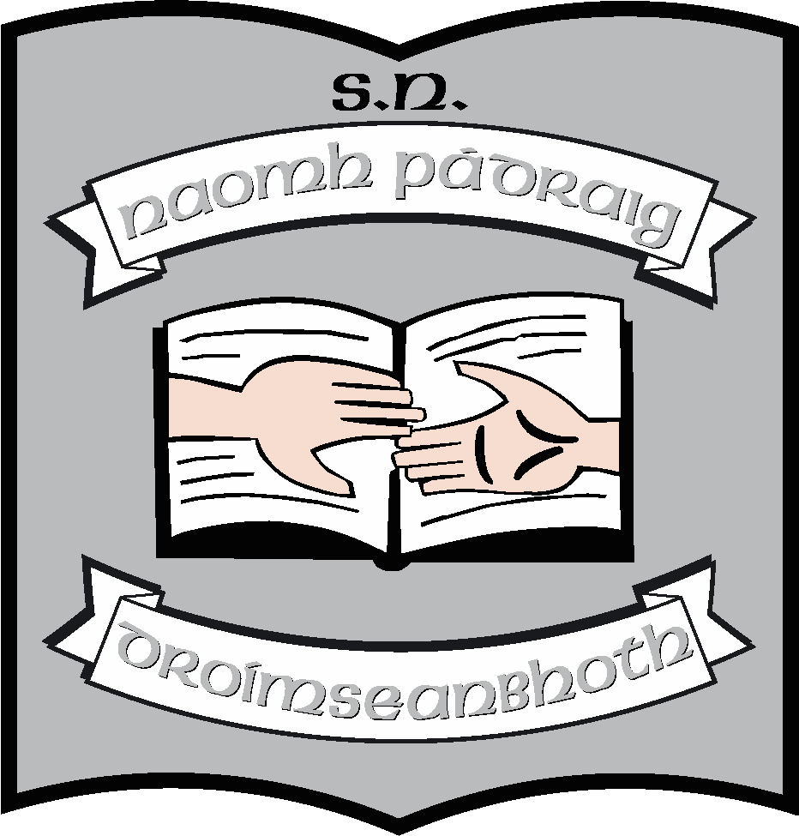St. Patrick’s N.S.
Drumshanbo,
Co. Leitrim.

Roll No: 19423J.

Remote Learning Policy

Reviewed: January 2023
Ratified: February 2023
Due for Review: 2027

Remote Learning Policy 2023
Introduction
We are reviewing this policy to outline how the school will engage with teaching and learning in the event of a whole or partial school closure.
The primary obligations of all schools are to see to the education of our pupils and the welfare of our school community. Remote learning seeks to continue this even when the pupils and teachers can no longer be present in the school.
This policy, therefore, seeks to ensure.
- that remote learning is safe for all.
- that personal and sensitive data is also protected under GDPR legislation.
- that learning takes place in an environment that is respectful and fair and meets its statutory duties.
- That the wellbeing of pupils and staff is protected.
This policy should be read in tandem with our school’s
- Code of Behaviour Policy
- Anti-Bullying Policy
- Acceptable Use Policy
- Data Protection Policy
- Mobile Phone Policy
This is a working document. As we continue to explore options available to support distance or blended learning, the document will be updated accordingly.

Guidelines for good online communication
Teaching and learning relies on co-operation and communication between home and school. This is even more important when it comes to remote teaching and learning. With that in mind, we would ask everyone involved in the process to adhere to the following guidelines:
- Staff and students are expected to behave in an appropriate, safe, respectful, and kind manner online.
- Under no circumstances should pictures or recordings be taken of interactions between teachers and pupils.
- It is the duty of parents/guardians to supervise children while they are working online and to ensure that any content submitted to their teacher is appropriate.
- Staff members will communicate with pupils via Google Classroom (Senior classes), Seesaw (Junior classes) and Aladdin. Support may also be offered via telephone or Zoom calls. Any electronic forms of communication will be for educational purposes and to allow for communication with families.
- Parental permission will be acquired before setting up a profile for a pupil on a communication forum.
- Support meetings/calls will be for pupils. If parents wish to have meetings with teachers, they can do so by arrangement via the school office.
- For security reasons, passwords will be provided to families, where applicable.
- St. Patrick’s NS cannot accept responsibility for the security of online platforms, in the event that they are compromised.

Media which will be primarily used by the school:

E-mail/Aladdin
Each teacher will communicate weekly with parents/guardians via Aladdin. Queries relating to the work of the class can be addressed by a parent during school hours (09:30 – 15:00) and should relate strictly to a child’s teaching and learning. Other queries should be relayed by phone or email to the school office.
Google Classroom
Google Classroom is an online platform which enables pupils to connect to their folder of work and to access their teacher when required. This will be monitored within the school day. (09:30 – 15:00). Lessons may be pre -recorded and uploaded on Google Classroom. In this way they can be accessed at any time. Google Classroom will be used in 3rd to 6th classes.
Seesaw
Seesaw is an easy-to-use online platform which enables pupils to connect to their folder of work and to access their teacher when required. Lessons may be pre -recorded and uploaded on Seesaw. In this way they can be accessed at any time. This will be used in Junior Infants to Second classes.
Zoom
Zoom is an online platform that allows video meetings. These meetings can be one-to-one, group, whole class or even whole school. Zoom may be used to offer individual support to pupils or for class meetings.

Rules for pupils using online communication.

For submitting learning:
- Submit work and pictures that are appropriate.
- Submit within the allocated time.

For video calls (Zoom)
- Pictures or recordings of the video call are not allowed.
- Remember our school rules, class rules and code of behaviour - they are still in place, even online.
- Set up your device in a quiet space, with no distractions in the background.
- Join the video with your microphone muted.
- Raise your hand before speaking, just like you would do in class.
- If you have the chance to talk, speak in your normal voice, using kind and friendly words.
- Show respect by listening to others while they are speaking.
- Ensure that you are dressed appropriately for the video call.
- Be on time - set a reminder if it helps.
- Enjoy! Don’t forget to wave hello to everyone when you join!

Guidelines for parents and guardians
In general, please remember that our learning platforms and video calls are for the children. You are encouraged to supervise and welcome and be in the vicinity but, as in school, the interactions will be between the teacher and the pupil.

For learning
- It is the responsibility of parents and guardians to ensure that pupils are supervised while they work online.
- Check over the work which pupils send to their teacher, ensuring it is appropriate. This may not be necessary in all classes.
- Continue to revise online safety measures with pupils – check out our Acceptable Use Policy (AUP)

For video calls/Zoom
- Under no circumstances should pictures or recordings be taken of video calls.
- Ensure that the school has the correct email address for inviting you to join apps and meetings.
- The main purpose of a video call is to engage in online learning activities while maintaining a social connection between the school staff and pupils. Encourage pupils to listen and enjoy the experience.
- Be aware that when participating in group video calls, children can be seen and heard unless you are muted or have disabled your camera.
- Follow the Zoom invitation link you have been sent to join the meeting via your school network email address. Please note that the link to the meeting will not work unless you are an invited guest.
- Please ensure your child is on time for the scheduled Zoom call. Open the link approximately five minutes before the scheduled meeting time. Please wait for the host to start the meeting.
- Make sure to familiarize your child with the software in advance. For video in particular, show them how to mute/unmute and turn the camera on/off.
- Participants in the call should be dressed appropriately.
- An appropriate background/room should be chosen for the video call.

Any breach of the above guidelines will result in a discontinuation of this method of communication. It may also result in a person being immediately removed from a meeting or a meeting being terminated.
Remote Teaching and Learning Protocols for Pupils
- Check assigned work each school day.
- Communication may only take place during normal school hours.
- The normal school calendar will apply.
- The following school policies apply to remote teaching and learning:
  - Code of Behaviour
  - Anti- Bullying Policy
  - Acceptable Use Policy
- Teaching and learning best practice will continue to apply, with students expected to present all assignments to the best of their ability and on time.

Remote Teaching and Learning Protocols for Parents
- We ask parents/guardians to ensure protocols for students are adhered to.
- Check-in on their child’s schoolwork on a daily basis if necessary and talk to their child about the work being assigned.
- The health and wellbeing of all is paramount. Circumstances may change for any of us unexpectedly, teachers or parents, so please keep schooling in perspective and do not allow anything school related to impinge on your child negatively. You are the primary educator of your child, and you make those calls. We encourage your children to engage with the school. We provide work and guidance and ask parents and pupils to do their best and that is all.
- Should remote learning be necessary again, we would be continuing with the work of the school at this time especially in the areas of Literacy and Numeracy, so it would be important that children keep up.

Remote Teaching and Learning Protocols for Teachers/SNAs
- Check uploaded work daily.
- Communication may only take place during normal school hours.
- The normal school calendar will apply.
- The following school policies apply to remote teaching and learning:
  - Child Protection Policy
  - Data Protection Policy
- Teaching and learning best practice will continue to apply with students expected to present all assignments to the best of their ability and on time, where possible. Relevant feedback and support will be provided by the class teacher and the Special Education Teacher on an ongoing basis.
Exceptional Closures:
In the event of exceptional closures e.g. no heating, water, electricity or inclement weather we will be guided by the Government guidelines and the most up to date advice.
This plan has been agreed on by the school staff in conjunction with the BOM.

Martin McGowan 28/02/23
Chairperson Date

Ruth McLoughlin 28/02/23
Principal Date

