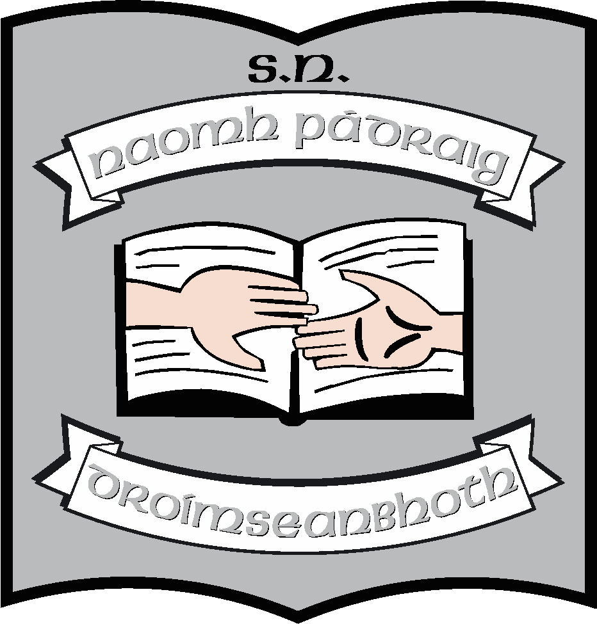St. Patrick’s N.S.
Drumshanbo,
Co. Leitrim.

Roll No: 19423J

Special Needs Assistant Policy

Created: March 2015
Reviewed: May 2021
Due for review:2026

St. Patrick’s National School

Special Needs Assistant Policy 2021

Introduction

Under the Education for Persons with Special Educational Needs Act, 2004, children with special educational needs are entitled to supports to enable them to participate in inclusive education. Such supports include Special Needs Assistants – SNAs.
Currently there are seven SNA posts in our school, being filled by eight people (one post is filled by 2 people who are job-sharing) Our SNAs make a much-needed, significant and welcome contribution to the work of the school.

Rationale

This policy was formulated so that

- All staff, including the SNAs have clear guidelines on procedures within the school
- Each SNA can see themselves as contributing positively to the learning experiences of the children and the overall efficiency of the school
- A culture of fairness and equality is seen to be in operation throughout the school
- To address issues such as seniority and suppression of posts.

Relationship to school ethos

St. Patrick’s NS is a place where the uniqueness of every child is respected in a spirit of equality. We wish to ensure that each pupil can access the curriculum in a manner appropriate to his/her ability. Our SNAs are a key part of this endeavour. This policy sets out the role of the SNA in the school community.

Aims/Objectives of this policy

- To facilitate the inclusion of SNAs as valuable members of staff in a whole school context
- To ensure the effective deployment of SNAs in enhancing the social skills and self-esteem of the children in their care.
- To enable the SNA to be an effective support to the class teacher
- To provide optimum learning experiences for all children through judicial use of the skills and talents of the SNA
- To clarify the tasks and duties to be undertaken by the SNA.

Procedures and Content

Conditions of employment

The conditions of employment and the duties of an SNA are regulated by Department Circular 30/14.

SNAs are not specifically assigned to an individual child but rather to the school as a whole In the case of special classes, there is a general allocation of 2 SNAs, where there are 4 or more pupils in the class.
During lunch break each SNA must have direct responsibility for a particular child or children.

The school operates a “last in first out” policy. However, it must be noted that all positions are up for regular review in association with the DES, the BOM, NEPS, and NCSE.

Hours of Work

The full time SNA is expected to work 32 hours per week and the short-day SNA is expected to work 27 hours per week.

SNAs, as part of their contract, are expected to perform some duties before and after school the school day i.e. the preparation and tidying up of classrooms, reception and dispersal of children.

An additional 72 hours (pro-rata for short-day SNAs) per year outside of the normal school year must be worked. These days are at the discretion of the Board of Management in consultation with the individual SNAs.

Recruitment Procedures

The recruitment procedures for the appointment of ancillary staff (SNAs) to St. Patrick’s NS are as follows:
- The post is advertised on Education Posts
- The nature of the post is stated and the applicant is asked to supply references / referees
- The closing date is listed as 2 weeks after the insert of the advertisement
- The selection Board gives at least one week’s notice of interview
- Agreed criteria are set prior to interview and are applied to all candidates
- The Selection Board consists of the Chairperson of the Board of Management, Principal and an independent assessor with an appropriate gender balance
- A marking scheme is used and retained for 18 months as a record
- All appointments are subject to Board of Management approval and the provisions of the Employment Equality Act.

The successful candidate is required to furnish the Board with:
a) A medical cert
b) A Garda Clearance Cert
c) A signed Confidentiality Clause.

On Appointment

On appointment to the school (an SNA is not appointed to a specific child) each SNA is required to:

- Sign a contract of employment and a Confidentiality Clause
- Supply school administration with P.P.S number, telephone number etc.
- Asked to become familiar with circulars detailing sick leave, maternity leave, leave of absence etc.
- Sign the DES appointment form.

Duties

The duties of SNAs are outlined in Circular 30/14, which should be read in conjunction with this policy.
SNA duties are assigned at the discretion of the principal, or another person acting on behalf of the principal (Special Educational Needs Organiser), and/or the Board of Management.

The main duties of the SNA are as follows:

- Preparation and tidying up of classroom(s) in which the pupil(s) is/are being taught.
- Assisting children to board and alight from school buses if the child requires such help and does not have a bus escort. Where necessary, SNAs may need to travel as an escort on school buses on occasions where this is required.
- Generally attending to the needs of children with additional needs
- Implementing strategies outlined in Support and/or Behaviour plans.
- Implementing strategies outlined in S & L/OT reports
- Making and preparing resources
- Providing special assistance as necessary for pupils with particular difficulties e.g. helping physically disabled pupils to move safely within the class/school, with lunch, with typing, writing etc.
- Assistance with clothing, feeding, toileting and general hygiene.
- Assisting on out-of-school visits, walks, swimming and similar activities.
- Assisting the teachers in the supervision of pupils during assembly, recreational and dispersal periods.
- Accompanying individuals or small groups who may have to be withdrawn temporarily from the classroom.

- General assistance to the class teachers, under the direction of the Principal, with duties of a non-teaching nature.

(Special needs Assistants will not act either as substitute or temporary teachers. In no circumstances will they be left in sole charge of a class).
Where a Special Needs Assistant has been appointed to the school to cater for a specific pupil, duties shall be modified to support the particular needs of the pupil concerned.

SNA in the Autism class

In our school, the majority of our SNAs are attached to the Cairde and Laochra classes. From an Autism perspective here are some points regarding the role the SNA can play:
- The child must feel comfortable and safe in their school environment, and with the challenges that school brings and the anxiety so often associated with people with Autism this is of major importance. SNAs are someone who a child with Autism can feel comfortable with and develop a bond with over time.
- Children with Autism may need space and often find it very difficult to cope if someone overcrowds them. Therefore, the SNA has a difficult task, which will vary from child to child, in establishing the balance between supporting them in their work and allowing them space.
- The SNA is someone who can really focus on the specific challenges of a child with Autism. The SNA overtime can learn what the child is able to cope with and what stresses them out. This is of major importance as it means that there is someone in the classroom who understands where a child with Autism may be majorly anxious or at risk of getting very angry or upset. It also means there is someone there who can ensure that a child with Autism is not put into a situation which they find particularly hard to cope with.
- The SNA plays an important role in enabling a child with Autism to become more independent. Establishing the balance between gently pushing them on and considering their limits, once the child with Autism gets to know an SNA and trust that they will be there if things get too much for them, it can really boost their confidence.
- The SNA can play a great role in gently challenging a child with Autism. Head-on confrontation will rarely work with a child with Autism, more likely it will result in a major melt-down or negative behaviour. The SNA is someone who can withdraw a child from a circumstance and allow the issue to be addressed at a later stage when they have calmed down.
- The SNA should understand that, in terms of behaviour, expectations may be different for some children. He/she can support the implementation of behaviour plans.
- The SNA can be a great support in helping to socialise a child with Autism, encouraging them to play with other children in the class as much as they are able or can tolerate. Equally, they can play an important role in ensuring other children are kind and inclusive of the child in the playground, as children will often look up to the SNA figure in yard supervision.
- SNAs play a major role in ensuring that a child with Autism gets the maximum out of class time and concentrates and applies themselves to a task as much as they can. SNAs can help the child to stay focused and doesn’t miss out on anything the teacher says due to distraction, problems with following instruction or in grasping what they are being asked to do.
- As the SNA is someone who the child with Autism generally grows to trust the SNA can be a kind but firm voice who can help the child to realise what behaviours are acceptable or unacceptable in the school setting.
Supervision duty

SNA’s will assist supervision of children at each break time with direct responsibility for children with special needs. SNA’s will provide pre-school supervision on a rotational basis under the direction of the BOM when and if this resumes, following Covid.

Rotation

SNAs can be allocated to different children throughout the school on a rotational basis. The principal will make the allocations.

Roles and Responsibilities

Principal

- Responsibility for assigning role specific and child specific tasks to the SNA in association with the class teacher
- Direct responsibility for co-ordinating the integration and devising the role of the SNA
- Monitoring the effectiveness of the SNAs contribution to the needs of designated children
- Responsibility for passing on information received regarding any training opportunities for the role
- Managing areas of conflict which may arise
- Ensure that the SNA is inducted appropriately not just to their specific SNA role but the whole school community.

Class teacher and Resource teacher

SNA must work in co-operation with and under the direction of the Class Teacher.
- The class teacher will provide the Support Plans/Behaviour plans which include strategies that may be implemented by the SNA.
- The class teacher will provide daily schedules and timetables for the SNA

All communication with parents re SEN pupils will be done via class teacher – not SNA.

The Role of the SNA and Responsibilities
The role of the SNA is

- To foster the participation of pupils in the social and academic processes of the school
- To enable pupils to become more independent learners
- To help to raise standards of achievement for specific pupils.
- To help to ensure the safety and wellbeing of the children in their care

- Fostering the participation of pupils in the social and academic processes of the school

This form of support for pupils is seen in

Supervising and assisting small groups of pupils in activities set by the teacher
- Activities are set by teachers and the SNA works with the group under the management of the teacher. The SEN pupil is then able to work with the group without being stigmatised as ‘different’ because of frequent separation from their classmates for individual tuition.

Developing pupils’ social skills.
- Supporting children in groups, who might otherwise have been separated from other children for individual attention, promotes the inclusion of those children in mainstream work.

Supporting children in managing behaviour
- SNAs can help to implement supports plans in relation to behaviour. (S)he can provide regulation and movement breaks. (S)he is well placed to pre-empt difficulties and anxieties.

Spotting early signs of bullying.
- Some children find it easier to confide in an SNA and (s)he may be the first to be alerted to instances of bullying. All such information must be treated as serious and be notified to the class teacher straight away.

Helping the inclusion of all children.
- (S)he can do much to help the inclusion of children into their school and support individual children who for one reason or another find it difficult to form friendships and good relationships with others. Organising games on the yard is a particularly successful way to do this.

Keeping specific children, identified by the teacher, on task.
- Helping the child to maintain focus and bringing him/her back on task will enable them to become better learners. (S)he can do this by explaining points quietly, and repeating teacher’s instructions. It is helpful to make notes for the pupil as the teacher is speaking.

- Enabling pupils to become more independent learners

Children learn better if their efforts are appreciated and they feel valued. As they gain confidence, they will become more independent. SNAs can help pupils develop independence in their learning in several ways:

Showing Interest
- SNAs have an important part to play in raising the self-esteem of children by showing interest not only in their work but in what they do outside of school.

Assisting individuals in educational tasks
- The SNA can assist the pupil to increase his/her knowledge, skill and understanding, but this assistance must be balanced. Intervention should only occur if absolutely necessary. Allow the pupil to make mistakes- never do the work for them. Be there to help, support and encourage – not to provide the right answer. Implement the schedule that allows the child to work as independently as possible. (It is important not to allow or encourage the child to ‘cling’ as this can be stultifying and demeaning for the pupil. It can also mean the child gets insufficient input from the teacher. The SNA needs to know when to stand back and enable the child to work with other pupils in a group.)

Working with outside agencies
- The SNA can play an important part in supporting the work of outside agencies such as speech therapists, occupational therapists and educational psychologists, under the guidance of the class teacher.

Assisting pupils with physical needs
- Assisting pupils, when help is necessary, in a tactful manner, and not at other times, enables pupils with disabilities to become more independent learners and to move towards independence as adults. This applies to assistance with clothing, feeding, toileting and general hygiene. The pupil may need assistance to board and alight from school buses or on out of school visits, walks and similar activities. The SNA will also be required to assist the teacher in the supervision of pupils with special needs during assembly, recreational and dispersal periods.

- Help to raise standards of achievement of all pupils

Even when working with individual pupils, the SNA is assisting with the others in the class as they are thereby free to progress at their own pace.

Being involved at whole class level
- SNAs can alternate helping with particular pupils, identified by the teacher with supporting the needs within a class as a whole. An extra pair of hands, eyes and ears is very useful. Supporting the teacher by listening to reading or reading to small groups is very helpful. (S)he can also reinforce the teachers work on request.

Preparing classroom materials
- Getting materials ready for the lesson, preparing schedules, worksheets, resources books and setting up equipment all help free up teaching time to the benefit of all the class.

SNA’s will have an input in drawing up and reviewing Support Plans and Behaviour Plans.

- SNA’s will keep appropriate daily records which are filed securely. (Such records are essential for target setting, progress review, Support Plan review etc.

- In the interest of whole staff development, SNAs will, where possible, attend all relevant staff meetings.

D. To help to ensure the safety and wellbeing of the children in their care

All of the previous points are combined to ensure the safety and wellbeing of the pupils in the care of the SNA.

As members of staff, we also expect SNAs to
- To continue to upskill by availing of CPD opportunities
- To maintain professional standards of confidentiality in everything related to the child/children in his/her care

Parents with questions or issues about school policy or practice should be referred directly to the class teacher or the Principal. This applies to direct face-to-face communication or indirect telephone communication. (It is not appropriate for parents to have a phone number of a member of staff).

Grievance and Disciplinary Procedures

We follow the Procedures for SNAs that have been agreed by all parties (FORSA, SIPTU, Management Bodies and Department of Education and Skills). These procedures are contained in Circular 0072/2011 and will be provided to each SNA upon request

Success Criteria

This policy is geared to making a positive difference to the teaching and learning of Special Needs Children in our school. It is also about communicating the value we place on the SNAs in our school and our awareness of the work that they do and the difference they make within the school community. We will know that the policy is achieving its aims when

- In every way possible, children with additional needs are included in the life of the school
- They experience a safe and stimulating environment
- They become independent learners and acquire life skills
- They are enabled to achieve the targets set out in Support Plans
- Our SNA team sees itself as an integral and valued part of our community

Development and Communication of this Policy and Plan:

All SNAs were consulted in the review of this plan. Our school’s final policy and procedures in relation to SNAs will be presented to all staff and to the Board of Management in the final term of the 2020 - 2021school year

Review and ratification

When this policy has been in ratified by the Board of Management it will become policy in the school thereafter. It will be fully reviewed in 2025 unless changes of personnel/guidelines/procedures cause an earlier review.

***************************************************************************
Ratification of policy for St. Patrick’s NS

Martin McGowan 23/06/2021
Chairperson Date

Máirín O’Keeffe 23/06/2021
Principal Date

