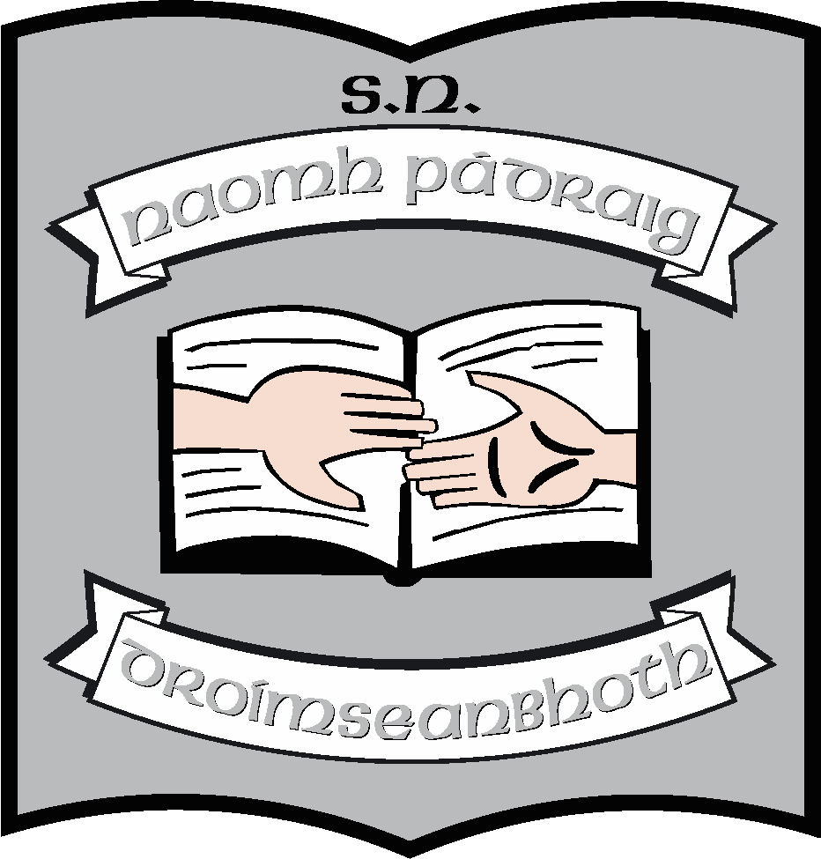St. Patrick’s N.S.
Drumshanbo,
Co. Leitrim.

Roll No: 19423J

SPHE

Reviewed: August 2021
Ratified:
Due for review: 2026

St. Patrick’s National School

SPHE Policy

Introduction

Introductory Statement

This policy is a statement of the aims and objectives, principles and strategies for the teaching and learning of SPHE at St. Patrick’s National School.
It is based on a policy developed by the principal in 2015 and follows on from School Self-Evaluation of SPHE in 2018-2019. On foot of the evaluation, considerable changes have been made to the way in which SPHE is taught throughout the school and this policy is being reviewed to reflect these changes.

SPHE is an integral part of our curriculum because it provides opportunities to foster the personal development, health and well-being of the individual child, to help him/her to build supportive relationships and become an active and responsible citizen.

Rationale

We hope that the application of this policy will help us to
- To foster the personal development, health and well-being of all the children in our care.
- To help them to create and maintain positive and supportive relationships.
- To help them to become active and responsible members of society.
- To help them develop a framework of values, attitudes and skills which will enable pupils to make informed and responsible choices now and in the future.
- To benefit the teaching and learning experiences of the S.P.H.E Curriculum.
- To conform to the principles of learning outlined in the Primary School Curriculum.
- To ensure the provision of Stay Safe and RSE in the school
- To promote wellbeing among our pupils

The SPHE policy is being reviewed in line with other recently reviewed policies including
- AUP
- Mobile Phone policy
- Anti-Bullying

Following on from this policy we will review
- RSE Policy
- Substance Abuse Policy
- Healthy Eating Policy

Relationship to School Vision
Our mission statement states that we cultivate a positive atmosphere where children are inspired to achieve their full potential.
We see the provision of SPHE as key in achieving and maintaining this mission. We are keen to foster the personal development, health and well-being of the child. This, in turn, will help him/her to create and maintain supportive relationships and become an active and responsible in the local community, and eventually in the wider society.

Aims
In line with the curriculum our aims in the teaching of social, personal and health education are:
- to promote the personal development and well-being of the child
- to foster in the child a sense of care and respect for himself/herself and others and an appreciation of the dignity of every human being
- to promote the health of the child and provide a foundation for healthy living in all its aspects
- to enable the child to make informed decisions and choices about the social, personal and health dimensions of life, both now and in the future
- to develop in the child a sense of social responsibility, a commitment of active and participative citizenship and an appreciation of the democratic way of life
- to enable the child to respect human and cultural diversity and to appreciate and understand the interdependent nature of the world

Content
SPHE is planned in such a way that the child will receive a comprehensive programme in SPHE over a two year period. The strand units not covered in one year must be included in the teacher’s planning for the following year.
Overview of content for SPHE over two years:
Strands | Strand | Strand Units (Year 1) | Strand | Strand Units (Year 2)
September/October | Myself | Self-identity | Myself and Others | Relating to Others
November/December | Myself and Others | Myself and my family | Myself and the Wider world  Myself (3rd – 6th) | Media Education  Making Decisions
January/February | Myself | Safety and Protection:  Stay Safe Programme  Internet Safety | Myself | Safety and Protection:  Stay Safe Programme  Internet Safety
March/April | Myself and the Wider World | Developing Citizenship | Myself and others | My friends and other people
May/June | Myself | Growing and Changing  Taking Care of my Body | Myself | Growing and Changing  Taking Care of my Body  Developing Citizenship

This is a suggested school wide timetable, but all classes must cover the Stay Safe Programme as timetabled above and all classes must cover the RSE programme annually.

Contexts for SPHE
SPHE will be taught through a combination of contexts:
- Positive school climate and atmosphere
Our school community strives at all times to promote a positive school climate.
- Key messages to promote pupil wellbeing are referred to, as appropriate, during the year through newsletters, meetings with parents, at assembly and on a regular basis in classes. We base much of this on the Weaving Wellbeing Programme. Positive messages are displayed in our assembly hall.

- We make every effort to cater for the individual needs of the children. Individual needs may be social, emotional, spiritual, physical or intellectual. Through assessment, observation and discussion with parents we strive to identify and meet individual needs.

- We provide opportunities to enhance the self-esteem of all members of the school-community.

- We aim to actively value diversity and to prioritise inclusive and respectful language. We will prioritise both racial and gender equality and respect for those with special needs. We believe that children learn to respect themselves and others through experiencing respect in their own lives and through witnessing respect being shown to others.

- We work to develop an effective communication system within the school and between the school and home. Attention will be paid to encouraging everyone to express opinions and concerns and to respond to the opinions and concerns of others as a dimension of classroom work and general school life.

- We promote health and safety in the school. With the help of our school community we on focus on healthy lunches, healthy lifestyle and mind. Road, water, farm safety and regular fire drills are some of the areas promoted also. Taking responsibility and pride in the school environment is encouraged through our involvement in the Green Schools programme and through constant review and promotion of behaviour and habits required for maintaining a clean environment. Playground markings for yard time activities, children’s work on display throughout school and the school garden also promote a welcoming physical environment.

- We promote democratic processes in all levels of school life while balancing roles, rights and responsibilities. Children experience and practice the democratic process by:

- Negotiating the class rules at the start of the year.
- Electing or taking part in School Council

- Sharing responsibility.

- Valuing the opinions of others.

- Experiencing a sense of belonging to their own class group and the wider school community.

- Develop a sense of commitment to common goals.

- Children on the Healthy Schools Committee

- We have agreed that we will prioritise care in our own behaviour as adults and in our expectations of children. We will help children to learn to care for each other through actively building relationships within each class. We will seek to build identity, security and belonging, competence and purpose through:
    - Discussion, promotion of and valuing difference.
    - Agreeing ground rules for responsible behaviour and clarifying values on an ongoing basis.

    - Caring for and promoting inclusion of others and learning that it’s OK to be different.

    - Promoting inclusive and respectful language.

    - Promoting support and co-operation.

    - Respecting individual strengths.

    - Supporting individual needs through teacher support.

    - Supporting individual needs of children in times of family or individual personal crises (children who suffer serious illness and need to be in hospital or out of school for long periods; children who suffer bereavement, especially bereavement in the immediate family; engaging exterior services e.g. NEPS, CAMHS.

    - Create meaningful differentiated learning opportunities.

    - Celebrating the wide range of children’s strengths at assemblies.

    - Communicating regularly about learning and general development with the home.

- Discrete time
- Timetabling – 30 minutes per week. (or 1 hour per fortnight, at the teacher’s discretion)
- The topics which will be addressed through discreet time are listed in our S.P.H.E. core curriculum.
- Discretionary time will be used for S.P.H.E. as it is an integral part of our school life and all the skills and practices of S.P.H.E. will be used incidentally throughout the school day e.g. conflict resolution on the yard, bullying and waste-management
- When drafting time-tables for withdrawal of pupils for supplementary teaching, teachers will include these pupils for as much of the S.P.H.E. programme as possible.

- Integration with other subject areas
Some of the opportunities to integrate SPHE throughout the curriculum are identified below:
- Language:
  - using language precisely
  - acquiring appropriate vocabulary
  - developing communication skills
- History:
  - developing empathy
  - exploring changing influences on our lives
- Science:
  - exploring the way the body works
  - the process of physical growth
- Geography:
  - developing a sense of place
  - exploring local and national issues
- Mathematics:
  - interpreting and representing data
  - measuring and estimating
- Visual arts:
  - creating and exploring images and pictures
- PE:
  - choosing teams and playing games in a fair manner
- Drama
  - Co-operating

And also
- Weaving Wellbeing
- The Grow in Love programme

Approaches and methodologies
Active learning is the principal teaching and learning approach recommended for SPHE. The SPHE programme reflects a spiral approach, where similar aspects are revisited in different ways according to the age, stage of development and readiness of the child. SPHE is intrinsic to the learning and teaching that occurs both formally and informally in the school and in the classroom.
- Teachers are to make themselves familiar with the content objectives for their own class
- It is essential that a balance is achieved between skill development, the fostering of values and attitudes and the acquisition of information.
- Familiarity will be maintained if teachers change classes or if new teachers join the class through receiving S.P.H.E. school plan
- Stay Safe will be covered every year in all classes
- Webwise (or similar) materials will be used in all classes to promote Internet Safety
- Further information on RSE content and arrangements for teaching same is outlined on the RSE policy.

The following active learning strategies are promoted in the school:
  - Drama activities
- Co-operative games
- Use of IT particularly in the areas of Media Studies and Internet Safety
- Pictures, photographs and visual images
- Discussion: in pairs, small groups and with whole class
- Written activities.
- Information and communication technologies
- Looking at children’s work: portfolios, projects …
- Visits from experts in areas related to the strands of the SPHE curriculum
- Visits from local Garda, Fire Officer, Cycle Safety group etc.

The following approaches and methodologies are used for SPHE
- Talk and discussion
- Skills through content
- Collaborative learning
- Problem-solving
- Use of the environment

Creating a health-promoting physical environment
The children will learn how to care for and respect the wider environment as they share the responsibility for taking care of their own immediate physical surroundings.
- We promote care for the environment and we are in the Green Schools Programme
- We have a healthy lunches policy
- We have a number of gardens which children help to maintain
- PE and team games are a routine part of our curriculum
- During Covid, children have been involved in cleaning and sanitising their areas in class

Generic approach
Rather than treating topics in isolation, SPHE aims to develop in the child a generic set of skills, attitudes, values and understanding, relevant to a range of social, personal and health issues. This is reflected in many of our key policies
- Code of Behaviour
- Anti-bullying
- Child protection
- Substance Abuse
- Internet – Appropriate Use Policy
We also try to promote them through our classroom rules & rewards systems, through our manners code and using school assembly

Assessment
- The school assesses the child’s progress in S.P.H.E. by teacher observation, classroom atmosphere, teacher designed tests and tasks and self-assessment for pupils.
- Teacher will observe to see:
- The ability of the child to co-operate and work in groups or to work independently

- The informal interactions between the child and adults and between the child and other children

- Physical and emotional maturity

- The quality of presentation of work

- The participation and interest of the child in a variety of activities.
- As S.P.H.E. is an integral part of the revised curriculum, information regarding the child’s abilities, strengths and overall progress in S.P.H.E. is shared with the pupil and parents, e.g. parent-teacher meetings, homework journals and end of year reports.
- Children from 2nd class onwards will use a wellbeing notebook which is for their own use but which may be shared with teacher
- Children will be encouraged to self-assess and to reflect on the content being covered in SPHE

Roles and responsibilities
An SPHE programme is most effective when it is based on a consistency in approach and where responsibility is shared by all of the school community
Role of Board of Management
It is the responsibility of the board of management to support and facilitate the school approach to SPHE as it is being developed. The board will also fund CPD, when necessary, in courses which involve training involving pupil well-being and health.

The Role of the Parents
Since parents have the primary role in the social, personal and health education of their children, it is envisaged that they support teachers in implementing the programme. We encourage them most particularly to get involved in policy making for SPHE, RSE, Codes of Behaviour, Anti-bullying policy and Child Protection. (During this school year 2014 - 15 parents have been involved in drafting RSE and Substance Abuse policies.)
Parents are also asked to discuss lesson plans from SPHE with their children, specifically in the Stay Safe Programme and the RSE lessons in senior classes.
The Role of the Principal
The principal has a central role in ensuring that the SPHE curriculum is effectively implemented in the school in accordance with the school plan. She will be responsible for policy review and for making parents, teachers and board members aware of the content of the policy and any changes contained therein.

The Role of the Teacher
Because children are more likely to gain from a curriculum where there is a consistency in the approach taken by all teachers in the school, it is important that teachers work in collaboration with one another. Where teachers may have developed skills in the use of various approaches in SPHE or may have had previous experience of using materials in this area, sharing this expertise with each other is important.
Each class teacher will be responsible for the planning, resourcing and implementation of the SPHE curriculum in her/his classroom.
All teachers will support the implementation of the school codes of behaviour, manners, fair play etc. which are an inherent part of the SPHE curriculum.
Catering for the individual needs of the children
The SPHE programme will be adapted to suit various needs, interests and concerns of individual children.
Should a situation arise for a child within any school year such that the scheduled programme needs to be changed to better meet the needs of that child, we will do so.
SEN teachers will be asked to assist in supporting children with individual needs in the area of SPHE. In this event, appropriate targets will be included in Support Plans.
Success criteria
We will continually evaluate and assess the children’s progress using the following:
- Teacher observation
- Teacher designed tasks
- Portfolio and projects
- Staff feedback
- Parent/pupil feedback
- Reviewing general behaviour and school Code of Behaviour

Implementation and review

The policy will be implemented by the principal and staff of St. Patrick’s N.S. and will be supported by the B.O.M.

Implementation/Ratification and Review

This policy review will be shared with ISM and with staff. Following any revisions, it will be presented to the Board of Management at the next meeting (September 2021). If ratified, it will become school policy and will be published on the school website. It is due for full review in summer term of 2026. The responsibility for the review will lie with the principal, teachers, BOM and parents of children attending the school at the time of review.
An anticipated change in curriculum may lead to an significantly review. Changes to Stay Safe, to government policy or concerns within the school community may also necessitate earlier review.

**************************************************************************

Ratification of policy for St. Patrick’s NS

Chairperson Date

Principal Date

Resources

- Health (Prim-Ed series)
- Be Safe
- www.webwise.ie
- Walk Tall programme
- Trócaire resource packs
- RSE programme
- Stay Safe Programme

