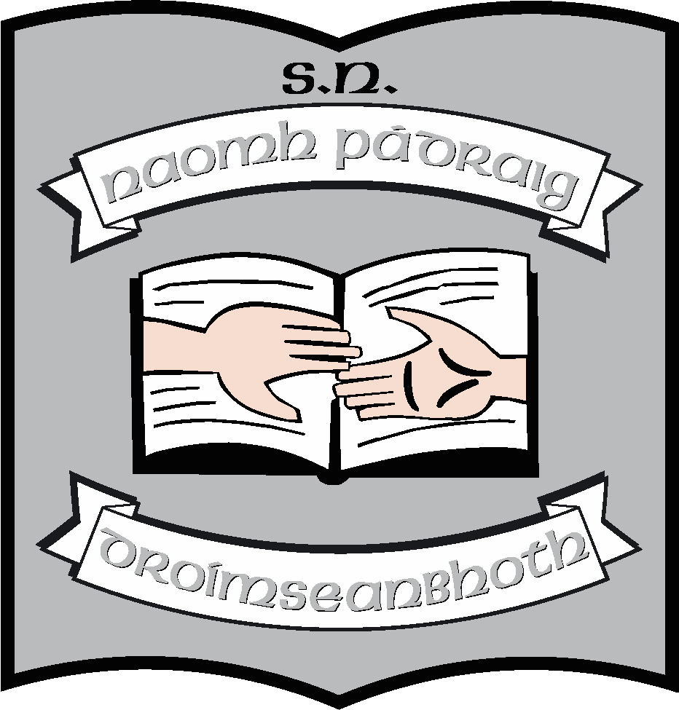St. Patrick’s N.S.
Drumshanbo,
Co. Leitrim.

Roll No: 19423

Statement for Autism Class (Staff)

Reviewed: January 2023
Ratified: February 2023
Due for review: 2027

St. Patrick’s National School

Statement for Autism Class (Staff)

January 2023

St. Patrick’s NS has two Autism classes. Each class can have a maximum of 6 pupils. Generally, one teacher and 2 SNAs are allocated to each class; however, the number of SNAs can be increased if there is a proven need. Class range and child age may vary within each class.

Mission Statement

In St. Patrick’s NS we want to give the highest quality of education to our children. As our school mission statement says:
- We provide a welcoming and safe environment where all pupils are equally respected.
- Friendship and co-operation are at the heart of our school.
- We cultivate a positive atmosphere where children are inspired to achieve their full potential.
We recognise and value the role of parents as the primary educator of their children. We want to work with them to provide the best and most appropriate teaching and learning for the children in our care. This can mean that we take an eclectic approach to meeting their individual learning needs. We don’t subscribe exclusively to any one approach to the education of children with Autism. We may choose to use elements of different and varied teaching methodologies for example TEACCH/PECS. Some children may use assistive technology to aid with communication.
Aim of Autism Class

The aim of the unit is to provide a caring learning environment which facilitates the nurturing of each pupil’s full educational potential. The achievement of this aim informs all of the planning processes and activities which occur in our classes. The principal, teachers, support staff and parents are partners in the children’s education with co-operation and communication between home and school being a vital ingredient in the educational process. We share the same purpose – the care and well-being of the children in our care, as well as their education and development.
A great emphasis is placed on the areas of communication, daily living skills, socialisation, literacy and numeracy. Our curriculum incorporates all of the subjects from the National curriculum. (Some pupils may be exempted from Irish if this is requested by parents and if the principal and teachers feel that it is in the best interest of the pupils, subject to the guidelines laid out in Circular 52/19)
Routines and General Information

- The school day runs from 09:20 to 14:00 for Junior and Senior Infants and until 15:00 for all other pupils.
- There is a 10-minute break at 11:00 and lunch is at 12.30. (This may be staggered if the need arises eg during Covid)
- Children are and dropped off/collected from the door of the class by parents/bus escorts
- Children may take part in extra activities during the year such as swimming and horse-riding and outings to library, shops etc. These will take place under the supervision of teachers/SNAs.
- Communication with parents will take place at Support Plan meeting, Team meetings and Parent-Teacher meetings. There will be regular communication with parents through use of communication books or using online platforms such as SEESAW. Parents should understand that this will be brief and may not happen every day as it takes away from teaching time. Parents can always communicate with the school through the office to set up meetings/calls with teacher. When children progress to getting homework, parents will be asked to sign homework notebooks/sheets.
- Where children are transitioning in or out of the Autism class, the school will work to set up a programme to support this.

Integration
At this time, we do not have a policy on the inclusion of children from Autism classes into mainstream classes. In general, we look at the needs and abilities of each individual pupil. Where a child’s learning is not compromised by being in the mainstream class, we will seek to include him/her. This may be with or without SNA support depending on the individual child and whether there is an SNA already in the mainstream class.
Section 2 of the Education for Persons with Special Needs Act 2004 states ‘A child with special educational needs shall be educated in an inclusive environment with children who do not have such needs unless the nature or degree of those needs of the child is such that to do so would be inconsistent with:
- The best interests of the child as determined in accordance with any assessment carried out under this act, or
- The effective provision of education for children with whom the child is to be educated’.

The amount of integration/reverse/parallel integration that each child receives in St Patrick’s NS is collectively decided upon by those professionals who deal with the child each day i.e. teachers (special education teachers and mainstream), the Principal and support staff. Parents will always be consulted. The views of other interested parties such as Psychologists, Speech Therapists and Occupational Therapists will be taken into account. However, the staff’s decision is final. The amount of inclusion for each child may depend on the day that the child is having. Sometimes a child may just not be able for the mainstream class environment.

As well as in-class, here are many opportunities for integration
- Playground
- Assembly
- Visiting sports/arts trainers
- Special events such as plays, sports days, school masses,

This section of our statement deals with the staff of the Autism classes.
Rationale

This section of the statement is formulated so that:

- All staff has well defined guidelines on best practice
- There is consistency between the two classes
- Optimum learning experiences will be provided for all the children of the school body.

Aims

In setting out the roles of the staff, our priority is the education and wellbeing of all of the children in the school. We aim

- To provide children in the Autism classes with a high quality educational experience that is appropriate to their needs
- To provide a teaching and learning experience that enables pupils with special educational needs to become exposed to learning in a mainstream setting if appropriate
- To enable the children in the mainstream classes to observe and interact with children with special needs, encouraging understanding and tolerance
- To develop the social skills and self-esteem of the children in the Autism Unit.

Staff Roles

In order for the children in the Autism Classes to receive the best possible education while in our school, a team of people must work effectively together to provide for their needs and to ensure that they are receiving quality teaching and learning.
This team includes the principal, class teachers and SNAs.
Principal

With reference to the Education for Persons with Special Needs Act 2004, the role of the principal entails:
- Developing inclusive whole-school policies and monitoring their implementation
- Assigning staff strategically to teaching roles, including special education roles
- Co-ordinating teachers’ work to ensure continuity of provision for all pupils
- Ensure that whole-school procedures are established to facilitate the effective involvement of parents, pupils and external professionals / agencies
- Ensuring that effective systems are implemented to identify pupils’ needs and that progress is monitored methodically
- Attendance at team meetings
- Liaising with parents, teachers and relevant professionals to ensure that the needs of the children are being met; making applications for support where appropriate.
- Facilitate the continuing professional development of all teachers in relation to education of pupils with special educational needs, and ensure that all school staff (class teachers, special education teachers and special needs assistants) are clear regarding their roles and responsibilities in this area
Whereas, the role of the principal is important, the team with direct day to day contact with the pupils have the greatest input into their education. As such they must work collaboratively and effectively to ensure that the children’s needs are being met and that they are making the best possible progress.

Special Class Teachers

The role of the class teacher is key as he/she leads the learning in the class. The list below is not exhaustive but is an attempt to identify the most important work being undertaken by him her.
The teacher
- Will identify and create a plan for the appropriate curriculum the child in the Autism Class should experience.
- Ensure SNAs are aware of this plan and clear as to their roles in implementing it – set up systems e.g. weekly team meeting to make this possible
- Provide a daily/weekly schedule for the class team to follow.
- Provide a list of appropriate activities for each child’s workstation, in line with the curriculum or skills e.g. social/life skill being taught to each child.
- Collaborate and consult with mainstream teachers on a regular basis in setting specific, measurable, achievable, relevant short-term and long term targets ensuring the needs of the child are being met.
- Assume responsibility for School Support Plans in consultation with the relevant support services, parents and the Principal. Plans will be in place by the end of October and will be updated in February and again after Easter if necessary.
- Supervise the use of equipment, and ensure that it is properly used, put away and maintained.
- Liaise and consult with parents.
- Liaise and consult with the relevant support services.
- Undertake appropriate assessments/diagnostic tests such as PEP3/ABLLS - R/AFLS
- Maintain complete and accurate records pertaining to the child including attainment records/behavioural records/incidents etc.

Special Needs Assistants/Care Assistants

The main role of the SNA in an Autism Class is to assist the class teacher with the specific goals and targets set down in the child’s IEP. He/She is a vital part of the team. In our classes an SNA may be assigned to a child as a key worker for a period of time – this will be directed by the teacher. This provides the SNA with an opportunity to get to observe the child very closely and to know what resources, methodologies may work best for the child. The SNA is also well placed to see what methodologies/activities do not work for individual children. Therefore, the SNA is a great source of information and support to the teacher in planning a and executing a child’s programme of work.

In practical terms the SNA may also
- See to any care/health & safety needs that a child may have.
- Ensure that the child has the resources he/she needs.
- Set up work-stations under the guidance of the teacher.
- Work to ensure the smooth running of the classroom as defined by the work schedule and work station schedules set out by the teacher.
- Work alongside the child to support him/her in the tasks that have been set.
- At all times ensure the safety of the child.
- Supervise the use of equipment, and ensure that it is properly used, put away and maintained.

Each class in our school is allocated a number of SNA’s by the area SENO. Normally one is allocated when 3 children are in a class. When the number of children exceeds 3, another SNA is allocated, another when the number reaches 7 and another when the number reaches 10. In special circumstances, the school may seek extra support and apply for additional SNAs in excess of the quota. Such applications are sent to the SENO.
Generally, the SNA’S are allocated to the school and employed by the Department of Education. They are not assigned to any one child and there is great scope in their job specification to move between classes when needs arise. (See also SNA Policy)

Class Teachers (Mainstream)

- Will differentiate teaching programmes to meet the needs of the child from the Autism Class
- Provide a suitable seating arrangement in a mainstream setting
- Collaborate with the Special Class Teacher and the SNA
- Provide feedback on progress.
- Work to support reverse/parallel inclusion where appropriate

Staff Development:

The Board of Management has been very supportive in funding and facilitating staff development for the teachers and SNAs working in the Autism Classes. The Board also recognises the dedication of our staff in undertaking courses in their own time in order to continually upskill so as to be able to improve the quality of provision for the children in their care. The Board will continue to support and facilitate CPD

- When the course is appropriate to meet the needs of children with Autism
- When attending a course does not compromise the continuing work of the class
- When the principal agrees that the course is necessary and worthwhile

Conclusion
This statement will be presented to the Board of Management for ratification. Although it is not a policy in the strictest sense, it is an important document in that it attempts to state our vision for the Autism classes and the expectations we have for staff working in these classes, in order to ensure the wellbeing of the children and the smooth running of the classes. It is an attempt to clarify the roles of principal, teachers and SNAs, all of whom have been consulted in drawing up this document. All staff will be asked to adhere to it, as far as possible.
There is another statement which relates to the role of parents of children in the classes which will also be presented to the Board at this time.

***************************************************************************
Ratification of policy for St. Patrick’s NS

Martin McGowan 28/02/23
__________________________________________________________________________
Chairperson Date

Ruth McLoughlin 28/02/23

Principal Date

