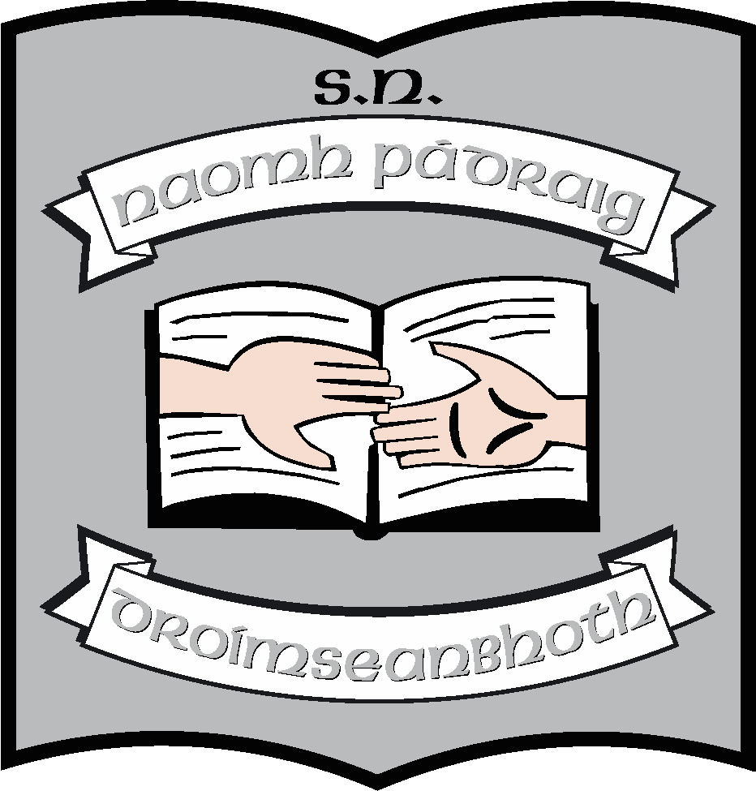St. Patrick’s N.S.
Drumshanbo,
Co. Leitrim.

Roll No: 19423J

Supervision Policy

Reviewed: May 2019
Ratified: May 2019
Due for review: 2024
Partial review: Annually - rota

St. Patrick’s National School

Supervision Policy 2019
Introduction
The Board of Management of St. Patrick’s N.S. recognizes that the safety of the children of this school is of paramount importance. To this end staff will take all reasonable precautions to ensure the safety of pupils.
Rationale
This supervision policy was introduced and is being reviewed after 5 years (2019) to ensure that we continue to take all reasonable precautions
- To ensure adequate provision of supervision for the children in our care
- To ensure that we are cognizant of child protection procedures
- To ensure that all members of staff are clear on their roles with regard to supervision throughout the school day – in class and outside of class.

Procedures
Before school
The Board of Management takes no responsibility for the supervision of children prior to 9:00am.
The children assemble from 9:00 – 9:10 at the entrance to the school nearest the main gate. They are supervised by an SNA. They stand in the shelter at this time.
Morning
- School officially opens to receive pupils at 9:10am.
- Upon entry to the school, children go to their classrooms and supervision is by the three teachers on duty.
- Teachers are in their classes from 9:20 to receive the children
- Children must remain in their seats once they enter the classroom – this is a school rule.
- Class begins at 9:30.

Small break
- Break is from 11:00am to 11:10am.
- Teachers should not leave children in the yard unless and until a teacher is there to supervise.
- Junior infants - 2nd class go to the yard outside the main door and behind the school. 3rd – 6th classes go to the big yard using the exit near the office. Teachers ensure that the pupils leave the room in an orderly manner. If it is raining, the children remain in their seats in their classroom.
- One of the teachers on the Senior yard may move to the Junior yard to support supervision there.
- Outdoor supervision is provided by 3 teachers and seven SNAs, with two teachers and 2 SNAs in the senior yard and one teacher and five SNAs in the junior yard.
- When bell rings for the end of break, children line up with their class groups at the appropriate door and return to the classroom. Those on supervision duty, remain with the lines until they walk to their classrooms. Children are not allowed to run in the school. Supervision by the teachers/SNAs on duty continues until teachers are back in their classrooms.
- Class resumes at 11:10
Lunch break
- Supervision continues as with small break. An extra SNA may move to the senior yard if any of the children from the Junior Autism classes are playing with buddies on the Senior yard.
Afternoon
- Junior and senior infants finish at 2pm. They are collected, one at a time, from their classroom door.
- 1st – 6th finish at 3pm. Those going home by bus go to the infant classrooms to get into their queues. Others are collected, some walk or cycle. There is also a collection by the afterschool team.

Break time supervision
Supervision rota
A rota for supervision is included with this policy. Three teachers are on duty each day. When a teacher is on supervision duty, he/she is asked to supervise
- From 9:10 – 9:20 in the hall and corridor as children enter and go to class
- From 11:00 – 11:10 in the yard (in school if raining) – one in the junior yard and two in the senior yard
- From 12:30 – 1:00 in the yard (in school if raining) – one in the junior yard and two in the senior yard

When supervising indoors, teachers are asked to ensure that one of the 3-person team monitors the corridor with 6th and infant classes while the others monitor the classes adjoining the hall. SNAs remain in the class to which they are attached.

There are seven SNAs in the school. An SNA is on duty outside the main door of the school from 9:00 – 9:10 to supervise children as they assemble. This is scheduled on a weekly basis.
- From 11:00 – 11:10 in the yard (in school if raining) – five in the junior yard and two in the senior yard or four in the junior yard and three in the senior yard (if necessary)
- From 12:00– 12:30 in the yard (in school if raining) – five in the junior yard and two in the senior yard or four in the junior yard and three in the senior yard (if necessary)

Guidelines for supervising teachers and SNAs:

- Teachers on duty will be in school to begin morning supervision at 9:10. They will leave their classes promptly at 11:00/12:30 and go to yard.
- The staff on duty will remain in the yard for the duration of the break.
- If a child is injured in the yard, one teacher/SNA will leave the yard to attend to the child. In the event that the teacher is concerned for the wellbeing of the child, he/she should ask the secretary to call a parent/guardian. Accident report forms should be filled after class. Supervising teachers should inform class teachers if they are concerned about any child.
- The supervising teachers will ensure that all children are lined up to return to class at the end of break, which is signaled by an electronic bell. They will select the winning line. They will remain with the children until the leave the yard, class by class.
- Teachers need to be vigilant while on duty.
- Only in exceptional circumstances should children be inside during break.
- Children need to seek permission to leave the yard
- Teachers should record all accidents on the forms provided.
- Incidents should be noted in day books and class teachers informed.
- Bullying issues should be noted by teachers and the principal should be informed.

*See also school Code of Behaviour and Anti-Bullying policies
Supervision of children during rainy days.
- Three teachers and seven SNAs will be on duty on rainy days. Each teacher will take responsibility for one side of the hall or for the new corridor – thus supervising three classes each.
- Each SNA will supervise in the class where she is regularly assigned.
- Therefore, teachers on duty should be particularly vigilant with the classes to whom no SNA has been assigned.
On rainy days, children will remain seated in their classrooms or play chess in the hall. The classroom teacher can assign children activities/games, before she exits her classroom. Children may be allowed to watch appropriate DVDs. Children will only be allowed to leave their seat after seeking permission from the supervising teacher.
In order to foster a sense of responsibility among senior pupils, the supervising teachers may assign duties to them, on a rota basis, to help with the activities in the junior and middle classrooms.
Children will use the toilets one at a time.

Home time supervision

At 3:00pm the children will line up to exit the classrooms.
- Children walking home will leave the school in an orderly manner.
- Children travelling on buses will go to their designated bus queues which gather in the infant classrooms.
- Children attending the After School Club gather outside the Third Class room
- Children going home by car exit the school and go to the car park using the crossing.

Note: A separate policy regarding the supervision of pupils on tours and school outings will be drawn up and presented to the board.
Circulation:

The Supervision Policy will be available in the school office for parents/guardians should they request to view or obtain a copy. The policy can be communicated by providing a written copy if requested, or by e-mail.
When it is ratified, it will be published on the school website.

Implementation/Ratification and Review
This policy will be presented to the Board of Management at the next meeting. If ratified, it will become school policy and will be published on the proposed school website. It is due for review in the summer term of 2024. However, changes in staffing, yard layout or in procedures of enrolment may precipitate an earlier review.
***************************************************************************
Ratification of policy for St. Patrick’s NS

Martin McGowan 27/05/2019
Chairperson Date

Máirín O’Keeffe 27/05/2019
Principal Date

