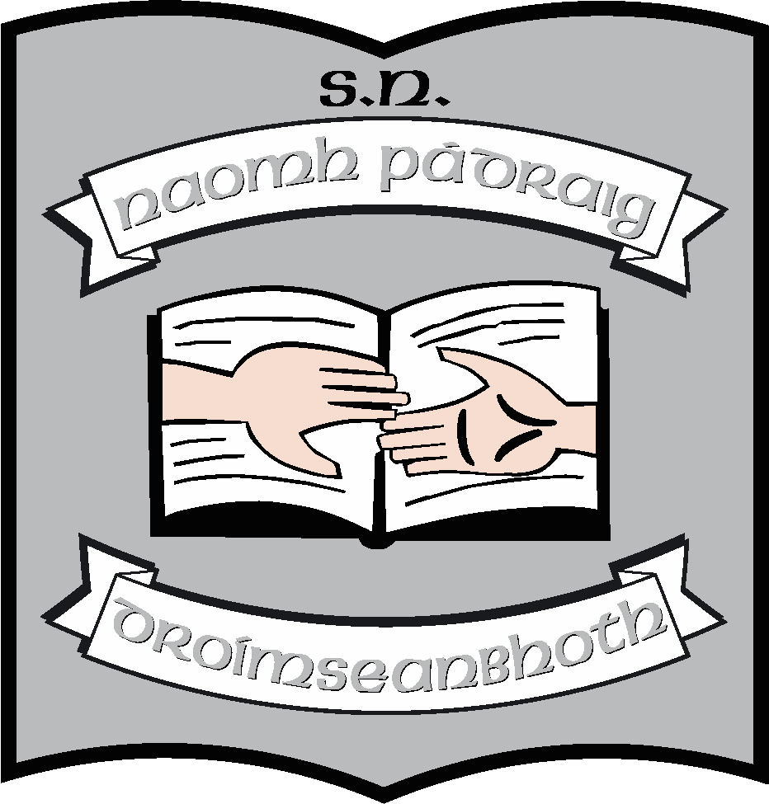St. Patrick’s N.S.
Drumshanbo,
Co. Leitrim.

Roll No: 19423J

Visual Arts Policy

Reviewed: February 2022
Ratified: March 2022

St. Patrick’s National School

Visual Arts Policy
Introductory Statement

This policy was originally formulated by the staff of St. Patrick’s NS in consultation with the Board of Management in autumn 2013. It conforms to the principles of the Primary School Curriculum and guides all teachers with classroom planning and yearly schemes.

The policy was formulated to provide for creative and aesthetic experiences through exploring, investigating, inventing, designing and making in a range of media. It promotes observation and ways of seeing and helps the child to acquire sensitivity to the visual, spatial and tactile world and to aesthetic experience.

Rationale for review

This review is based on our ongoing internal school self-evaluation. Review was due to take place in the current school year.

Vision

The development of visual arts is a very important aspect of the curriculum in our school. Through arts, the pupils are given the opportunity for organised expression of ideas, feelings and experiences in images, music, language, in gesture and in movement. This provides for sensory, emotional, intellectual and creative enrichment and contributes to the child’s holistic development. Art provides the child with a variety of ways of communicating with others. We see arts education as life enhancing. It stimulates creative thinking, and helps to promote capability and adaptability. Pupils’ attempts at artistic expression are valued, self-esteem is enhanced, and it is a positive experience for the child.

All children have equal access to visual arts education in our school. Opportunities are also provided for children with special education needs to show capabilities and independent achievements. Arts activities while carried out in a structured way within our curriculum are also integrated with other curricular areas.

Our visual arts education curriculum provides for a balance between expression and the child’s need to experience and respond to visual arts.

Art education is integral to primary education in helping to promote thinking, imagination and sensitivity and arts activities can be a focus for social and cultural development and enjoyment in school.

Aims

The aims of the visual arts curriculum are:

- to help the child develop sensitivity to the visual, spatial and tactile world, and to provide for aesthetic experience
- to help the child express ideas, feelings and experiences in visual and tactile forms
- to enable the child to have enjoyable and purposeful experiences of different art media and to have opportunities to explore, experiment, imagine, design, invent and communicate with different art materials
- to promote the child’s understanding of and personal response to the creative processes involved in making two and three-dimensional art
- to enable the child to develop the skills and techniques necessary for expression, inventiveness and individuality
- to enable the child to experience the excitement and fulfilment of creativity and the achievement of potential through art activities
- to foster sensitivity towards and enjoyment and appreciation of the visual arts
- to provide opportunities for the child to explore how the work of artists and craftspeople might relate to his/her own work

Objectives:

When due account is taken of intrinsic abilities and varying circumstances, the visual arts curriculum should enable the child to:

- look at, enjoy and make a personal response to a range of familiar and unfamiliar objects and images in the environment, focusing on their visual attributes
- explore and begin to develop an awareness to qualities of line, shape, colour and tone, texture, pattern and rhythm, spatial organisation and the three-dimensional quality of form
- express ideas, feelings and experiences in visual form and with imagination, enjoyment and sense of fulfilment
- experiment in spontaneous, imaginative and increasingly structured ways with a range of art materials, including pencils, paints, crayons, chalk, markers, inks, clay, papier mache, fabric and fibre, and construction materials
- explore the expressive and design possibilities of the materials within a range of two and three-dimensional media across all strands
- apply skills and techniques, demonstrating increasing sensitivity to the visual elements in his/her art work
- look with curiosity and openness at the work of a wide range of artists and craftspeople
- identify a variety of visual arts media and describe some of the creative processes involved
- develop an ability to identify and discuss what he/she considers the most important design elements of individual pieces, especially when they relate to work on hand
- discuss the preferred design elements in his/her work and in the work of his classmates
- begin to appreciate the context in which great art and artefacts are created and the culture from which they grow
- use appropriate language in responding to visual art experiences
Curriculum Planning

Strands and Strand Units:

The Visual Arts Curriculum is divided into six strands:

- Drawing
- Paint and colour
- Print
- Clay
- Construction
- Fabric and fibre.

These strands are interrelated. Consequently, each strand has a Making Art and a Looking and Responding structure. These activities are informed by the art elements: line, shape, form, colour and tone, pattern and rhythm, texture and spatial organisation.

In our school:

- The Visual Arts programme is structured in such a manner so that the children draw on their experiences, imagination and observations.

- Children have free choice where possible in selecting materials they wish to use in their own art activity.

- Children are afforded opportunities to develop sensitivity both informally and in context to the qualities of line, shape, form, pattern and rhythm, colour and tone, texture and spatial organisation by becoming aware of them in nature/art in their own work. They arise by having opportunities to look closely at the environment i.e. linkage with nature walks, science etc.

- From time to time where possible pupils are given the opportunity to select a medium through which to represent their personal interpretation of the stimulus.

- Children experience a variety of approaches to visual arts.

- Each visual art lesson consists of a stimulus, activity and evaluation, and each child is given the opportunity to personalise their interpretation of the stimulus.

- All teachers are aware of and familiar with the strands / strand units and content objectives of the visual arts curriculum and use these in their planning.
- Working with the strands and strand units provided, teachers are able to provide a range of activities for all strands in each class.
- Teachers ensure there is a balance between 2-D and 3-D strands and between making, doing, responding and looking.
- Continuity and progression from class to class is ensured as each teacher is aware of work in previous years.
- The school creates opportunities for the child to look at and respond to their natural and living environment through linkage with other curricular areas.

- The recent acquisition of a camera for each class will give children more opportunities in the Looking and responding strand units.

- The children have access to artists, craftspeople, designers, and from time to time local artists are invited in. This is also kept in mind when organising school tours. In the school year 2021 – 2022, the school has had visiting artists into 3rd, 4th, 5th and 6th. We hope this will continue in the following years.

- Pupils have an opportunity to look at and respond to art works through pictures available in school - National Gallery etc. and also the art of their peers through class/school displays.

- Activities in the strand unit Making and Doing automatically lead to activities in the strand unit of looking and responding.

- Equally, Looking and Responding is used as a stimulus for Making and Doing.

- While we believe that process is more important than product in the Visual Art curriculum, we like to display children’s work for their pleasure and for the enjoyment of the school community.

- The school has a theme month in November and March. The art the children complete over these months will reflect the theme in question.

Children with Different Needs

All children are enabled to make an important contribution to Visual Art classes, regardless of academic achievement. Children with physical difficulties are facilitated as the need arises, in a caring and compassionate manner. Children with exceptional abilities are encouraged and supported by entering competitions, doing projects which include visual arts activities.

Linkage and Integration

Integration:

Cross curricular integration opportunities are indicated at the end of each strand. These opportunities are identified when our visual arts programme is being planned. We ensure that visual objectives are closely defined within integrated activities. We use theme based activities to support integration in all areas of the curriculum eg
- Maths – shape, pattern
- History – history of art/artists, crafts in the past
- Geography – ethnic art and craft
- English – themes from oral language
- Gaeilge – ealaín bunaithe ar na téamaí
- Music – responding to music using Art etc.

The visual Arts programme is integrated with every aspect of the curriculum through interpretation, design, project work and illustration.

Linkage:

Opportunities are provided for linking strand with strand e.g.

- Strand and strand units are linked through concept and skill development in different media e.g. awareness of colour through painting and printmaking and through work in fabric and fibre.
- Linkage is achieved through activities that develop a theme e.g. interpreting the theme “Beach” in drawings, colour sketches, papier mache etc. This is reflected in our whole school themes of ‘My Locality’, ‘Homes and Houses’, ‘Bia’ and Country.

Language:

- Visual Arts activities provide many opportunities for incidental language development. Children are encouraged to talk about work in hand, about challenges they meet, their decisions they make about their choice of subject and how they use materials and tools. They are helped to talk with increasing confidence about what they are trying to do and about the qualities they see in their own work and the work of others.
- We enable the children to have the basic vocabulary of line, shape, colour and tone, texture, space, form pattern and rhythm from which their works are made. We also enable them to have an awareness of the way in which artists in our own culture and other cultures have used them.

Assessment and Record Keeping

Assessment is part of our visual arts programme. It helps to ensure that the programme is appropriate to the needs of the children.
Continuous assessment which takes place during the visual arts activities gives the teacher information on the child’s level of involvement and also on his/her rate of development. This type of assessment helps the teacher to plan ahead and may involve modification to certain aspects of the programme. This is an informal mode of assessment. It focuses on:

- the child’s ability to respond in a variety of ways to visual art tasks
- the child’s developing perceptual awareness (his/her own ability to access their own work and that of others)
- the child’s commitment and level of involvement with the task at hand

Summative assessment takes place periodically, by use of a questionnaire and the pupils are asked to fill in e.g.

- Did you enjoy your task
- Were you happy with medium given
- Did you find it difficult to use the materials given
- Did you find it easy to achieve task given
- Were you happy with the end product and what changes would you suggest
- Did you see anyone else’s work that you liked?

Pupils also keep a scrap book/folder/portfolio into which they place examples of work carried out during the year. This assessment is discussed with parents/guardians at parent teacher days and on other informal parental visits to the school. It is also commented on in school reports.
In infant classes, children are allowed to bring their art work home on a regular basis.

From September 2014 onwards, self-portraits will be drawn by every child and retained for the children and the teachers to look at how their drawing is developing from year to year.
Equality of Participation and Access

Equal opportunities are given to the boys and girls to participate in all classes / activities, and all strands in the curriculum with access to services, facilities and amenities in the school environment.

- The art lesson is used as an opportunity to integrate the culture of all pupils, non-nationals etc, e.g. St Patrick’s Day festivities, An Tóstal, religious celebrations, Halloween, Chinese New Year etc.
- Authentic materials from other cultures are used where the opportunity arises e.g. fabric pictures, beading hair.
- Activities and guidelines are adapted to suit individual needs and should be appropriate to the child’s ability and age. Brief, one-session art activities are more suitable for children with short attention span, and multi-sensory activities may sometimes be appropriate.
- For children experiencing any form of disadvantage, the school provides all necessary materials and gives extra help and attention where required.

Display:

Each teacher utilises the space within their rooms to display the children’s work. Hallways etc. are used also to display work. These are changed regularly. A display board is provided in the hall for each of the 6 classrooms leading off the hall to use.
Work is also displayed in the Church. This is usually associated with the sacraments.
Children’s work in local competitions are displayed e.g. Credit Union, Community Games, An Tóstal Art Competition

Art Resources

Resources and materials are purchased separately by each teacher annually and each class teacher retains a supply of resource materials.

ICT (useful Websites)

The masterpieces of many important museums and galleries around the world are accessible on the Internet, e.g.

www.nationalgallery.ie <http://www.nationalgallery.ie>
www.ark.ie <http://www.ark.ie>
www.artscouncil.ie http://www.artscouncil.ie
www.louvre.fr <http://www.louvre.fr>.

www.iamanartist.ie is useful for sourcing lesson plans.

Health and Safety

- Care is taken to ensure that non-toxic materials are used e.g. glues, paint etc. and that all cutting materials are suitable for children’s use.
- Activities using craft knives etc. receive close supervision.
- Lighting is adequate and the room is well ventilated while work is drying out. The school has a drying rack for art.
- Children are encouraged to wear protective clothing, and provided with absorbent paper for dealing with accidental spillages.
- In organising Arts and Craft materials and tools, plastic containers etc are used.
- Art materials and tools are washed after each lesson and stored in a closed cupboard.
- Children are always supervised on outside visits in relation to visual arts.
- Furniture is always arranged to facilitate safe movement.

Individual Teachers’ Planning and Reporting

Teachers use a thematic approach and fit in the stands and strand units as appropriate. Theme months in November and March on a set topic will guide the art lessons for that month. The teachers’ Cuntas Míosúil is a record of work done. This is available for perusal and will help inform teachers when their individual plans are being reviewed.

Timetable

The Visual Arts programme is allocated one hour per week from 1st to 6th classes in this school. Each teacher organises this on their timetable. Occasionally, this time is blocked when dealing with a project or at times of the year when extra provision is needed – in the weeks before Christmas/Sacraments etc.
Music and Drama are allocated to the remaining two hours per week from 1st to 6th and one and half hours for Infants. Integration with other subjects e.g. Gaeilge, Religion, provides opportunity for children to develop their artistic skills in a discrete manner.
Every effort is made to ensure that an equal amount of time is given to each strand. This means approximately six to seven hours are spent per strand in each school year.

Staff Development

Teachers have access to variety of resources, reference books and resource material. The PDST website contains many suggestions for Visual Arts. As our school plan is seasonally based, this website is accessed for ideas to help development of these themes. The teachers ‘In Touch’ magazine also supplies many ideas as does the Scoilnet website. Teachers attend Visual Arts Courses especially during the summer. Expertise gained at these courses is shared e.g. resources are photocopied and circulated to other staff. Staff members with particular skills in this area are always happy to support their colleagues. Internal sharing of knowledge and skill is the normal practice Brief consultations take place between staff members. From time to time aspects of Visual Arts may be discussed under the Curriculum Development section of staff meetings. We may engage external expertise to up-skill the staff on visual arts skills if deemed necessary.

We would like to acknowledge the work of the SNAs in the school in supporting the implementation of the Visual Arts curriculum in the school.

Parental Involvement

Parents are involved in supporting the visual arts plan by:

- Supplying various materials e.g. boxes, egg cartons etc. for art lessons e.g. construction
- Displaying the children’s art work at home and discussing with the children methods used to complete the task.
- Bringing their children on visits to Art Galleries, museums and exhibitions in order to stimulate their interest in art and make them aware of artists
Aspects of the visual art plan are communicated to parents through:

- Parent-teacher meetings
- Class displays
- Art pieces which the children often bring home once they are completed and also art that is kept in a folder to be brought home at the end of the year.
- Photographs of the children’s work are placed on the school Blog, to facilitate for occasions when parents cannot visit the school.

Community Links

Members of the community are involved in supporting the visual arts programme by:
- Visiting the school and displaying their work/expertise to the various classes e.g. local artists, crafts-persons etc.
- Allowing pictures/work to be displayed in their shops/offices

Success Criteria

- Each teacher includes Visual Arts in the teaching programme for one hour a week. This is covered in the Cuntas Míosúil and goes hand and hand with the school plan.
- From time to time the Visual Arts Programme is reviewed and discussed at Staff Meetings.
- Positive feedback from pupils, teachers, parents, ancillary staff and visitors to the school, and positive comments from the wider community.
- Inspector’s suggestions are welcomed and incorporated in reviewing plan.
- The plan has enhanced pupil learning by contributing to the development of the whole child.

Implementation

Roles and Responsibilities

Art is a shared responsibility. All class teachers have responsibility for the implementation of the art plan in our school. Outside personnel from the local and wider community have an input in the development of art. Visiting storytellers and theatre groups visit our school occasionally. The school also partakes in the local festivals where floats and costumes and banners are created annually. The children are given the opportunity to display and show their work through the marching and partaking of the parades.

Implementation Date: from date of ratification April 2022

The plan will be supported and implemented by the Principal and staff of the school. The plan will be monitored and evaluated as necessary at whole staff meetings.
Implementation/Ratification and Review
This policy will be presented to the Board of Management in April 2022. If ratified, it will become school policy and will be published on the proposed school website. We would envisage reviewing at least one/two strands annually. The whole policy may be due for review as part SSE in the Arts Curriculum. However, changes to the curriculum or to classroom organisation may precipitate an earlier review.

***************************************************************************

Ratification of policy for St. Patrick’s NS

Chairperson Date

Principal Date

Appendix 1 to Visual Arts Policy: Fabric and Fibre
In February 2015 a review of the Visual Arts Policy of St. Patrick’s NS was undertaken, with a focus on fabric and Fibre. They need to review this strand was identified by the ISM team. All teachers were given a copy of the content of objectives for Fabric and Fibre. They consulted in their class pairs to ensure that all objectives were covered. (See attached sheets)
The following comments were made:
- Costumes are designed/invented/constructed using a variety of fabrics for summer frieze & for class play ( First class)
- Tactile qualities and material properties of fabrics are discussed and taught as part of the materials strand of the Science programme ( First class)
- Toys and costumes are made as part of the fifth class programme
- Knitting activities are used to cover a number of the objectives in sixth class
The following suggestions were made
- We need to investigate the possibility of liaising with a material/curtain shop to develop a scrap box in the school.
- We need to invest in some jewellery making activities.
- We would welcome input from an artist/dressmaker/clothes designer to facilitate the children’s apreciation of fabric and fibre.
Action plan for September 2015
- Find out about the possibilty of having an artist in residence next year with a focus on fabric and fibre (Principal)
- Investigate local fabric shops for off cuts ( All teachers)
- Investigate websites especially www.iamanartist.ie for new ideas ( All teachers)
- Purchase a selection of resources which would promote teaching of the fabric and fibre specifically
- Hessian
- Suitable needles
- Beads
- Buttons
- Thread
- Pinking scissors
These objectives will be met before the summer so that teachers can plan for September 2015.

6th class will have an Artist in Residence to do a project around the store
• 3rd & Cairde & Laochra will have an Artist in residence under the BLAST scheme to create a sound installation in the sensory garden
• Has every class done the self-portraits which we carry forward to each class by way of a portfolio?
• Can everyone look at the fabric and fibre appendix to the VA policy – is there some element of this that you are covering – do you need resources to help you with this?(I'm attaching it)

