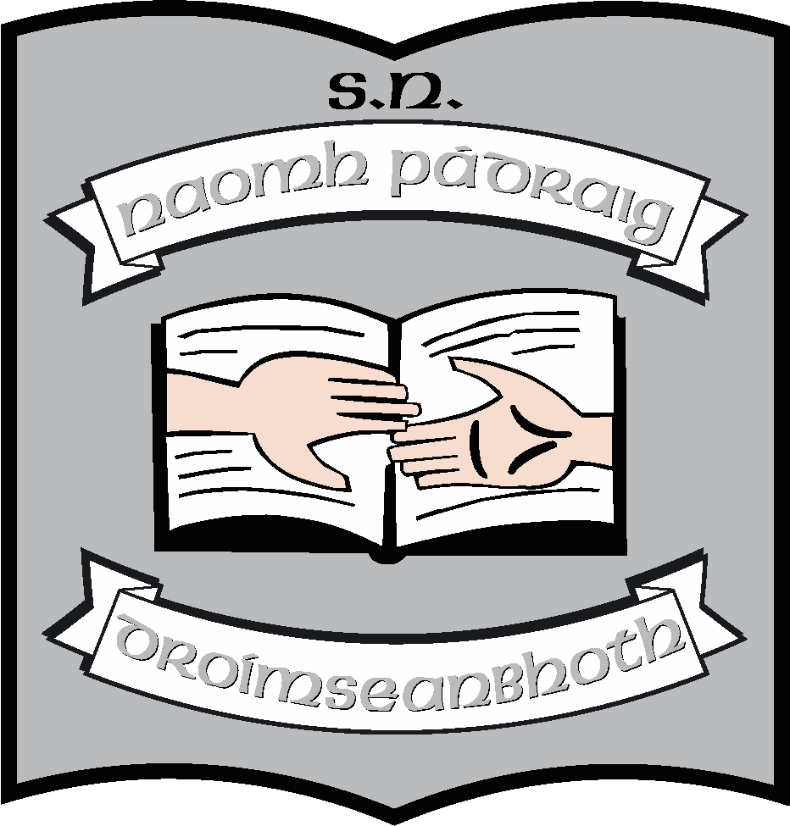 St. Patrick’s NS;
Whole School Aims

It is the aim of all members of staff, as far as possible, to strive to achieve the following aims:

- To provide a broad-based, integrated curriculum in order to facilitate the acquisition of knowledge and to promote enjoyment in learning.

- To provide knowledge and skills to equip all pupils for further study and work.

- To encourage all pupils to reach their true potential.

- To develop in the pupils a sense of moral values and good healthy relationships with others.

- To develop in the pupils a strong sense of belief in themselves and others

- To foster close relationships between the school, the pupils, the pupils’ family and the local community and to develop a sense of community.

- To promote health and wellbeing.

- Spéis agus suim a chothú sa chultúr – teanga, spórt, ceol,stair msl.

