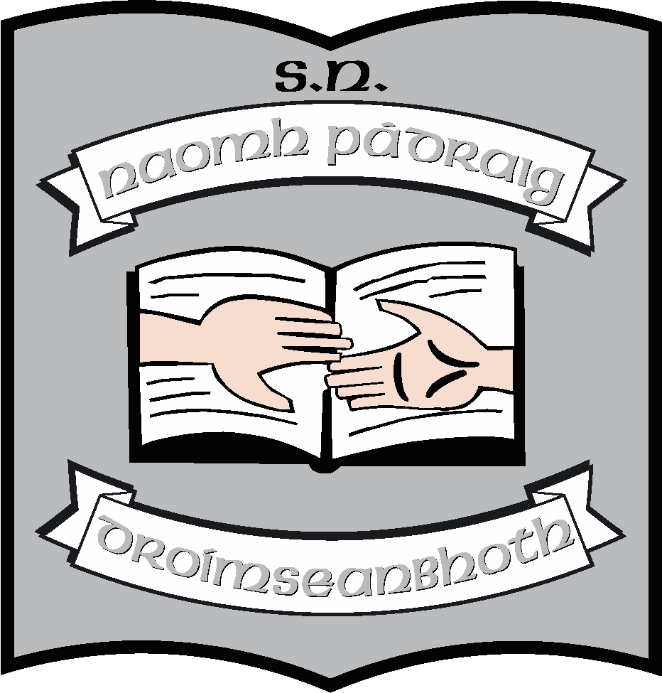First Class Book List 2023 -2024

Books/Stationery: (School will provide all items listed below).
English | Over the Moon:  Reader 1 – Adventures of an Astronaut  Reader 2 – Fun at the Circus  Better English Literacy Skills 1st Class  English in Practice 1  Master Your Grammar 1 (CJ Fallon)
Maths | Busy at Maths 1  Busy at Maths Shadow Book 1  Busy at Maths Individual Pupil Profile  New Wave Mental Maths 1 (Revised Edition)
Irish | Abair Liom 2nd edition (Digital Version)
SESE | Folens Explorers 1st Class (Digital Version)
Music | Into Music (Digital version) (Folens)
Stationery | Project Copy 15A 40pg x 2  Exercise Copy No.11 x 2  Learn to write handwriting copy B2 40 pg x 1  Hardback Notebook A6 x 1  A4 Plastic Zipped Folder x 2  A4 scrapbook 48pg x 10  Ruler (30cm)  Triangular Grip Pencil  Rubber  Red Pens (2)  Pritt Stick

Other requisites – (Parent(s)/Guardian(s) must pay for items listed below).
Art Materials | €18
Homework Diary | €2
Photocopying | €18
Standardised Testing | €2
Seesaw (Learning Platform) | €10
Total | €50

