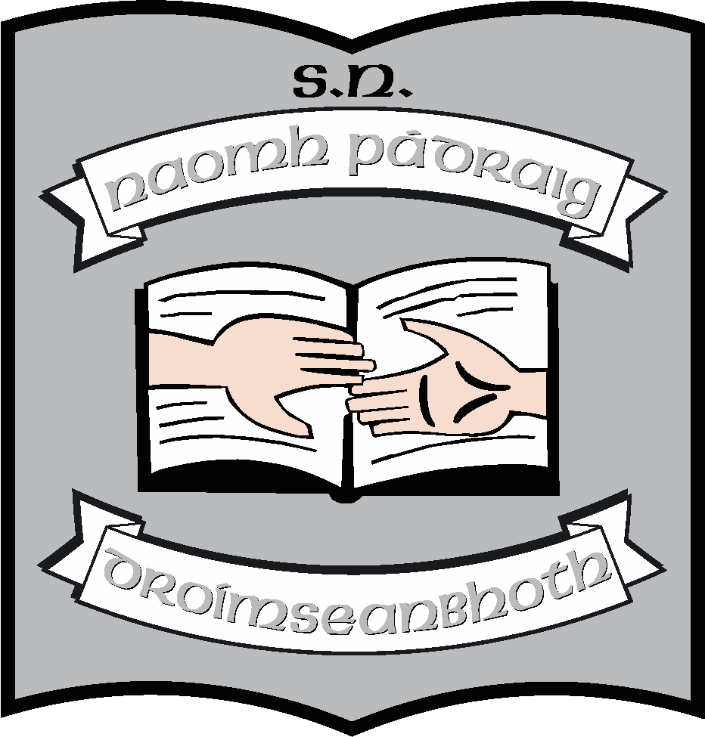Second Class Book List 2023 – 2024

Books/Stationery: (School will provide all items listed below).
English | The Wild Explorers 2nd class Reader  (Over the Moon Series(Gills)- Skills Book 2nd class  English in Practice 2nd Class  Master your Grammar 2nd Class  Away With Words 2
Maths | Mental Maths 2 (Revised Edition)  Busy at Maths 2  Busy at Maths Shadow Book 2  Tables Champion 2nd Class  Busy at Maths Individual Pupil Profile (Assessment Tests)
Irish | Abair Liom 2, 2nd edition (Digital Version)  Bréagáin  Féasta
SESE | Let’s Discover (CJ Fallons)
Religion | Grow in Love 4 (2nd Class)
S.P.H.E. | Weaving Well-being 2nd class
Music | Into Music (Digital version) (Folens)
Handwriting (Cursive) | “Mrs. Murphy’s – Cursive handwriting notebooks 1 & 2
Stationery | 4 x 120-page Maths copy  3 x 88-page lined copies  3 x 15A Project copies  1 A6 Notebook (Hardback)  1 B2 Handwriting Copy (40 pages)  1 x Ormond Spelling Book  3 x A4 Cardboard Folders  1 x A4 Plastic Zipped Folder  1 x A3 Plastic Zipped Folder  1 Drawing copy (blank)  1 hardback A5 notebook (lined)  Small Scissors  Pritt Stick

Other requisites – (Parent(s)/Guardian(s) must pay for all items listed below).
Art Materials | €18
Homework Diary | €2
Photocopying | €18
Standardised Testing | €2
Seesaw (Learning Platform) | €10
Total | €50

Pupils should also have:
- Red pen, pencils, rubber, sharpener, long ruler, highlighter, whiteboard marker

