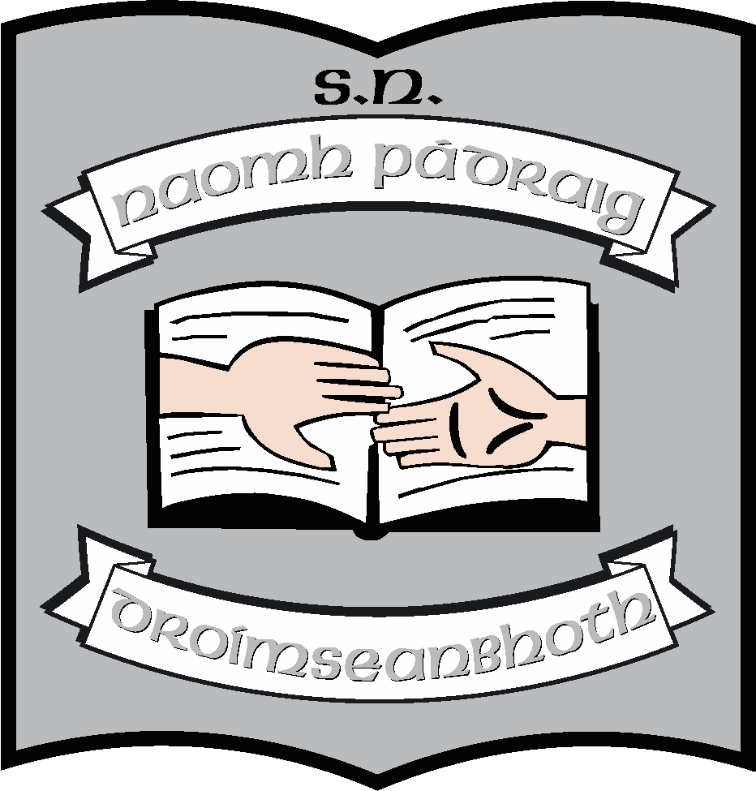 Third Class Book List 2023 – 2024

Books/Stationery: (School will provide all items listed below).
English | Ready to Go! – (Anthology and Portfolio ) (CJ Fallon)  New Wave English in Practice 3  Spell it! Folens  Newsflash
Maths | New Wave Mental Maths 3(revised)  Busy at Maths 3  Busy at Maths Shadow Book 3  Busy at Maths Individual Pupil Profile Term Assessment 3rd class
Irish | Abair Liom E (3rd Class) (New edition) (Folens)  Réaltaí  Spréacha
SPHE | Weaving Well-Being 3rd Class
Religion | Grow in Love 5
Music | Into Music (Digital version) (Folens)
Stationery | 3 120-page maths copies  8 120-page writing copies  1 40-page Ormond learn to write  1A4 memorandum copies  1 100-page notebook  1 A3 document wallet with zip (plastic)  1 A4 document wallet with zip (plastic)  1 A4 cardboard folder  Small scissiors  Pritt Stick

Other requisites: (Parent(s)/Guardian(s) must pay for items listed below).
Art Materials | €20
Homework Diary | €2
Primary Planet | €3
Photocopying | €20
Standardised Testing | €5
Total | €50
Pupils should also have:
- Irish & English dictionaries – (we recommend Collins). Not the small dictionaries – next size up.
- Atlas – (we recommend Folens version)
- Blue, black & red pens, pencils, rubber, sharpener, long ruler, highlighters & colouring pencils/twistables

