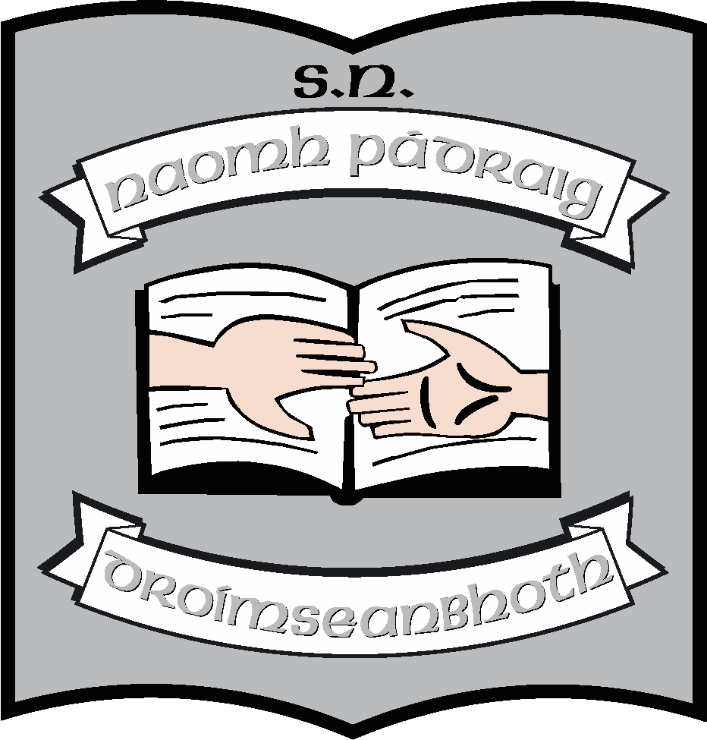Fourth Class Book List 2023 - 2024

Books/Stationery: (School will provide all items listed below).
English | Lift Off! (Anthology & Portfolio Book) (CJ Fallon)  New Wave English in Practice 4th Class  Spell it! Folens  Newsflash
Maths | Busy at Maths 4  Busy at Maths 4 Shadow Book  Busy at Maths Pupil Profile Assessment  New Wave Mental Maths – 4th class(revised edition)
Irish | Abair Liom (new edition) (Folens)  Seoda  Lasracha
SESE | Let’s Go: (CJ Fallon); History, Geography and Science
Religion | Grow in Love – Fourth Class
S.P.H.E. | Weaving Well-Being 4th Class
Music | Into Music (Digital version) (Folens)
Stationery | 2 120 - page Maths copies (C3)  1 88 – page Maths copy  4 120 - page lined copies (No. 11)  4 88 - page lined copies  1 blank 40 page drawing copy  1 nature study copy  1 100pg notebook  1 cardboard document folder A4  2 document zipped wallet (plastic) A4  Small scissors  Pritt Stick

Other requisites: (Parent(s)/Guardian(s) must pay for items listed below).
Art Materials | €20
Homework Diary | €3
Primary Planet | €2
Photocopying | €20
Standardised Testing | €5
Total | €50

Pupils should also have:
- Irish/English dictionary – (we would recommend Collins dictionaries)
- Atlas
- Blue, black, red pens, pencils, rubber, sharpener, ruler and colours

