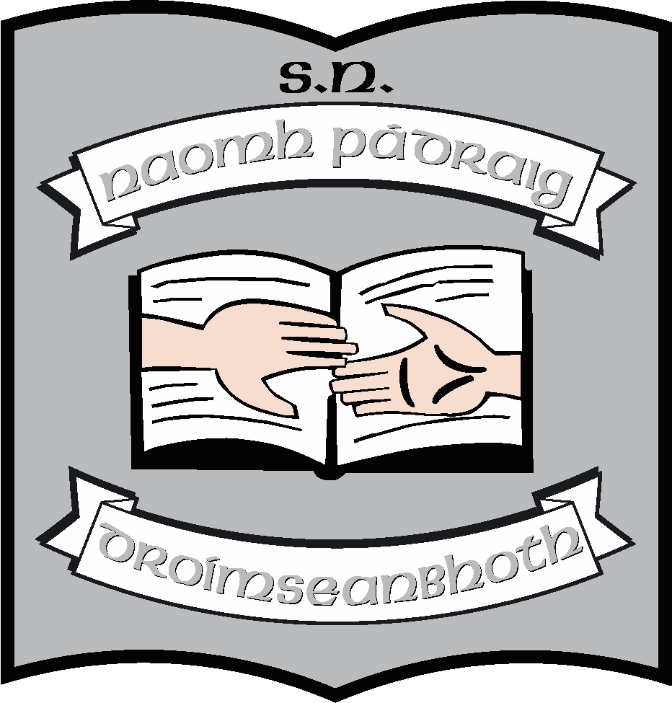Sixth Class Book List 2023 - 2024

Books/Stationery: (School will provide all items listed below).
English | Flying High (CJ Fallon)  My Read at Home 6  New Wave English in Practice 6th Class  Spell it! Folens  The Primary Planet
Phonics/Grammar | Portfolio Book (accompany Flying High)
Maths | Busy at Maths 6  Busy at Maths Shadow Book 6  New Wave Mental Maths for 6th Class  (Revised Edition)
Irish | Abair Liom (Digital version) (Folens)  Gleannta  Tonnta
SESE | Let’s Go, (CJ Fallon); History, Geography and Science
Religion | Grow In Love 8 Pupil Book for 6th Class
Music | Into Music (Digital version) (Folens
Weaving Well-Being 6th Class  “Empowering Beliefs” | Weaving Well-Being  Empowering Beliefs – Pupil Book
Stationery | 2 x 120-page maths copies  1 x 88 pages maths copy  4 x 120-page lined copies  3 x 88 pages lined copies  1 x 100 pages spelling notebook  1 A3 Scrap Book (for Art)  1 A4 document wallet  1 A4 folder with plastic sleeves  Scissors  Pritt Stick

Other requisites: (Parent(s)/Guardian must pay for items listed below).
Art Materials | €20
Homework Diary | €2
The Primary Planet | €3
Photocopying | €20
Standardised Testing | €5
Total | €50

Pupils should also have:
- English and Irish Dictionaries (we recommend Collins).
- Blue, black, red pens, pencils rubber, sharpener, ruler
- A mathematical set
- An Atlas
- Black Sharpie marker/permanent black marker
- Colouring pencils

