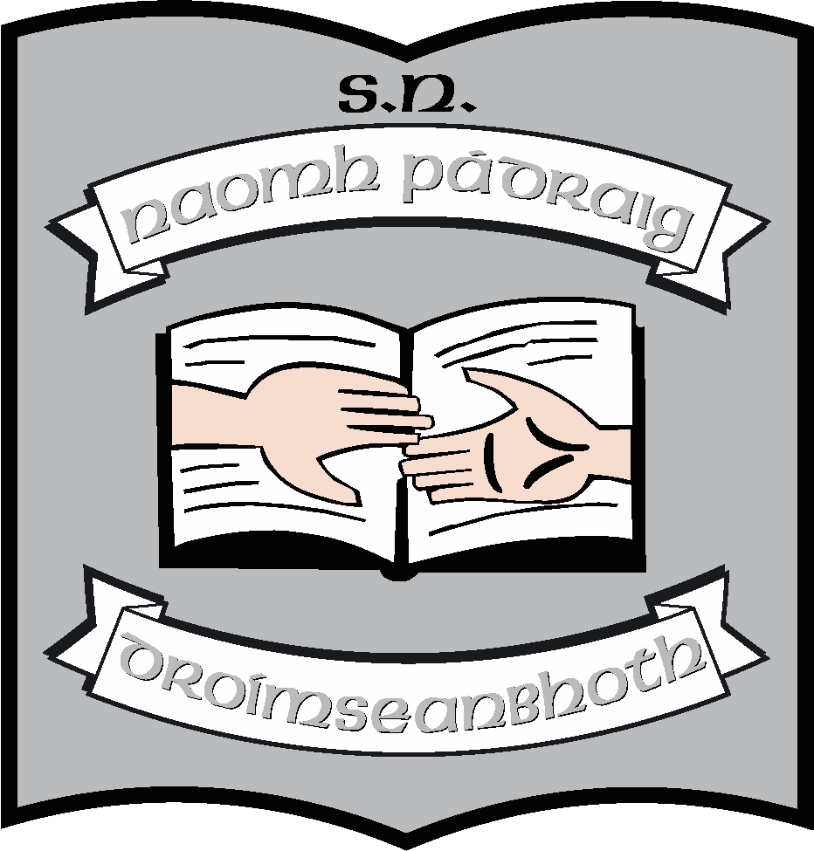

Annual Report of the Board of Management of St. Patrick’s NS
2022 - 2023
The Board of Management of St. Patrick’s NS consists of
- Martin McGowan (Chairperson & Bishop’s Representative)
- Fr. Frankie Murray (Bishop’s Representative)
- Aisling Fee (Parents’ Representative & Treasurer)
- Pascal Gillard (Parents’ Representative & Safety Officer)
- Stella Kehoe (Community Representative)
- Enda McGloin (Community representative)
- Louise Brennan (Teachers’ Representative & Recording Secretary) *
- Ruth McLoughlin (Teachers’ Representative & Secretary)

Meetings
During this school year, the board had scheduled termly meetings in September, November, February, May and June.
Policy
The following policies were reviewed during this school year.
September
- Child Protection Policy
- Child Protection Statement
- Anti-Bullying Policy
- Data Protection
February
- Admissions Policy
- Admissions Policy ASD Class
- AUP
- Bus Escort Protocol
- Communication Policy
- Critical Incident Policy
- Extra Personal Vacation
- Intimate Care Policy
- Remote Learning Policy
- School Owned Assisted Technology Policy
- Special Educational Needs (SEN) Policy
- Statement for Autism Class Parents
- Statement for Autism Class Staff

June
- Admissions Policy Autism Class
- SESE History Policy
- Assessment Policy
- Attendance Policy
- Geography Policy
- Information for Substitute Teachers/SNAs
- Parental Involvement Policy
- SESE: Science Policy
- Transition to Secondary School Policy
- Maths Policy

The topic for School Self-Evaluation was homework and we are entering year three with this. Surveys have been completed by all stakeholders. Results have been analysed by the School Leadership Team and a new policy has been drafted. This will be ratified at the next meeting.
The second topic for School Self-Evaluation this year is Well-Being with particular emphasis on Autism Best Practice and inclusion. All stakeholders have been surveyed and a School Improvement Plan has been developed. This will be presented to the Board of Management at the next meeting.
In terms of curricular planning
- The school is working to start implementation of the New Primary Curriculum in the coming school year. We have introduced a new Social Environmental Science Education scheme from CJ Fallon’s to all classes and we have updated our Irish Scheme to a new edition. We have introduced a new spelling scheme from 1st class to 6th class also.

Maintenance
- The new building has been completed with still some items on the snag list to be resolved.
- The whole interior of the school has been painted.
- We have a consultant’s report ready for submission when the next Summer Works Scheme opens up but have already made an application to Emergency Works regarding the state of the roof. SWS did not open for this summer.
- We have ordered new noticeboards, built in shelves and shelved other rooms to accommodate the move of SETs and the establishment of two new mainstream classes.
- Tarmac for the Junior yard has been priced and will be ordered.
- Abbots staff are coming to work voluntarily on July 22nd and have donated €5,000 to purchase outdoor equipment for children.
- Surveillance Cameras will be installed outside for the yard areas, the lobby and the office.
Resources
- The board has continued to invest in new laptops for all teachers. The old laptops were wiped, reconditioned and new software installed to be used by pupils. We now have a trolley with 30 laptops for pupils. We ordered four new interactive whiteboards for the two new mainstream classes, one for SET and one to replace the first class board which is no longer working.
- A new Irish, History, Geography, Science and Spelling schemes have been introduced for the following school year.

Other
The school was in receipt of additional SET and EAL hours which were used to help all children.
We would like to thank Allen Gaels for providing Luke Fee for coaching GAA football to all pupils since February. All children improved and benefitted from this.
We currently have 11 Ukrainian pupils enrolled in the school. Additional EAL hours were allocated to support these pupils. We should have 21 non English speaking children next year which should entitle us to a fixed-term teaching post.
The school used the Droichead process for the second time and Doireann McManus was successfully probated.
BLAST funding enabled us to employ local artist Colette Langan. She helped the pupils in 6th class create a map of Drumshanbo in a stain-glass window. This beautiful piece of art is displayed in the lobby area.
We wish to acknowledge the new Philip Fee Memorial Perpetual Trophy provided by the Fee family for our football leagues. We thank them most sincerely for replacing the trophy which Philip donated over 30 years ago. Thank you.
The Parents’ Association continued to support the school by fund-raising and providing support for school events and resources. This year they provided additional funding to pay for gymnastics, tennis, funding to enable us to attend the Christmas panto in Dublin and swimming for 2nd and 4th. They also funded celebrations in 2nd class, related to First Communion and in 6th Class related to end of year. Our outgoing PA are Ray McNamara, Sharon Casey, Jacyntha Smith, Caroline McCabe, Brendan Barry and Jim Scollan. Paul Martin and Siobhain McGowan have agreed to remain on the new committee. Our new committee comprises of Kevin Blessing, Damian Guckian, Ríona Daly, Ciara Flynn, Edel Spark and Thomas Scollan.
We wish to thank all our staff for their hard work and enthusiasm. They continue to maintain a very high standard of teaching and learning. Their dedication to the children in our care is outstanding.
We also wish to acknowledge our Board of Management who oversee every aspect of school life. We thank them for their commitment and time.
Finally, a huge thank you to all our pupils and parents without who are the heart and soul of our school. Your support is so appreciated and valued.
June 2023

