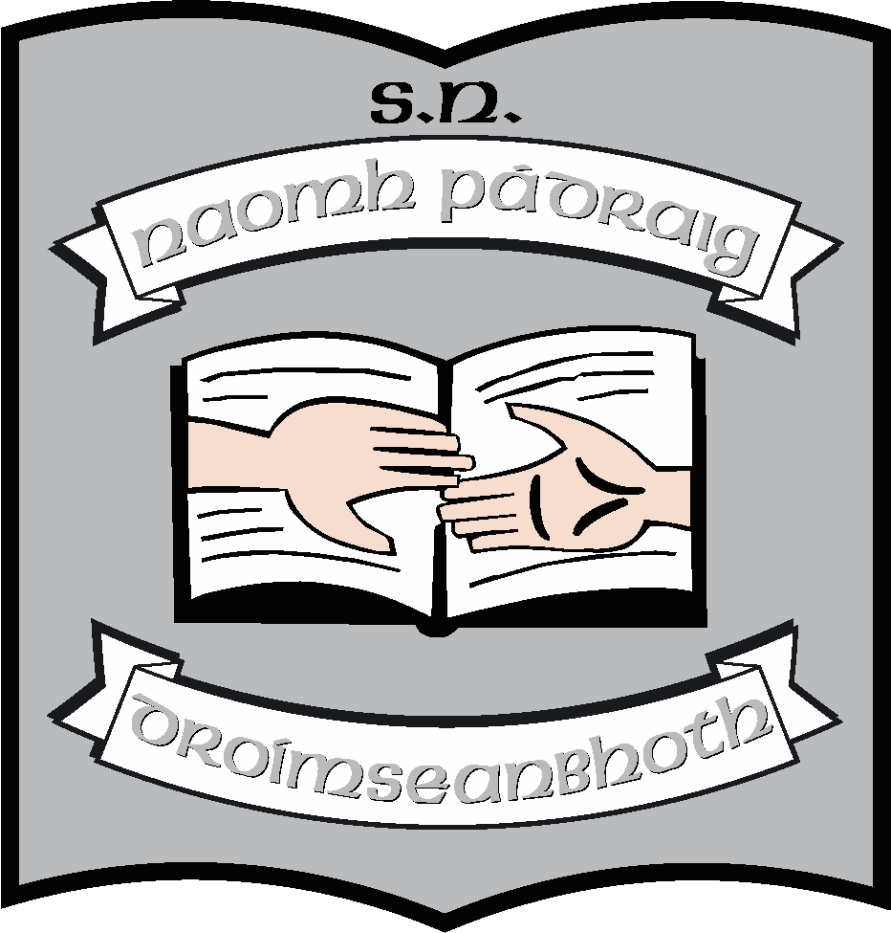Junior Infant Book List 2023 – 2024

Books/Stationey: (School will provide all items listed below).
English | Over the Moon Skills Book (Gill Education)  9 Fiction Reader Pack (Gill Education)  Mrs. Murphy’s Junior Infant Copies (Edco)  (3 copies in one pack)
Maths | Busy at Maths (Junior Infants) (CJFallon)  Junior Infants Home/School Links (CJFallon)
Irish | Abair Liom A (Second Edition) (Folens)
SESE | Explorers; Folens; Junior Infants  (Digital version)
Music | Into Music (Digital version) (Folens)
Stationery | A4 zipped plastic homework folder  1 A4 paper folder (ART)  3 Square Cut Folders  3 Ormond project copies (40 pages, size 15)  2 Drawing Copies (Blank)  1 x A4 Hardback 120 pages  1 A4 Scrap Book  2 triangular grip pencils  2 rubbers  Playdoh  Pritt Stick

Other requisites – (Parent(s)s/Guardian(s) must pay for items listed below)
Art Materials | €20
SEESAW (Learning Platform) | €10
Photocopying | €20
Total | €50

