St. Patrick’s National School. Roll No. 19423J

Drumshanbo, Co. Leitrim
Tel: 071 96 41755
Email: stpatricksnsdrumshanbo@gmail.com
Website: stpatricksnsdrumshanbo.ie
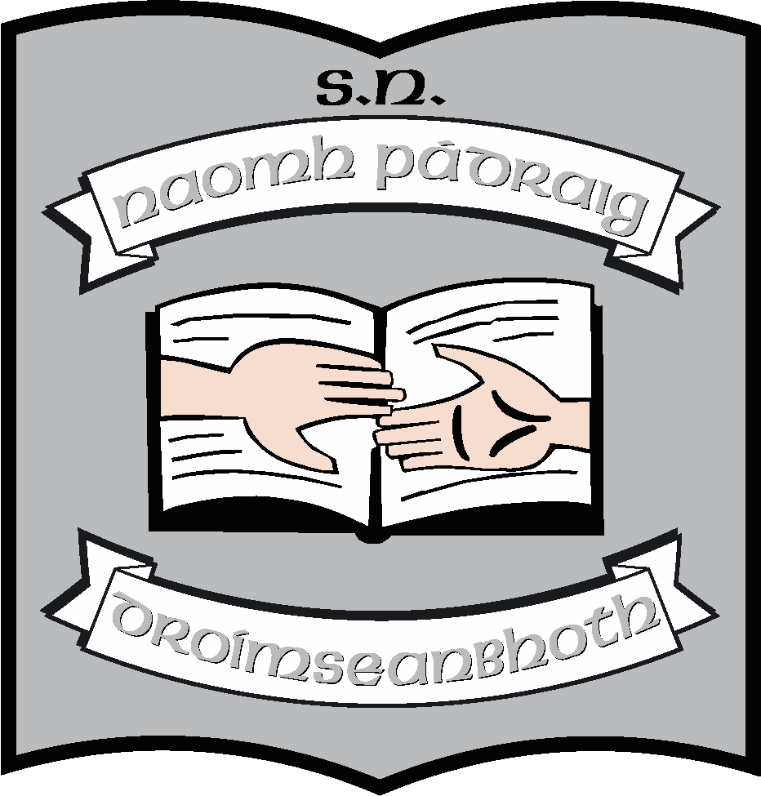
12th June, 2023.
Dear Parent(s)/Guardian(s),
Book lists for 2023 – 2024 are going up onto the school website today. We can send a hard copy home if you wish, just email the school. We will continue to operate a book rental scheme as we have done for years but can offer you a better price this year because the Dept. of Education have introduced “free schoolbooks” for all children in primary schools. They have given us a grant to purchase books and copybooks. If you look at the booklist for your child, we have tried to include everything they will need. All schoolbooks remain the property of the school and are on loan to pupils. Pupils will retain books for one school year and return to the school, in good condition, at the end of the year.
There are items on the booklists, under the heading “other requisites” which we are not covered under the scheme and for which we must seek payment. These include photocopying, art & craft, standardised tests and homework notebooks. (Photocopying paper has doubled in price this year, our learning platform “Seesaw”, used in the junior end of the school has just notified us of a considerable price increase).
Taking all this into account, we have reduced the cost of the book rental scheme this year from €80 to €50 per child.
We can take cash payments, but, for reasons of security, we would prefer that you make all payments electronically.
When you pay electronically you will need to
- Log in to your online banking.
- Set the school up as a payee using the ADD PAYEE option in the menu. (It will be a SEPA payee).
- The PAYEE NAME is St. Patrick’s NS.
- You will need the school IBAN and BIC codes:
- IBAN: IE90 BOFI 9053 8730 4877 88
- BIC: BOFIIE2D
- Please put your child’s name in as a reference so that it will appear on our records and we will know who has made the payment – there is a REFERENCE box in the on screen form
There is a book form on the back of this letter, we would be grateful if you could return it to us when you are making payment. It might be a good idea to email the school too and put Payment and your family name in the subject line of the email.
Thank you, as always, for your help and support.
______________
Ruth McLoughlin

