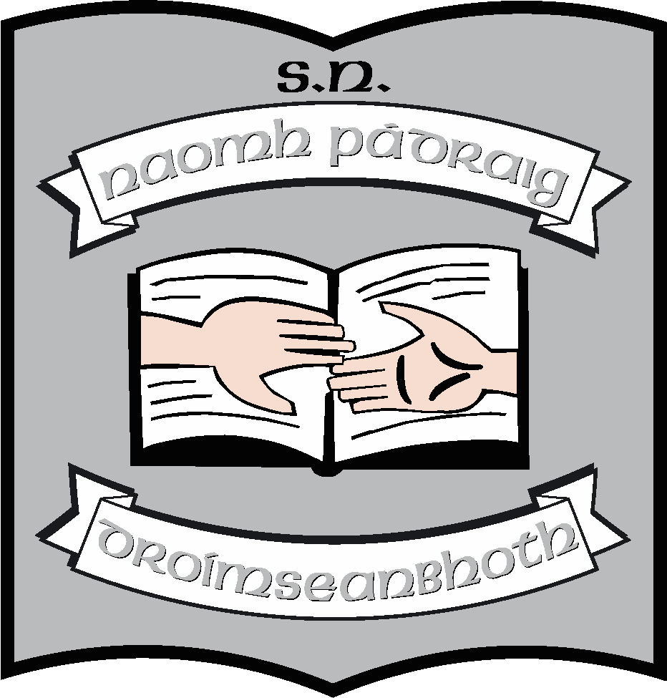St. Patrick’s N.S.
Drumshanbo,
Co. Leitrim.

Roll No: 19423J

Anti-bullying Policy

Reviewed: August 2023
Ratified: 26th September 2023
Full review: 2028

St. Patrick’s National School

Anti-bullying Policy 2023

Introductory Statement
In accordance with the requirements of the Education (Welfare) Act 2000 and the Code of Behaviour guidelines issued by the National Education Welfare Board (NEWB), the Board of Management of St. Patrick’s N.S. has adopted the following anti-bullying policy within the framework of the school’s overall code of behaviour. This policy fully complies with the requirements of the Anti-Bullying Procedures for Primary and Post-Primary Schools which were published in September 2013.
These procedures recognize that a cornerstone in the prevention of bullying is a positive school culture and climate that is welcoming of difference and diversity and is based on inclusivity and respect (DES Procedures 2013.4)
Rationale:
This policy was drawn up in order to comply with the new Anti-Bullying Procedures as outlined by the Minister for Education in Circular 45/13.
Relationship to Characteristic Spirit of the School
We aim to provide each child with an education, in a carefree and happy environment where difference is tolerated as per our Mission Statement.
Aims:
- To raise awareness of bullying as a form of unacceptable behaviour with school management, teachers, pupils, parents/guardians
- To create a school ethos which encourages children to disclose and discuss incidents of bullying behaviour.
- To ensure comprehensive supervision and monitoring measures through which all areas of school activity are kept under observation.
- To develop procedures for noting, investigating and dealing with incidents of bullying behaviour.
- To implement a programme of support for those affected by bullying behaviour and for those involved in bullying behaviour.
- To work with appropriate agencies in countering all forms of bullying and anti-bullying behaviour.

- The Board of Management recognises the very serious nature of bullying and the negative impact that it can have on the lives of pupils and is therefore fully committed to the following key principles of best practice in preventing and tackling bullying behaviour:
- A positive school culture and climate which-
  - is welcoming of difference and diversity and is based on inclusivity;
  - encourages pupils to disclose and discuss incidents of bullying behaviour in a non-threatening environment; and
  - promotes respectful relationships across the school community;
- Effective leadership;
- A school-wide approach;
- A shared understanding of what bullying is and its impact
- Implementation of education and prevention strategies (including awareness raising measures) that build empathy, respect and resilience in pupils; and explicitly address the issues of cyber-bullying and identity-based bullying including in particular, homophobic and transphobic bullying.
- Effective supervision and monitoring of pupils;
- Supports for staff;
- Consistent recording, investigation and follow up of bullying behaviour (including use of established intervention strategies); and
- On-going evaluation of the effectiveness of the anti-bullying policy.

- In accordance with the Anti-Bullying Procedures for Primary and Post-Primary Schools bullying is defined as follows:
- Bullying is unwanted negative behaviour, verbal, psychological or physical conducted by an individual or group against another person (or persons) and which is repeated over time.
The following types of bullying behaviour are included in the definition of bullying:
- deliberate exclusion, malicious gossip and other forms of relational bullying,
- cyber-bullying and
- identity-based bullying such as homophobic bullying, racist bullying, bullying based on a person’s membership of the Traveller community and bullying of those with disabilities or special educational needs.

Isolated or once-off incidents of intentional negative behaviour, including a once-off offensive or hurtful text message or other private messaging, do not fall within the definition of bullying and should be dealt with, as appropriate, in accordance with the school’s code of behaviour.
However, in the context of this policy, placing a once-off offensive or hurtful public message, image or statement on a social network site or other public forum where that message, image or statement can be viewed and/or repeated by other people will be regarded as bullying behaviour.
Negative behaviour that does not meet this definition of bullying will be dealt with in accordance with the school’s Code of Behaviour.
Additional information on different types of bullying is set out in Section 2 of the Anti-Bullying Procedures for Primary and Post-Primary Schools.

- The relevant teacher(s) for investigating and dealing with bullying is (are) as follows: (see Section 6.8 of the Anti-Bullying Procedures for Primary and Post-Primary Schools): -

- The individual class teacher in the first instance.
- The Principal and Deputy Principal will also be involved if needs be.
- Any teacher may act as relevant teacher if circumstances warrant it.
The B.O.M and staff of St. Patrick’s N.S. believe that the above staged approach to dealing with bullying works best.

Some examples of bullying behaviours
General behaviours which apply to all types of bullying | - Harassment based on any of the nine grounds in the equality legislation e.g. sexual harassment, homophobic bullying, racist bullying etc.  - Physical aggression  - Damage to property  - Name calling  - Slagging  - The production, display or circulation of written words, pictures or other materials aimed at intimidating another person  - Offensive graffiti  - Extortion  - Intimidation  - Insulting or offensive gestures  - The “look”  - Invasion of personal space  - A combination of any of the types listed.
Cyber | - Denigration: Spreading rumors, lies or gossip to hurt a person’s reputation  - Harassment: Continually sending vicious, mean or disturbing messages to an individual  - Impersonation: Posting offensive or aggressive messages under another person’s name  - Flaming: Using inflammatory or vulgar words to provoke an online fight  - Trickery: Fooling someone into sharing personal information which you then post online  - Outing: Posting or sharing confidential or compromising information or images  - Exclusion: Purposefully excluding someone from an online group  - Cyber stalking: Ongoing harassment and denigration that causes a person considerable fear for his/her safety  - Silent telephone/mobile phone call  - Abusive telephone/mobile phone calls  - Abusive text messages  - Abusive email  - Abusive communication on social networks e.g. Facebook/Ask.fm/ Twitter/You Tube/Snap chat/TikTok/ Instagram/WhatsApp/ or on games consoles  - Abusive website comments/Blogs/Pictures  - Abusive posts on any form of communication technology
Identity Based Behaviours
Including any of the nine discriminatory grounds mentioned in Equality Legislation (gender including transgender, civil status, family status, sexual orientation, religion, age, disability, race and membership of the Traveller community).

Homophobic and Transgender | - Spreading rumours about a person’s sexual orientation  - Taunting a person of a different sexual orientation  - Name calling e.g. Gay, queer, lesbian...used in a derogatory manner  - Physical intimidation or attacks  - Threats
Race, nationality, ethnic background and membership of the Traveller community | - Discrimination, prejudice, comments or insults about colour, nationality, culture, social class, religious beliefs, ethnic or traveller background  - Exclusion on the basis of any of the above
Relational | This involves manipulating relationships as a means of bullying. Behaviours include:  - Malicious gossip  - Isolation & exclusion  - Ignoring  - Excluding from the group  - Taking someone’s friends away  - “Bitching”  - Spreading rumours  - Breaking confidence  - Talking loud enough so that the victim can hear  - The “look”  - Use or terminology; such as ‘nerd’ in a derogatory way
Sexual | - Unwelcome or inappropriate sexual comments or touching  - Harassment
Special Educational Needs,  Disability | - Name calling  - Taunting others because of their disability or learning needs  - Taking advantage of some pupils’ vulnerabilities and limited capacity to recognise and defend themselves against bullying  - Taking advantage of some pupils’ vulnerabilities and limited capacity to understand social situations and social cues.  - Mimicking a person’s disability  - Setting others up for ridicule

- The education and prevention strategies (including strategies specifically aimed at cyber- bullying and identity-based bullying including in particular, homophobic and transphobic bullying) that will be used by the school are as follows (see Section 6.5 of the Anti-Bullying Procedures for Primary and Post-Primary Schools):

- Through a programme of positive action, the school promotes an atmosphere of friendship, respect and tolerance.
- The entire school community (pupils, parents, staff and BOM) have a shared understanding of what bullying behaviour is.
- The SPHE curriculum, including the Stay Safe programmes, are used throughout the school to support the anti-bullying policy.
- The Weaving Wellbeing programme introduced from 2nd to 6th is used annually in these classes.
- We have ‘buddy benches’ in both yards to encourage children to play with someone feeling left out.
- Sporting activities may be used as an opportunity for channeling and learning how to control aggression and other emotions.
- Peer tutoring programmes such as Buddy Reading, Chess and large outdoor games will be used to develop friendship between pupils in Junior and Senior Classes. In addition to giving older pupils a sense of responsibility it will also foster a culture of kindness in the school.
- Positive self-esteem is fostered among the pupils by celebrating individual differences/achievements, by acknowledging and rewarding good behaviour and by providing opportunities for success.
- Pupils are helped to develop empathy by discussing feelings and by trying to put themselves in the place of others.
- Teachers respond sensitively to pupils who disclose incidents of bullying.
- The school’s anti-bulling policy is discussed regularly with the pupils.
- Pupils are openly encouraged to talk to a teacher if they witness some bullying behaviour or if they are the victims of such behaviour,
- Parents are openly encouraged to phone in and let the principal know if they are concerned about such behaviour.
- Staff are particularly vigilant in monitoring pupils who are considered at risk of bullying/being bullied.
- All disclosed incidents of bullying are investigated.
- Members of the BOM are familiar with the school’s policy on bullying and actively promote it on a repeated basis among staff, parents and pupils.
- Parents contribute to and support the school’s policy on bullying by encouraging positive behaviour both at home and at school, by being vigilant for signs and symptoms that their child is being bullied or is bullying others, by communication concerns to the school.
- RSE Programme
- Walk Tall Programme
- Circle Time
- Assembly Time
- Grow in Love
- Weaving Wellbeing
- Social Skills Programme

- Procedures for investigating and dealing with bullying

The school’s procedures for investigation, follow-up and recording of bullying behaviour and the established intervention strategies used by the school for dealing with cases of bullying behaviour are as follows (see Section 6.8.9 of the Anti-Bullying Procedures for Primary and Post-Primary Schools).
- The primary aim for the relevant teacher in investigating and dealing with bullying is to resolve any issues and to restore, as far as is practicable, the relationships of the parties involved (rather than to apportion blame);
- In investigating and dealing with bullying, the teacher will exercise his/her professional judgement to determine whether bullying has occurred and how best the situation might be resolved;
- All reports, including anonymous reports of bullying will be investigated and dealt with by the relevant teacher. In that way pupils will gain confidence in ‘telling’. This confidence factor is of vital importance. It will be made clear to all pupils that when they report incidents of bullying they are not considered to be telling tales but are behaving responsibly;
- Non-teaching staff such as secretaries, special needs assistants (SNAs), bus escorts, caretakers, cleaners are encouraged to report any incidents of bullying behaviour witnessed by them, or mentioned to them, to the relevant teacher;
- Parents and pupils are required to co-operate with any investigation and assist the school in resolving any issues and restoring, as far as is practicable, the relationships of the parties involved as quickly as possible;
- It is very important that all involved (including each set of pupils and parents) understand the above approach from the outset;
- Teachers will take a calm, unemotional problem-solving approach when dealing with incidents of alleged bullying behaviour reported by pupils, staff or parents;
- Incidents are generally best investigated outside the classroom situation to ensure the privacy of all involved;
- All interviews will be conducted with sensitivity and with due regard to the rights of all pupils concerned. Pupils who are not directly involved can also provide very useful information in this way.
- When analysing incidents of bullying behaviour, the relevant teacher will seek answers to questions of what, where, when, who and why. This will be done in a calm manner, setting an example in dealing effectively with a conflict in a non-aggressive manner.
- If a group is involved, each member will be interviewed individually at first. Thereafter, all those involved will be met as a group. At the group meeting, each member will be asked for his/her account of what happened to ensure that everyone in the group is clear about each other’s statements;
- Each member of a group will be supported through the possible pressures that they may face them from the other members of the group after interview by the teacher;
- Those involved may be asked to write down their account of the incident(s);
- In cases where it has been determined by the relevant teacher that bullying behaviour has occurred, the parents of the parties involved will be contacted at an early stage to inform them of the matter and explain the actions being taken (by reference to the school policy). The school will give parents an opportunity of discussing ways in which they can reinforce or support the actions being taken by the school and the supports for their pupils;
- Where the relevant teacher has determined that a pupil has been engaged in bullying behaviour, it will be made clear to him/her how he/she is in breach of the school’s anti-bullying policy and efforts will be made to try to get him/her to see the situation from the perspective of the pupil being bullied, to be empathetic towards the other child;
- It will also be made clear to all involved (each set of pupils and parents) that in any situation where disciplinary sanctions are required, this is a private matter between the pupil being disciplined, his or her parents and the school;
- Follow-up meetings with the relevant parties involved should be arranged separately with a view to possibly bringing them together at a later date if the pupil who has been bullied is ready and agreeable. This can have a therapeutic effect;
- In cases where the relevant teacher considers that the bullying behaviour has not been adequately and appropriately addressed within 20 school days after he/she has determined that bullying behaviour has occurred, it must be recorded by the relevant teacher in the recording template at Appendix 3(See Section 6.8.10 (iii). The relevant teacher will record the facts and statements from those involved.
- In determining whether a bullying case has been adequately and appropriately addressed the relevant teacher will, as part of his/her professional judgement, take the following factors into account:
  - Whether the bullying behaviour has ceased;
  - Whether any issues between the parties have been resolved as far as is practicable;
  - Whether the relationships between the parties have been restored as far as is practicable; and
  - Any feedback received from the parties involved, their parents or the school should be discussed with the Principal or Deputy Principal.
- Where a parent is not satisfied that the school has dealt with a bullying case in accordance with these procedures, the parents will be referred, as appropriate to the school’s complaints’ procedures;
- In the event that a parent has exhausted the school’s complaints’ procedures and is still not satisfied, the school will advise parents of their right to make a complaint to the Ombudsman for Children, having first determined what part of the procedures were not followed.

- Procedures for recording bullying behaviour

The Board of Management will ensure that the school has clear procedures for the formal noting and reporting of bullying behaviour and these will be documented in the school’s anti-bullying policy. All records will be maintained in accordance with relevant data protection legislation. The school’s procedures for noting and reporting bullying behaviour will adhere to the following:

- While all reports, including anonymous reports of bullying will be investigated and dealt with by the relevant teacher, the relevant teacher will use his/her professional judgement in relation to the records to be kept of these reports, the actions taken and any discussions with those involved regarding same;

- If it is established by the relevant teacher that bullying has occurred, the relevant teacher will keep appropriate written records which will assist his/her efforts to resolve the issues and restore, as far as is practicable, the relationships of the parties involved.

- The relevant teacher will use the recording template at Appendix 3 to record the bullying behaviour in the following circumstances:
- in cases where he/she considers that the bullying behaviour has not been adequately and appropriately addressed within 20 school days after he/she has determined that bullying behaviour occurred; and
- where the school has decided as part of its anti-bullying policy that in certain circumstances bullying behaviour will be recorded and reported immediately to the Principal or Deputy Principal as applicable

In each of the circumstances at (a) and (b) above, the recording template at Appendix 3 will be completed in full and retained by the teacher in question and a copy provided to the Principal or Deputy Principal as applicable. It should also be noted that the timeline for recording bullying behaviour in the recording template at Appendix 3 does not in any way preclude the relevant teacher from consulting the Principal or Deputy Principal at an earlier stage in relation to a case.

- Intervention Strategies
In St. Patrick’s N.S. teachers will use one or a combination of the following intervention strategies when dealing with incidents of bullying behaviour:
• The Traditional Disciplinary Approach
• Strengthening the Victim
• Mediation
• Restorative practice
• The Support Group Method and
• The Method of Shared Concern.

The teachers are fully aware that no one intervention will work in all situations and all teachers have a copy of the PDST Anti-Bullying Support Material booklet which outlines the above strategies in detail.

- Supports for pupils affected by bullying

Staff will facilitate a programme of support for pupils who have been bullied. Such pupils may need counselling and/or opportunities to participate in activities designed to raise their self-esteem, to develop their friendship and social skills and thereby build resilience whenever this is needed.

A programme of support for those pupils involved in bullying behaviour will also be part of the school’s intervention process. Pupils involved in bullying behaviour need assistance on an ongoing basis. For those with low self-esteem, opportunities should be developed to increase feelings of self-worth. It is, therefore, important that the learning strategies applied within the school allow for the enhancement of the pupil’s self-worth. Pupils who engage in bullying behaviour may need counselling to help them learn other ways of meeting their needs without violating the rights of others.

Pupils who observe incidents of bullying behaviour will be encouraged to discuss them with teachers.

Details of the school’s programme for working with pupils affected by bullying will include the following:

- Speechmark Programme (Helping Children Series)
- Social Skills Programme (Speechmark)
- Being the best person I can possibly be
- Walk Talk Programme
- Stay Safe Programme
- Recommending other Programmes eg. Rainbows
- Liaising with SESS, PDST, NEWB, NEPS, HSE

- Supervision and Monitoring of Pupils

The Board of Management confirms that appropriate supervision and monitoring policies and practices are in place to both prevent and deal with bullying behaviour and to facilitate early intervention where possible.

- Prevention of Harassment

The Board of Management confirms that the school will, in accordance with its obligations under equality legislation, take all such steps that are reasonably practicable to prevent the sexual harassment of pupils, or staff, or the harassment of pupils, or staff, on any of the nine grounds specified i.e. gender including transgender, civil status, family status, sexual orientation, religion, age, disability, race and membership of the Traveller community.
The school also has a Grievance Procedure in place for staff and a Complaints Procedure in place for parents.
- Publication and communication of policy
This policy has been made available to the wider school community and to school personnel through the school web-site. It is readily accessible to parents and pupils in hard copy form (on request) and to the Parents’ Association. A copy of this policy will be made available to the Department and the patron if requested.
- Review
The Anti-Bullying policy will be monitored and reviewed by the Board of Management on an annual basis in line with the DES procedures. It will be presented to the Board at the first meeting of each school year.

***************************************************************************

Ratification of policy for St. Patrick’s NS

Martin McGowan 26/09/2023
Chairperson Date

Ruth McLoughlin 26/09/2023
Principal Date

Attachments to this Policy:
Appendix 1: Practical tips for building a positive school culture.
Appendix 3: See recording template at Appendix 3 (See Section 6.8.10 (iii) ) of the Anti-Bullying Procedures for Primary and Post Primary Schools published in September 2013.

Appendix 1. Practical tips for building a positive school culture.
The following are some practical tips for immediate actions that can be taken to help build a positive school culture and climate and to help prevent and tackle bullying behaviour.
• Model respectful behaviour to all members of the school community at all times
• Explicitly teach pupils what respectful language and respectful behaviour looks like, acts like, sounds like and feels like in class and around the school
• Display key respect messages in classrooms, in assembly areas and around the school. Involve pupils in the development of these messages
• Catch them being good - notice and acknowledge desired respectful behaviour by providing positive attention
• Consistently tackle the use of discriminatory and derogatory language in the school – this includes homophobic and racist language and language that is belittling of pupils with a disability or SEN
• Give constructive feedback to pupils when respectful behaviour and respectful language are absent
• Have a system of encouragement and rewards to promote desired behaviour and compliance with the school rules and routines
• Explicitly teach pupils about the appropriate use of social media
• Positively encourage pupils to comply with the school rules on mobile phone and internet use • Follow-up and follow through with pupils who ignore the rules
• Actively involve parents and/or the Parents’ Association in awareness raising campaigns around social media
• Actively promote the right of every member of the school community to be safe and secure in school
• Highlight and explicitly teach school rules in pupil friendly language in the classroom and in common areas
• All staff can actively watch out for signs of bullying behaviour
• Ensure there is adequate playground/school yard/outdoor supervision
• School staff can get pupils to help them to identify bullying ‘hot spots’ and ‘hot times’ for bullying in the school

