|  |
| --- |
| **St. Patrick’s National School.**  **Roll No. 19423J**    **Drumshanbo Co. Leitrim**  **Tel: 071 96 41755**  **stpatricksnsdrumshanbo@gmail.com** |

Dear Parents/ Guardians,

I am writing to let you know that

engaged in the following behaviour on a number of occasions in recent days:

1. Deliberately hurting/ causing injury to another pupil
2. Using inappropriate language
3. Continually disrupting class
4. Spoiling playtime for the other pupils
5. Continually disrupting the learning experience of the other pupils
6. Disrespectful behaviour to a member of the school community
7. Regularly failing to complete homework
8. Other

|  |
| --- |
| Comments |

Please talk to your child and remind them of the importance of following school rules.

Signed:

Date:

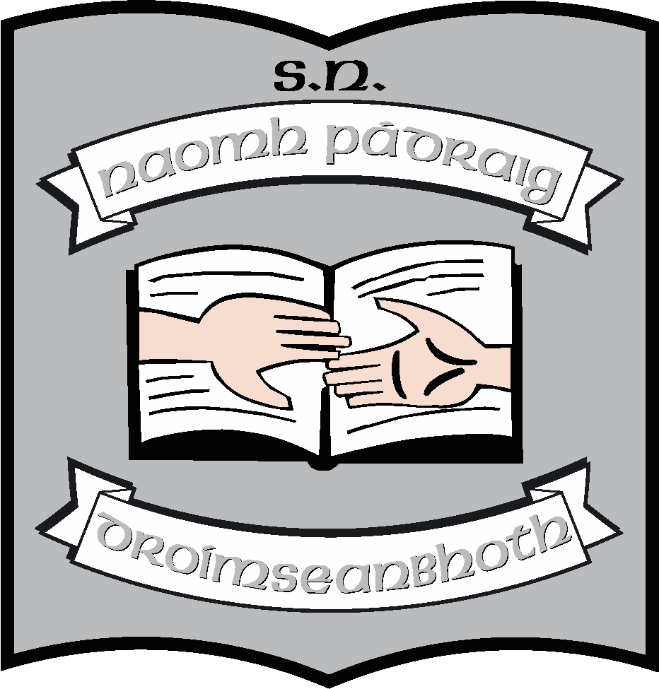**St. Patrick’s National School.**

**Roll No. 19423J**

|  |
| --- |
| I have spoken to  ________________________________________________________________  about his/her behaviour. He/She promises to follow the school rules in future.  Signed:  Date: |