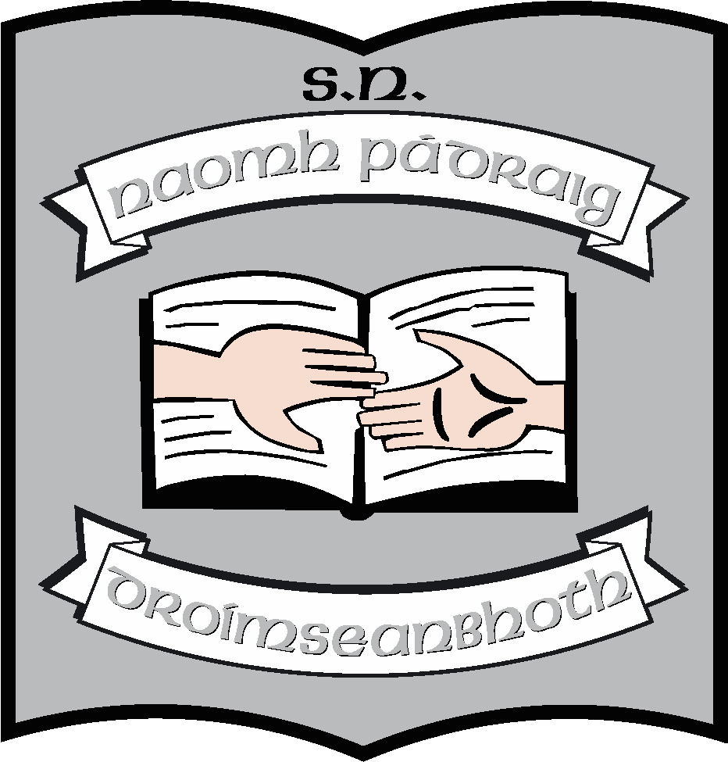St. Patrick’s N.S.
Drumshanbo,
Co. Leitrim.

Roll No: 19423J

Notification regarding the BOM’s review of the Child Safeguarding Statement 2023

Reviewed: October 2023
Ratified: 18th October 2023
Full review: 2027

St. Patrick’s National School

Notification Regarding BOM Review of Child Safeguarding Statement
2023 - 2024

To: Bishop Paul Connell Patron of Ardagh and Clonmacnoise

The Board of Management of St. Patrick’s National School wishes to inform you that:

• The Board of Management’s annual review of the school’s Child Safeguarding Statement was completed at the Board meeting of 18th October 2023.

• This review was conducted in accordance with the “Checklist for Review of the Child Safeguarding Statement” published on the gov.ie website

Signed: Martin McGowan Date: 18th October 2023

Chairperson, Board of Management

Signed: Ruth McLoughlin Date: 18th October 2023

Principal/Secretary to the Board of Management

