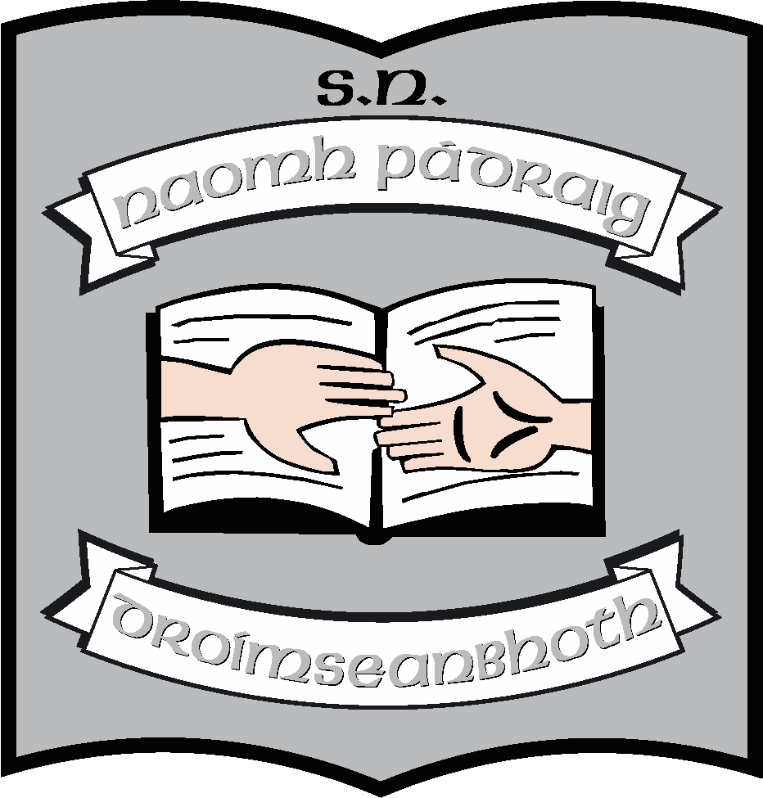 St. Patrick’s NS;
Admission Notice
(in respect to Admission for 2024 – 2025)

Admission Policy and Application Form

A copy of the school’s Admission Policy and the Application Form for Admission for the 2024/25 school year is available as follows:
To download at: https://stpatricksnsdrumshanbo.ie/blog/enrolment-information/
On request:
Email: stpatricksnsdrumshanbo.gmail.ie or
write to: St. Patrick’s NS, Drumshanbo, Co. Leitrim. N41 PY61.

PART 1 - Admissions to the 2024 - 2025 school year

Application and Decision Dates for admission to 2024 - 2025
The following are the dates applicable for admission to Junior Infants:

The school will commence accepting applications for admission on | 05/10/2023
The school shall cease accepting applications for admission on | 12/01/2024
The date by which applicants will be notified of the decision on their application is | 01/02/2024
The period within which applicants must confirm acceptance of an offer of admission is | 14/02/2024

Note: the school will consider and issue decisions on late applications in accordance with the school’s admission policy.

Special Class Application and Decision Dates for admission to St. Patricks’ NS

We have no places available in our special classes and therefore cannot accept enrolments for 2024/25.

Failure to accept an offer within the prescribed period above may result in the offer being withdrawn.

Number of places being made available in 2024- 2025

The number of places being made available in junior infants is | 30
The number of places being made available in the special class catering for children with Autism is | 0
Number of names placed on waiting list for Special Classes for the school year concerned is | 10

PART 2 - Admissions to the 2022 - 2023 school year

In respect of the 2022 - 2023 school year, the total number of applications for admission received by the school was as follows:
Breakdown of places allocated for the 2022 - 2023 school year:
Number of places available: | 37
Number of applications received: | 38
Number of Offers made and accepted under each criteria: | 36 – mainstream  1 – special classes
Total number of offers made | 37
Number of names placed on waiting list for mainstream for the school year concerned. | 0
Number of names placed on waiting list for Special Classes for the school year concerned. | 4

PART 3 - Admissions to the 2023 - 2024 school year

In respect of the 2023 – 2024 school year, the total number of applications for admission received by the school was as follows:

Breakdown of places allocated for the 2023 - 2024 school year:
Number of places available: | 51
Number of applications received: | 38
Number of Offers made and accepted under each criteria: | 36 – mainstream  0 – special classes
Total number of offers made | 36
Number of names placed on waiting list for mainstream for the school year concerned. | 2
Number of names placed on waiting list for Special Classes for the school year concerned. | 10

Date: 05/10/2023

