St. Patrick’s N.S.
Drumshanbo,
Co. Leitrim.

Roll No: 19423J

SEN Policy 2023

Reviewed: November 2023
Ratified: December 2023

Introductory Statement
Under the new General Allocation Model, since September 2022, St. Patrick’s National School has an allocation of 80 hours of support teaching to meet the needs of the children in the school. There are 2 Autism classes in the school with an enrolment of 12 pupils in total, staffed by two full time teachers and 5 SNAs. This year we have an EAL/SEN teacher for newly arrived pupils from Ukraine. The hours granted for this based are dependent on the number of children recognised for EAL Support by the Department of Education. The school submits our numbers and the hours are granted accordingly.
Our policy was last updated in 2019 to reflect:
- The General Allocation Model
- Changes in our practice in recent years with a greater focus on in-class/whole-class support and a reduction in the model of withdrawing children for learning support.
- A perceived increase in social/emotional difficulties among pupils.
- Our ongoing commitment to ensuring that pupils experiencing learning/social/emotional difficulties receive the support that they need in so far as we can provide it.

In the year 2022- 2023 Ms. Regina Mc Loughlin undertook training in Reading Recovery so she will spend a period of time each day working with children on a 1-1 basis in Senior Infants as part of her training and programme delivery.
Table 1: Enrolment for September 2022:
Name Of School | Roll No. | No. Of children on roll  2023 - 2024
St. Patrick’s N.S. | 19423J | 247(Mainstream)
 |  | 12 (Special classes)

Table 2: Allocation of 80 Hours
SET teacher | Hours
Orla Walsh | 25 hours
John Molloy | 25 hours
Regina McLoughlin | 25 hours
Louise Henry | 5 hours (Fridays)
Niall Craig | 20* subject to change

Class | SET
Junior Infants | Orla Walsh, Niall Craig SET
Senior Infants | Regina McLoughlin (Reading Recovery/SET)
First Class | Regina Mc Loughlin (Reading Recovery), Orla Walsh SET
Second Class | Orla Walsh, John Molloy, Niall Craig SET
Third Class | John Molloy , Niall Craig, Louise Henry SET
Fourth Class | John Molloy, Niall Craig SET
Fifth Class | John Molloy, Niall Craig, Louise Henry SET
Sixth Class | John Molloy, Louise Henry SET

Table 3: Autism Classes

Name of School | St. Patrick’s NS, Drumshanbo
Rachel Noone | Cairde Class  Enrolment: 6  SNA allocation: 3
Louise Brennan | Laochra Class  Enrolment: 6  SNA allocation: 2

Classroom Resources:
Ms Regina Mcloughlin’s room, Mr Molloy’s room and Mrs. Walsh’ room are in the main school building. These rooms can be used for withdrawal groups. Mr Craig EAL teacher is based in the language support room in the portacabin on the small yard.

Aims of SEN Policy:
The purpose of this policy is to:
- provide practical guidance to staff, parents and other interested parties about our SEN procedures and practices.
This policy aims to outline our procedures and practices as to how we:
- identify additional needs that our pupils may have
- allocate resources to effectively meet these needs
- divide the roles and responsibilities among our school community in relation to pupils with additional needs
- track, monitor, review and report on the progress of children with additional needs
- communicate information between the SET team, principal, staff and parents/guardians
As such we seek to comply with legislation (Education Act 1998, Equal Status Act, 2000) and fulfil DES circular 0013/17 -Circular to the Management Authorities of all Mainstream Primary Schools; Special Education Teaching Allocation, and new 2017 Guidelines for Primary Schools: Supporting Pupils with Special Educational Needs in Mainstream Schools).
Guiding Principles of SEN Policy:
- All children have a right to an education, which is appropriate to them as individuals. We want all of our children to feel that they are a valued part of our school community.
- The resources provided to support pupils with special educational needs, will be used to facilitate the development of a truly inclusive school
- Support provided to pupils with special educational needs will be based on identified needs and be informed by regular reviews of progress (in consultation with parents and pupils) as outlined in the Continuum of Support Guidelines. Support will be offered taking into account the allocation available to the school and the appropriateness of the support in meeting the needs of the child.
- The class teacher has primary responsibility for the progress and care of all pupils in the classroom, including pupils with special educational needs
- Pupils with the greatest levels of need will have access to the greatest level of support, and whenever possible, these pupils will be supported by teachers with relevant expertise who can provide a continuum of support

Inclusion:
We are fully committed to the principle of inclusion and the good practice which makes it possible. Our policy as set out in this document, aims to enable children with SEN to become fully integrated members of our school community. This will be achieved by careful consideration of the needs of each child and by either modifying activities or by providing support that will help the child to participate in them.
The following practical steps are in place to ensure that pupils with special educational needs are included as fully as possible in the life of the school and the classroom:
- Buddy system
- Yard inclusion
- Educational outings
- School tours – provision made for special needs of pupils
- Sport’s Day and sporting events
- SPHE classes
- Paired/ Shared Reading/Literacy Lift-off etc.
- Whole school events such as plays, assemblies
- Transition programmes
- Core curricular programmes based on child’s abilities
- Wellbeing programmes
- Regulation stations/ Sensory Path
- Peered tutoring
- Aistear
- Drama
- P.E.
- Visual Art
- Swimming
- Horse-riding
- Gardening
- Cookery
- Religion
- SESE – where appropriate.
Setting Suitable Learning Challenges
We aim to give every child the opportunity to experience success in learning and to achieve as high a standard as possible. (See also More Able Children policy, Appendix 4) In order to do this, we will use the ‘Continuum of Support Process’ as outlined in Table 1 below to identify educational needs. Identification of educational needs is central to setting suitable learning challenges for our SEN pupils. Using the continuum of support framework, our school will identify pupils’ educational needs to include academic, social and emotional needs, as well as needs associated with physical, sensory, language and communication difficulties. It is important to look at a pupils needs in context, and to use our resources to support this (for example, learning environment checklist, teacher checklist for whole-class structures and supports).
As far as possible, it is our aim to minimise the difficulties that children may experience when going for inclusion. We believe that meaningful inclusion takes place when all children involved are learning at their own level. In the case of the Autism Classes, we encourage inclusion out of the class to the mainstream and inclusion into the class from the mainstream

Identification of Additional Needs of Pupils
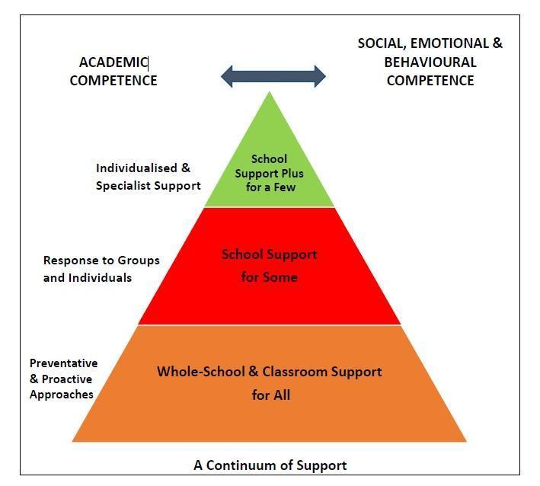

Identification of educational needs is central to our policy and the new allocation model. By using the Continuum of Support framework, we can identify pupils’ educational needs, to include academic, social and emotional needs, as well as needs associated with physical, sensory, language and communication difficulties. This, in turn, allows us to identify and respond to needs in a flexible way.

The Continuum of Support suggests the following levels of support:

The flow diagrams outline how we gather information to identify needs and support children with additional needs. A more comprehensive explanation of each stage can be found in the Continuum of Support – Guidelines for teachers 12 - 35
https://www.education.ie/en/Schools-Colleges/Services/National-Educational-Psychological-Service-NEPS-/neps_special_needs_guidelines.pdf

Stage 1 Classroom Support

Classroom Support is the most common, and typically the first response to emerging needs. It is a response for pupils who have distinct or individual educational needs and who require approaches to learning and/or behaviour which are additional to or different from those required by other pupils in their class where classroom differentiation doesn’t meet this need. Problem-solving at this level typically begins when a parent or teacher has concerns about an individual pupil. The teacher, Class Co-ordinator and parents discuss the nature of the problem and consider strategies which may be effective. Classroom Support incorporates the simple, informal problem-solving approaches commonly used by class teachers to support emerging needs.

Classroom  Support | The class teacher considers how to differentiate the learning programme effectively to accommodate the needs of all pupils in the class.  A classroom support plan is developed and/or adjusted over time for those pupils who do not respond appropriately to the differentiated programme.  This is informed by:  - Parental consultation  - Teacher observation records  - Teacher-designed measures/assessments  - Basic needs checklist *  - Learning environment checklist*  - Pupil consultation - My Thoughts About School Checklist  - Literacy and numeracy tests  - Screening tests of language skills  A classroom support plan is opened by the class teacher in consultation with the SET team and runs for an agreed period of time, typically six to eight weeks and is subject to review. (Class teacher will run two cycles of classroom support and review before child moves to the next stage on the continuum). A class teacher will have no more than 2 or 3 classroom support plans open and running at any given time.
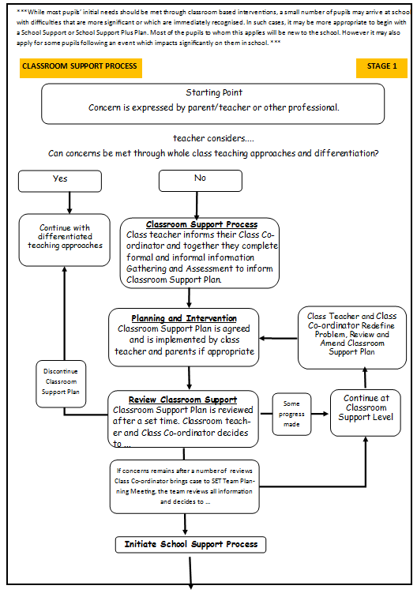
Stage 2 School Support

In some cases, interventions at classroom support level are not enough to fully meet the pupil’s special educational needs. School Support may, therefore, be required. The class teacher needs to involve the Special Education Teacher Team (SET Team) in the problem-solving process at this point and it involves more systematic gathering of information and the development and monitoring of a School Support Plan.
School  Support | At this level a support plan is devised and informed by:  - Teacher observation records  - Teacher-designed measures/assessments  - Parent and pupil interviews  - Learning environment checklist  - Diagnostic assessments in literacy/numeracy  - Formal observation of behaviour including ABC charts, frequency measures  - Functional assessment as appropriate, including screening measures for social, emotional and behavioural difficulties  A support plan at this level may detail suitable teaching approaches including team-teaching, small groups or individual tuition.  A school support plan operates for an agreed period of time and is subject to review.
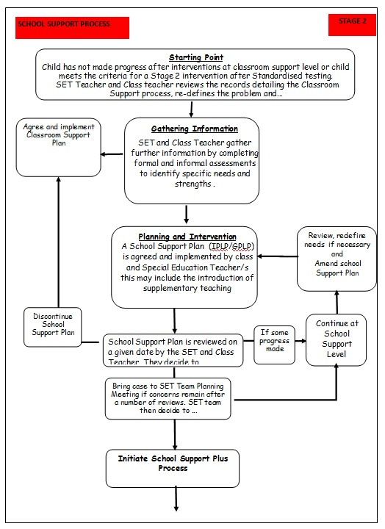
Stage 3 School Support Plus

If a pupil’s special educational needs are severe and/or persistent, they are likely to need intensive support. School Support Plus will generally involve personnel outside the school team in the problem solving, assessment and intervention process. However, the information from Classroom and School Support work will provide the starting point for problem-solving at this level. Where a pupil has a diagnosis/report from an outside agency, recommendations in the report will be considered in deciding what supports are offered. However, within the school, we may not always be able to offer the support recommended. Also, we may not always feel that the recommendations are borne out by the evidence we have regarding a pupil. We retain the right to offer what we feel is the most appropriate intervention for each pupil, taking into account evidence from teachers, parents and any other agencies that may be involved. Classroom support and school support will continue to be an important element of any intervention.

School  Support  Plus | This level of the continuum is informed by a detailed, systematic approach to information gathering and assessment using a broad range of formal and informal assessment tools, reports from outside professionals (as appropriate) and may include:  - Teacher observation and teacher-designed measures  - Parent and pupil interviews  - Functional assessment  - Results of standardised testing such as measures of cognitive ability, social, emotional and behavioural functioning, adaptive functioning etc  Data generated from this process is used to plan an appropriate intervention and can serve as a baseline against which to map progress.  A support plan at this level is likely to be more detailed and individualised, and to include longer term planning and consultation.

* adapted from NEPS Continuum of Support - see page 32 - 35 of guidelines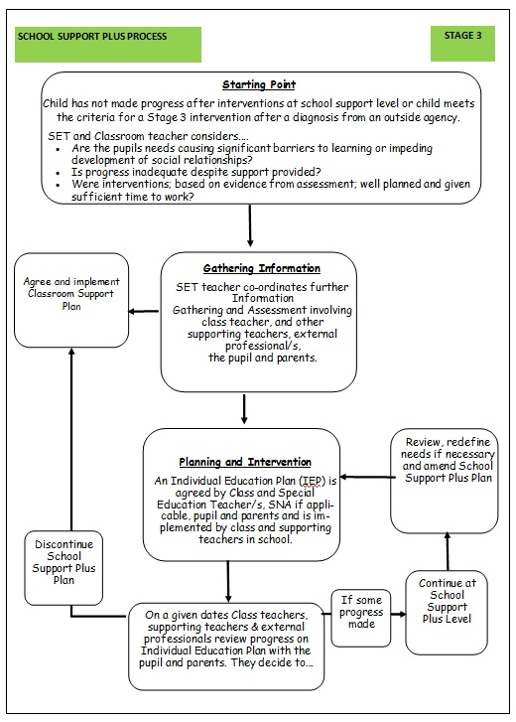

Information Gathering and Assessment

The Sen Co Ordinator and SET team maintain a register listing the children on the COS (Continuum of Support). Children are placed at their current level of support (CS, SS, SSP). This register is reviewed at six points through out the school year. (September, Halloween, Christmas, February midterm, Easter, and June). At each review point children may be moved to the next appropriate level of support. However, if a child presents with a more pressing concern, their needs may be addressed at any time.
New support plans for children in mainstream classes in receipt of support will be drawn up by October midterm and reviewed at the end of each school year or more frequently if required.
Children at School Support Plus stage will also have a review of their support plans in February each year, prior to MDT meetings if applicable. This includes all children enrolled in the Autism classes.
A useful step in identifying pupils who may need learning support in English or Mathematics is for the class teacher to administer one or more screening measures. The screening measures that are administered depend on the age and stage of development of the pupils concerned but the following will be administered annually:
- Junior Infants: ALPACA will be used in Junior Infants at three points throughout the year – October, January and May. This is a whole class assessment. BIAP where necessary where teacher has developmental concerns about individual children.

- Senior Infants: ALPACA – October of Senior Infants. This is a whole class assessment. M.I.S.T and Drumcondra Maths screener will be used in Senior Infants in Term 2 and Term 3. SET will also assess to select children for the Reading recovery programme.

- First Class onwards: Reading and Maths tests (Micra and Sigma) will be used from first class onwards. Irish tests (Drumcondra) will be used in 5th class only.

- The NRIT test is used in 2nd and 4th class.
In mathematics we focus on language development and development of mathematical procedures and concepts.
We continually review the assessment and screening tests that we use in order to balance the needs of our pupils and the need to provide information for appropriate support. Therefore, we may deviate from the above list prior to the review date.

Inventory of Test Materials:

Screening Tests

- ALPACA Assessment - Digital Assessment
- Benchmarking Kit for PM Plus
- Belfield Infant Assessment Profile (BIAP)
- Maths Trackers
- Middle Infant Screening Test (MIST)
- Drumcondra Early Numeracy
- Burt reading test
- Drumcondra Gaeilge
- Micra-T
- New Non- Reading Intelligence Test (NRIT)
- GL Dyslexia Screener - Digital and Paper Diagnostics Follow On Screener
- Gl Dyslexia Screening Test (DST – Junior and Senior)
- Maths assessment tests related to classroom schemes
- MALT Maths assessment kit

Diagnostic Tests

In our school the following tests are available for administration:
• Jackson Phonics Test
• Aston Index
• Quest Literacy and Maths tests
• York Assessment of Reading for Comprehension (YARC)
- Dyslexia Profile Follow on Diagnostic Test
- Drumcondra Spelling Test
• Assessment of Comprehension and Expression
• NRIT
• Single Word Spelling Test

In Autism Classes and in some mainstream settings, use is made of checklists, teacher designed tasks, Dolch lists, functional language lists etc. The ASD classes have specific ASD assessment kits
Prevention and Early Intervention Strategies

Our strategies for supporting the needs of children:

- Implementation of early intervention programmes in the early primary classes as an effective response to meeting the needs of children with low achievement. These programmes:
  - Include a strong emphasis on oral language laying the foundation for meaningful reading.
  - Emphasis on phonological awareness.
  - Sometimes involve small group teaching.
  - Examples of new programmes being introduced in 2023-2024 are Heggerty Phonological Awareness Programme and UFLI (Infants -2nd)
- The development of agreed approaches to the teaching of Literacy and Numeracy in order to ensure progression and continuity from class to class.
- Comprehension Strategies
- Listening Skills
- Writing Genre
- Word Attack Skills
- Whole school planning
- Literacy Lift-off and Station Teaching - Junior Infants to 2nd
- Guided reading in senior classes.
- Peer Assisted Learning
- Comprehension programmes for senior classes
- Team Teaching
- Aistear in Junior and Senior Infants
- Social skills groups
- Weaving Well-being
- Mata sa Rang
- Maths Station Teaching (Team Teaching)
- Withdrawing individuals/groups
- Sensory path

Each year we plan to use as many of the above listed interventions as we can resource and have time to provide. We may be in a position to introduce other interventions as our new model evolves or we may find that we have to reduce our interventions – this will depend on the needs of the children.

We also encourage
- Close collaboration and consultation between all teachers and the SET team.
- Promotion of literacy e.g. Print-rich environment, DEAR (Drop Everything and Read), Trips to the Library
- Promotion of Numeracy E.g. Mental Maths
- Parental involvement in promoting literacy and numeracy e.g. Homework Policy Guidelines for Parents.

Allocation of Resources

Planning Template to Guide the Allocation of Additional Teaching Supports for Pupils with SEN(Primary Guidelines P.19 & 20)
Action 1: Identification of pupils with special educational needs | Review existing information on pupils’ needs, using school-based data and any information from parents and external professionals. Engage in additional screening and data gathering as required, using informal and formal assessment approaches (for example, teacher observations, information on social and emotional competence, standardised tests, diagnostic tests).  Identify all pupils with special educational needs in the school. Match their needs to the appropriate level on the Continuum of Support.
Action 2: Setting targets | Based on individual needs, set clear learning targets for each pupil at each level of the continuum of support.
Action 3: Planning teaching methods and approaches | Identify the level and type of intervention required to meet targets for each pupil on the continuum of support. Schools should consider methodologies best suited to promoting meaningful inclusion such as differentiation, heterogeneous grouping, team-teaching and small group teaching. They should also be mindful that the interventions and supports that they are using are evidence-informed.
Action 4: Organising early intervention and prevention programmes | Based on identified needs, choose evidence-informed early intervention/prevention programmes to address concerns. Identify time needed and staffing commitment required.
Action 5: Organising and deploying special education teaching resources | Cross-reference the needs of pupils at school support and school support plus levels and consider common needs that can be met by grouping to ensure effective and efficient teaching and learning approaches. Agree which teacher(s) will cater for these groups/individuals and when and where the teaching will take place.  Be mindful of the requirement that pupils with the greatest level of need should receive the greatest level of support from teachers with relevant expertise.
Action 6: Tracking, recording and reviewing progress | Establish a tracking and recording system, to ensure that the progress of all pupils in meeting their identified targets is monitored:  - At whole-school and classroom support level by all teachers  - At the school support and school support plus levels by class teachers and special education teachers.

Once a pupil’s needs have been identified, where they have been listed as Stage2/3, Special Education Teachers (SETs) are deployed to address these needs as required. (Children at Stage 1 will have received in-class support from their teacher who may seek advice/recommendations from the SET). We deploy SETs in a variety of ways in order to effectively meet pupils’ needs. We aim to strike a balance between in-class support, group and individual support while ensuring that the needs of children with additional needs are met inclusively.
Importantly, the level and type of support reflect the specific targets of individual pupils as set out in their support plans and are informed by careful monitoring and review of progress. In this way, following a period of intervention, some pupils may no longer require additional teaching support; some may require the same level, while others may require more intensive support.
In planning the allocation of additional teaching supports, the overriding principle is that resources are deployed to address the identified needs of pupils. Importantly, those with the highest level of need should have access to the greatest level of support. We consider methodologies best suited to promoting meaningful inclusion such as differentiation, heterogeneous grouping, whole-class interventions, team-teaching and small group teaching. In addition to literacy and numeracy difficulties, many pupils will have specific needs in such areas as oral language, social interaction, behaviour, social /emotional development, sensory processing difficulties, motor skills and difficulties with application to learning.
In our school there is constant communication between mainstream teachers and SETs. As described previously, COS register will be reviewed each June again during term 1 of each year. Children may be added to the list at any time. Formal Support plan reviews will take place annually in June. New targets may be added to support plans at school support and school support plus as targets are achieved and new targets are set.
The class teacher and the SET involved in supporting the pupil will be responsible for his/her support plan. A child’s support plan may have input from other SETs if he/she is getting support from an additional SET which may happen in the case of the visiting SET.
.
SELECTION PROCESS FOR ALLOCATING ADDITIONAL TEACHING SUPPORT
Stage 3 School Support Plus | - Children with identified complex needs by an external professional such as a  - Physical Disability  - Severe Hearing Impairment  - Severe Visual Impairment  - Severe Social / Emotional Disturbance  - Mild General Learning Disability  - Moderate General Learning Disability  - Severe/Profound General Learning Disability  - Autistic Spectrum Disorder (Need based as per professional report)  - Assessed Syndrome  - Severe specific Speech and Language Disorder/Impairment  - Multiple disabilities | Individual Education Plans | Type of Support  In-Class Support  Team-Teaching  Group Withdrawal  Individual Withdrawal  Personnel  SET teacher  Class Teacher  Outside Agencies
Stage 2 School Support | - Children newly arrived in Ireland for whom English is an additional language  - Children on or under the 12th Percentile in Literacy Standardised Tests  - Children with an identified need assessed by external professionals on or below the 30th percentile in literacy such as  - Borderline Mild General Learning Disability  - Mild General Learning Disability  - Specific Learning Disability  - Attention Deficit Disorder/ Attention Deficit Hyperactivity Disorder  - Social/Emotional difficulties  - Children on or under the 12th Percentile in Numeracy Standardised Tests  - Children with an identified need by external professionals who are on or below the 30th percentile in Numeracy  - Borderline Mild General Learning Disability  - Mild General Learning Disability  - Specific Learning Disability  - Attention Deficit Disorder/ Attention Deficit Hyperactivity Disorder  - Social/Emotional difficulties  - Children who have not achieved targets set at classroom support level following two invention cycles.  - Children in 1st – 6th who have not made adequate progress after EAL interventions | Group or Individual Profile and Learning Programme | Type of Support  In-Class Support  Team-Teaching  Group Withdrawal  Individual Withdrawal  Personnel  SET teacher  Class Teacher

Roles and responsibilities

To facilitate the effective implementation of a school policy on special needs and learning support- support services, the roles of the different partners – the Board of Management, Principal, Class teachers, SEN Team, Parents and Pupils are crucial.
Role of Board of Management:
- To oversee the development, implementation and review of school policy on special educational needs.
- To ensure that adequate classroom accommodation and teaching resources are provided for special education teachers.
- To provide a secure facility for the storage of records relating to pupils in receipt of special educational needs.

Principal:
The principal has overall responsibility for SEN procedures and practices in the school. The new allocation model states the principal’s leadership role is central. She should
- Develop inclusive whole school polices
- Implement and monitor the school’s SEN policy on an on-going basis.
- Ensure that the children with the greatest needs have the greatest provision.
- Assign staff strategically to teaching roles.
- Assign SET teachers to work with each class.
- Plan to ensure continuity of provision for all pupils
- Ensure that whole-school procedures are established to facilitate the effective involvement of parents, pupils and external professionals/agencies
- Ensure that effective systems are implemented to identify pupils’ needs and that progress is monitored methodically
- Facilitate the continuing professional development of all teachers in relation to education of pupils with special educational needs, and ensure that all school staff (class teachers, special education teachers and special needs assistants) are clear regarding their roles and responsibilities in this area
- Communicate with the SENO (Special Education Needs Organiser)
- Oversee whole school assessment
- Allocate time within the school timetable for the SET team to plan and consult with teachers and parents
- Inform staff about external agencies and provide information on continuing professional development in the area of SET
- Meet with parents regarding any concerns about their child and update them regarding their progress
- To work with teachers regarding external assessment services that are available and the procedures to be followed in initiating referrals.
- To attend multi-disciplinary meetings regarding children with special educational needs.
SEN Co-ordinator (Post-holder in the school):

SEN co-ordinator (SENCO) should:
- communicate with the principal in relation to SEN matters on an on-going basis
- liaise with external agencies about the provision for pupils with additional needs
- liaise with the NEPS psychologist, the SET team and class teachers to prioritise children for psychological assessments (NEPS)
- coordinate regular SET team planning meetings to ensure effective communication and support for children with additional needs
- Liaising with and advising SNAs with regard to supporting children with special needs
- Monitoring and evaluating SEN provision
- Facilitating planning for class teacher with support teacher
- Supports the implementation of a tracking system at a whole-school level to monitor the progress of children who avail of additional support
- available and the procedures to be followed for initial referrals
- Advises parents on procedures for availing of special needs services
- Selects children for psychological assessment in consultation with class and support teachers and with Adele McConkey (NEPS)
- Liaises with external agencies such as NEPS to arrange assessments of children with SEN
- collaborate with the SET team in creating timetables for additional support
- meet with parents regarding any concerns about their child, advise parents on procedures for availing of special needs services and update them regarding their progress
- co-ordinate the whole-school standardised testing at each class level
- co-ordinate the screening of pupils for additional support, using the results of standardised tests
- select children for external diagnostic assessment, where parental permission has been sought and granted
- oversee the tracking system of test results on password-protected Aladdin software to monitor the progress of pupils
- maintain lists of pupils who are receiving additional support on the COS register

Class Teacher:

Effective teaching and learning is critically important for all pupils, and especially for those with special educational needs. Meaningful inclusion implies that all pupils are taught in stimulating and supportive classroom environments where they are respected and valued. Mainstream class teachers have first-line responsibility for the education of all pupils in their classes. Accordingly, classroom teachers should ensure that they plan their lessons carefully to address the diverse needs within the classroom. This will include adapting their teaching approaches for some pupils whose individual progress, application, motivation, communication, behaviour or interaction with peers are causes for concern. This may require targeted interventions to develop relevant adaptive skills related to these needs. All mainstream class teachers will implement teaching approaches and methodologies that facilitate the meaningful inclusion of pupils with special educational needs. These include:
Class teachers have primary responsibility for the teaching and learning of all pupils in his/her class, including those selected for additional support. They should

- Co-operative teaching and learning within mainstream classrooms
- Collaborative problem-solving activities
- Heterogeneous group work
- Differentiation
- Interventions to promote social and emotional competence
- Embedding Information and communications technology (ICT) in teaching, learning and assessment
- implement teaching programmes which optimise the learning of all pupils and, to the greatest extent possible, prevent the emergence of learning difficulties
- create a positive learning environment within the classroom
- differentiate teaching strategies, approaches and expectations to the range of experiences, abilities, needs and learning styles in their class
- administer and correct standardised tests of achievement in literacy and numeracy, following the school's guidelines
- discuss outcomes of standardised testing with liaison SET Class Co-ordinators to assist in the selection of children for supplementary teaching
- meet with parents regarding any concerns about their child and update them regarding their progress
- gather information and assess children presenting with needs to inform teaching and learning using the Continuum of Support
- open a Pupil Support File once additional needs have been identified which require classroom support
- develop classroom support plans for children in receipt of Classroom Support
- collaborate with SET and parents to develop appropriate support plans
- collaborate with SET to regularly review support plans
- where applicable, collaborate with the SET team regarding teaching aims and activities for team teaching and whole class interventions
- adjust the class timetable to ensure that children in receipt of supplementary teaching will not be absent for the same subject/activity during each session
- co-ordinate the role and responsibilities of the SNA in relation to the needs of pupils with SEN within the class(es) to which they are assigned
- liaise with and seek advice from their liaison SET

Every pupil needs to be taught a broad and balanced curriculum that is appropriate to his/her developmental level. Pupils’ levels of interest, attention, concentration and persistence should be gradually developed, extended and rewarded, using appropriate teaching strategies. To cater for the range of learning needs in any class, mainstream class teachers will regularly need to differentiate their lessons. This can be achieved by:

- Varying the level, structure, mode of instruction and pace of lessons to meet individual needs
- Adapting lessons to take account of pupils’ interests
- Matching tasks to pupils’ abilities and needs
- Adapting and utilising resources, including the use of technology
- Aspiring towards suitably challenging learning outcomes and assessing accordingly

Teachers can make lessons accessible to a broad range of pupils through the use of a variety of appropriate teaching approaches and methodologies, including active learning, small-group tuition, individual teaching, and scaffolded instruction. This may also require environmental adaptations to promote curricular access.

Special Education Teacher (SET)
The Role of the Special Education Teacher
Special education teachers should be familiar with a wide range of teaching approaches, methodologies and resources to cater for particular learning styles and to meet a variety of needs. Teaching approaches will include a combination of team-teaching initiatives, co-operative teaching, early intervention and small group or individual support. Depending on the learning needs identified, a pupil with special educational needs may be supported at classroom level, or through mainstream classroom placement with additional teaching delivered through in-class or withdrawal support models.

Some pupils with more complex and enduring needs may require specific methodologies, teaching approaches and/or learning activities. Such interventions should be based on careful identification of strengths and needs, including multi-disciplinary assessment when necessary.
The type of support offered depends on the child’s individual needs and takes the form of:
- curriculum support
- life and/or social skills training
- physical training/gross motor development
- speech training/communication and/or language development
- behaviour modification programmes
- assistance with sensory modulation
- development of anger management strategies
- a combination of some/all of the above

Special education teachers, in consultation with class teachers, should plan their interventions carefully to address pupils’ priority learning needs and to achieve the targets identified in the relevant continuum of support plan. Short-term planning should reflect the support plan targets and should break down the development of skills and content into small incremental steps to address each pupil’s specific needs on a weekly basis. Outcomes for pupils should be routinely assessed, recorded and used to review progress. These outcomes should also be used to inform the targets for the next phase of intervention.
In addition to consultation around the individual needs of their child, parents also value receiving good information on the nature and type of the special educational needs provision available in the school. Our school will consult with parents when developing and reviewing polices relating to the education of children with special educational needs. This helps to ensure that parents understand the school’s approaches and better enables them to support their children in transitioning through the school.

The SET teacher should:
- familiarise themselves with a wide range of teaching approaches, methodologies and resources to cater for particular learning styles and to meet a variety of need
- assist in the implementation of a broad range of whole school strategies aimed at prevention and early intervention
- collaboratively develop Support Plans for each pupil selected for school support teaching with class teachers and other staff
- meet with class Teachers, parents/guardians and other staff members to identify priority learning goals for each pupil in receipt of School Support Plus.
- collaborate with class teachers and relevant staff for each pupil in receipt of School Support Plus
- regularly meet with class teachers, relevant staff to review support plans
- update and maintain planning and progress records for each individual or group of pupils in receipt of school support
- support whole-school procedures for screening
- administer and interpret diagnostic tests and inform class teachers and parents of the outcomes
- meet with parents regarding any concerns about their child and update them regarding their progress
- co-ordinate class groups and offer advice and support to class teachers regarding pupils on their caseload
- discuss the needs and progress of children on their caseload at planning meetings
- provide necessary information to an SEN pupil’s receiving school once a transfer letter has been received
- engage with CPD to upskill with regard to SEN
- provide support for children who may share concerns

Special Needs Assistants:

The duties of the SNA carried out according to the guidelines for Special Needs Assistants from the Department of Education and Skills and under the direction of the principal/class teachers, the SNA will meet the care needs of the SEN pupils to which they have been assigned. (Circular 10/76).
The SNA should
- support the needs of pupils in effectively accessing the curriculum
- contribute to the quality of care and welfare of the pupils
- support learning and teaching in the classroom through their support of children with care needs
- attend, where possible, training courses/workshops provided by the BOM
- attend support plan meetings and/or meetings with relevant professionals, when necessary
- ensure the safety of the SEN pupils in the schoolyard, and be present for the duration of the yard breaks along with the teachers on duty
- accompany SEN pupil to supplementary lessons when appropriate (see also SNA policy)

Parents/Guardians:

Collaboration and sharing of relevant information between home and school are essential elements of our SEN policy. Parents/Guardians through their unique knowledge of their own children have much to contribute to their child’s learning.
Parent/Guardian should:
- share any information, reports or reports pending from health professionals, and/or concerns regarding their child’s development. Copies of professional reports should be provided to the school at the enrolment stage
- support the work of the school and keep the class teacher informed of the progress and challenges they observe in their child’s learning
- attend meetings arranged by the class teacher or SET team
- support the targets outlined in their child’s support plans and engage in all suggested home-based activities
- Keep the school informed of any home factors which may affect the child
- inform the post-primary school of their child’s needs, at the transition stage
Effective communication with parents is critically important to the success of Special Educational Needs Programme. The Continuum of Support process and use of the Student Support File provide valuable opportunities to engage with parents and to build a collaborative approach to identifying and responding to the needs of pupils with special educational needs. Activities that may be organised to increase the involvement of parents in supporting their children’s learning, particularly parents in the Special Educational Needs Programme.
In addition to consultation around the individual needs of their child, parents also value receiving good information on the nature and type of the special educational needs provision available in the school. Our school will consult with parents when developing and reviewing polices relating to the education of children with special educational needs. This helps to ensure that parents understand the school’s approaches and better enables them to support their children in transitioning through the school
Such activities include:
- Supervising, assisting with, showing interest in and signing homework.
- Reading and telling stories to their child/children.
- Listening to and giving supportive feedback on oral reading.
- Where their child is in receipt of supplementary teaching, implementing suggested home-based activities and discussing the outcomes with the child’s teachers.
- Signing and returning consent forms to the school regarding withdrawal for support teaching.
- Talking positively about school and school work.
- Keeping the class teacher informed of any home factors which may be affecting their child’s progress.
- Participating in activities organised by the school that are designed to increase the involvement of parents in their children’s learning.
- Helping children to develop their organisational skills.
- Helping children to look after school books and other resources which are loaned to the children for use at home.
- Supporting programmes and initiatives implemented by the school.
- Developing children’s oral language through discussion.
- Motivating children to learn more.
- Selecting high interest books for the children.
- Visits to places of interest to broaden the range of children’s experiences.
- Encouraging children to use the library
- Engage children in activities to aid social and emotional development such as football, choir, drama, rugby etc.
Parents will be consulted regularly at all stages of processes outlined in this policy eg
- When a child is assessed as having needs that may require learning support
- When a child is identified as having behaviours/difficulties that may require further investigation within the school or by outside agencies
- During psychological assessments
- When a Support Plan – school/plus is being drawn up for a child
- When a review of a Support Plan means a significant change in the levels of support being given to a child

Pupils:

Pupils who are in receipt of supplementary teaching should, as appropriate:
- be given the opportunity to contribute to the setting of the medium and short-term learning targets
- become familiar with the targets that have been set for them
- develop ‘ownership’ of the skills and strategies that are taught during supplementary teaching and learn to apply these learning strategies and skills to improve their own learning
- contribute to the evaluation of their progress by participating in appropriate assessment activities, including self-assessment

Tracking, recording and reviewing progress

Provision for pupils with special educational needs relies upon clear identification processes and careful planning of interventions to address academic and/or personal and social development needs. Identification of needs, planning, target-setting and monitoring of outcomes are essential elements of school-wide support of our pupils.

Student Support File

We use a Student Support File to plan interventions and to track a pupil’s pathway through the Continuum of Support. All student support plans are recoded and stored on Aladdin. It facilitates us in documenting progress and needs over time and assists us in providing an appropriate level of support to pupils, in line with their level of need. Our Student Support File is based on the NEPS template and is stored on the school server. All support files should include:
- Cover sheet with pupil’s details
- A timeline of actions
- Record of support received
- Standardised/ Diagnostic test scores
- Support plans (See school template)
- Checklists as appropriate

Every school year, at the times identified in the policy, each class teacher will collate the results/checklists/observations/parental input etc. which has informed the supports provided for children during the year, to review the children in receipt of support – on the continuum and draw up a school register listing children who are stage1,2, or 3.

- On Stage 1 of the continuum (Class support)
- On Stage 2 of the continuum (School support)
- On Stage 3 of the continuum (School Support Plus)

This COS register wil be stored on the school drive for the purposes of planning . Each September the class teacher who will be working with the class for the new school year will be given the list relevant to their class. The list will be maintained throughout the year and reviewed in line with the termly reviews of the SET team.

A class teacher should open a Student Support File once a child is placed on Stage 1 –Classroom Support on the continuum. This is stored digitally using Aladdin, the school’s data system. In preparation for PT meetings, the most recent support plan should be printed and retained in the child’s file. At this time the existing hard copy will be replaced by an updated hard copy. There should be no loss of data here because although new information is continually added to the file, all information is retained electronically.
In the event that the file is closed, the hard copy is retained with the pupil’s records.

If, after a number of reviews, the child’s case is moved to School Support/School Support Plus, the SET is given access to the child’s digital support plan and may also retain a hard copy of the support plans in his/her files.

Support Plans

We use three different support plans for the three stages of support on the Continuum of Support.

Stage 1 – Classroom Support:

A Support Plan at stage 1 is a Classroom Support Plan. (CSP) This is a simple short term plan which is drawn up by the Class Teacher in collaboration with an SET which outlines the pupil’s additional educational needs and the actions, including individualised teaching and management approaches, which will be taken to meet the pupil’s needs. The plan may also include home-based actions to be taken by the pupil’s parents to support their child’s development. The Classroom Support Plan should include a review date. This could be at the end of a school term.

Stage 2 – School Support:

A Support Plan at stage 2 is for a group or individual whose needs cannot be met by a class support plan. It is called a School Support Plan. This plan is drawn up by the class teacher and appointed SET teacher. The SET teacher(s) involved will depend upon the needs of the child and who can most appropriately meet those needs. The plan will set out the nature of the pupil’s learning difficulties, define specific teaching, learning and behavioural targets and set a timescale for review. The plan may, for the most part, be implemented within the normal classroom setting and complimented by focused school based intervention programmes. Depending on the nature of the needs and on the school context, additional teaching might be within a small group or individual or a combination of both either in class or on a withdrawal basis. Home-based actions may also be included. After the plan has been drawn up, it should become a working document through the careful monitoring of the pupil’s response to the actions taken. Review of such a plan will depend on the nature and timescale of the interventions included in the plan but will always be at the end of the school year.

Stage 3 – School Support Plus:

A Support Plan at stage 3 is for an individual pupil whose needs cannot be met by a school support plan. It is called School Support Plus. This plan is drawn up by the class teacher and relevant SETs, in consultation with the child’s parents/guardians, professionals external to the school and (if appropriate) the child based on the information gathered. It will set out:
- The nature and degree of the pupil’s abilities, skills and talents
- The nature and degree of the pupil’s special educational needs and how those needs affect his/her educational development
- The present level of educational performance of the pupil
- The special educational needs of the pupil
- The special education and related support services to be provided to the pupil to enable the pupil to benefit from including:
- Strategies for supporting the pupil’s progress and inclusion in the classroom setting
- Individual and/or small group/special class interventions/programmes
- Specific methodologies/programmes to be implemented
- Specific equipment/materials and/or IT supports, if required to support learning and access to the curriculum
- Support required from a Special Needs Assistant (SNA), if appropriate
- The goals which the pupil is to achieve over a period not exceeding 12 months
- The pupil’s priority learning needs, long and short term targets to be achieved, the monitoring and review arrangements to be put in place

Meetings needed to draw up and review this plan will be co-ordinated by the SET who is working with the pupil. We envisage that School Support Plus plans will be drawn up by autumn midterm (October) each year and reviewed by spring midterm. (February) Parents will be invited to participate in this process. Our experience is that such plans are more long-term than class support or school support plans but, as always, this may vary depending on the needs of the child. In some cases, we may use short-term interventions and as such, we will plan and review accordingly. Plans will be reviewed as part of hand-over at the end of the school year.
Support plans for pupils enrolled in an Autism Class
School Support Plus is the plan that will always be used for children enrolled in the Autism class. Pupils already enrolled in the Autism classes may continue to use IEPs as their support plans but as new children enrol they should use the School Support Plus model.
School Support Plus plans are generally drawn up in October and reviewed in February. Parents are involved at all points in the process. Other therapists such as S & L and OT may be involved in setting targets. Some targets will take longer to be achieved and may prove to be ongoing although strategies may change.
Support plans are retained in the pupil’s file with his/her class teacher and on Aladdin.
Sharing/Storing Information and Plans
Our systems for creating, sharing and storing support plans of pupils have been outlined above but here is a brief summary:
- Every pupil in the school has a file, held in locked filing cabinets in the classroom. (When a pupil leaves the school, his/her file is moved to the locked past-pupil file in data room .) In terms of SEN, each file should contain
- Annual school report
- Any reports relating to child’s needs from outside agencies
- hard copy of any Support Plan which may have been drawn up for the pupil – replacing the plan from the previous year
- The most recent standardized literacy and numeracy test which the child has taken
Each teacher – class and SET - involved in supporting a child will have access to the child’s electronic record so that he/she can update the record of support/interventions being provided to that child. This is the means by which Support Plans will be created, shared, reviewed and stored. At the start of each school year SET and CT meet to draw up new SSPs. Once new targets have been agreed the new edition of the SSP is done on Aladdin. SET prints a hard copy of this plan and this is given to parents at the November P/T meetings where targets are discussed with parents, plan is signed and a copy is given to parents. Plan is reviewed at the end of the school year (Feb for SS Plus) and updated on Aladdin.
We envisage that each child should only have one file in the school, to be retained in the classroom. SET teachers may have an insert in that file.
- Whole class records will be retained by the SET team – records such as running records, standardized tests, MIST results etc.
- A whole school record of children in receipt of support is maintained – COS register
- If child has care needs and access to SNA then this is logged digitially on the Care Needs register. If a child has access to an SNA then a Care Plan document is prepared. School Template for this document is on Aladdin.
- All data in respect to individual children’s attainments in standardized tests and support plans is maintained on the school data system - Aladdin
Other Considerations with regard to SEN

Enrolment of children with identified special educational needs:
Parents enrolling children in the school can view our Admissions Policy and Enrolment Form on the school website. We have an additional Enrolment Policy for pupils enrolling in the Autism classes. Prior to the child’s enrolment, the schools will acquaint themselves with a child’s special needs by:
- Meeting between parents/principal/ class teacher/special needs staff and SENO as appropriate.
- Obtaining copies/details of reports, assessments etc. from psychologists, therapists etc.
- Contact with SENO, NEPS psychologist or other psychologist/speech therapist/Autism therapist/occupational therapist involved with the child.
- Liaison with family counsellor/ care worker where appropriate.
The following steps will be used to ensure a smooth transition into the school for both the pupil and the school.
- Parental visits to the school.
- Pupil visit to the school.
- Making all school employees and pupils aware of the need for the child with special educational needs to be educated in an inclusive environment.
- Liaison with SENO to arrange for individual personnel, resources, training where appropriate.
- In some circumstances a transition period may be established to help a child to settle in the school.
Referral of pupils to outside agencies including NEPS
Where teachers feel it necessary to seek intervention of outside agencies they should
- Consult with the SET
- Speak to parents
- Inform the Principal
In general teachers get the opportunity to consult with members of the Speech and Language team annually.
The NEPS psychologist attached to the school meets with the principal and the SET at the beginning of the year to discuss the needs of the pupils and to plan the support which will be offered to the school. This may take the form of CPD for staff, of advice for teachers with regard to individual pupils/whole school concerns or, it may involve an assessment and psychological report for an individual pupil.
In the event of a limited availability of assessments through NEPS priority will be given to the pupil with the greatest need.
Where an assessment takes place in the school, the class teacher should oversee initial contact with parents. The principal will liaise with assessment services. The relevant special education teacher will collect all documentation concerning the pupil’s test scores. This will be co-ordinated by the principal.
In general, our school has access to approximately 1/2 psychological assessments annually through the NEPS scheme.
Teachers may also recommend to parents that children in need of support, especially in the case of behavioural/emotional needs, should be referred through a GP.
Transfer to Post Primary
All children in 6th class will have an Educational Passport. This will be provided to Secondary schools upon request.
Where children with SEN are transitioning to the local secondary school, the 6th class teacher will liaise with the SET there.
The 6th class teacher will work to prepare the class for transition to secondary school. An SET may support this work.
An individual transition programme may form part of the support plan for some pupils in 6th as identified by consultation between the class teacher and SET.
Pupils with Exceptional ability
We seek to support pupils with exceptional ability by the following means:
- Differentiation of work
- Providing additional follow-on work of a higher level
- Recommendations to parents
- Occasional engagement with experts in areas such as PE, Art Music, IT
In exceptional circumstances a teacher may draw up a class support plan for a pupil with exceptional ability.
Related Policies
The schools’ curricular and organisational policies and plans take into account the needs of pupils with SEN, through differentiation of content and methodologies in curriculum areas.
Special needs are also reflected in the following policies: Enrolment, Code of Behaviour, Anti Bullying and Record Keeping.
Concluding Section
Success Criteria
The following points will be indicators of the success of the Special Educational Needs Policy.
- Pupils with special needs will be catered for.
- The progress of pupils with special needs will be monitored and recorded.
- Discussion/meetings with parents.
- Feedback from teaching staff, pupils, psychologists etc.
- Standardised test results
- Inspector’s Reports.

Roles and Responsibility
The roles and responsibilities of parents, teaching staff, principal and BOM have already been outlined in the policy
It is the role of the SENO to allocate the annual support provision to the school, based on the information provided to her by the principal.
Other agencies involved in meeting the needs of the pupils are the DES and NEPS. The school also relies on the support of a variety of therapists and psychologists in analysing the needs of our pupils.
Implementation, Ratification and Communication
This policy was originally drawn up in the 2017 – 2018 and is reviewed at the beginning of each school year. It will be updated every two years when the school receives its allocation of support hours. The underlying principles, roles and responsibilities will be reviewed every 5 years.
The current updated policy will be presented to the BOM at the December meeting in 2023. Following ratification, it will be published on the school web-site at the earliest opportunity.

***************************************************************************
Ratification of policy for St. Patrick’s NS

Martin McGowan 04/12/2023
___________________________________________________________________________
Chairperson Date

Ruth McLoughlin 04/12/2023
__________________________________________________________________________
Principal Date

