St. Patrick’s N.S.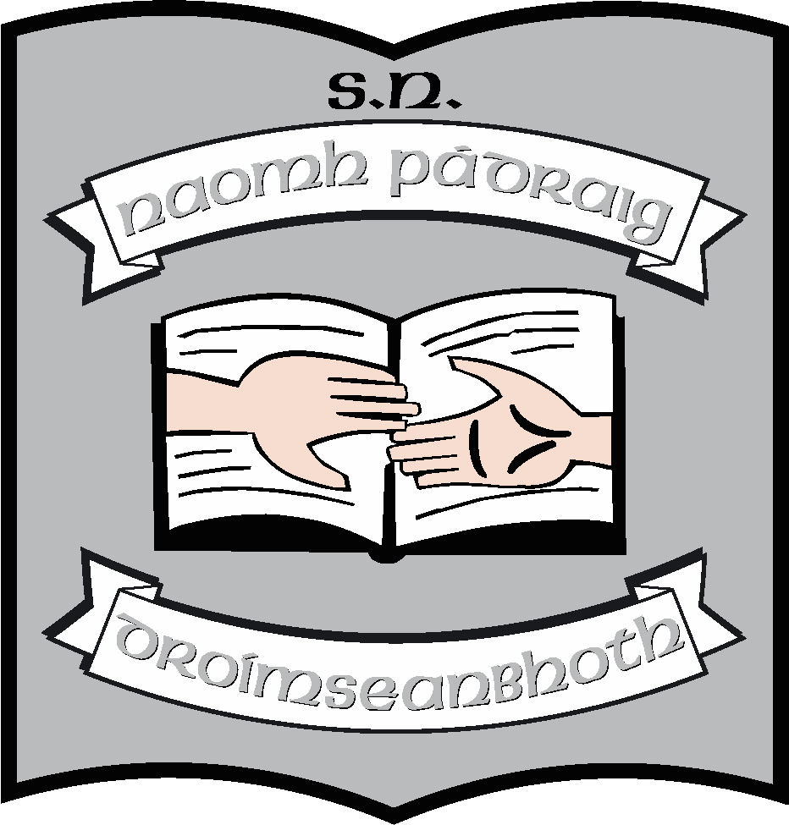
Drumshanbo,
Co. Leitrim.

Roll No: 19423J

Relationships & Sexuality Education
Policy

Reviewed: January 2024

Ratified: February 2024

St. Patrick’s National School

Relationships and Sexuality Education (R.S.E.) Policy

Introductory Statement

The Deputy Principal of St. Patrick’s N.S. formulated this policy in December 2014 and reviewed it in January 2022. It was reviewed again in 2024. It was developed to inform teachers and parents as to what material is covered in the RSE section of the SPHE.

Relationship to Characteristic Spirit of the School

In St. Patrick’s NS, we aim to teach the Relationships and Sexuality Education Programme (R.S.E.) having regard for the Catholic ethos of the school while respecting the rights of all the children and their parents regardless of religious denomination.

Rationale

R.S.E. has formed part of our curriculum for many years. This policy is to ensure that we are covering the appropriate content for the children and observing best practice in our teaching methods and in our responsibilities to the wider community.

Our School vision

Our school cherishes all pupils equally and endeavours to help them in achieving their true potential. With regard to R.S.E. programme we are therefore keen to foster the personal development, health and well-being of the child. We want to ensure that they are prepared for the changes and challenges that come with growing up and moving on in society.

Aims

The aims of this policy are:
- To contribute towards the development of all aspects of the individual child.
- To provide opportunities for children to learn about healthy friendships and relationships in ways that help them to form values and establish behaviours within a moral, spiritual and social framework.
- To deal with the issue of relationships and sexual education within the parameters of the revised S.P.H.E. programme.
- To foster an understanding of, and a healthy attitude to human sexuality and relationships in a moral, spiritual and social framework.
- To enable the child to develop a sense of personal responsibility and come to understand their own sexuality and processes of growth, development and reproduction.
- To help children learn, at home and in school, about their own development, about their friendships and relationships with others.
- To enhance the personal development, self-esteem and well-being of each child while providing pupils with appropriate and accurate information.

Content

What is R.S.E.?

Relationships and Sexual Education (R.S.E.) is a lifelong process of acquiring knowledge and understanding and of developing attitudes, beliefs and values about sexual identity, relationships and intimacy. This education is already being delivered both consciously and subconsciously by parents, teachers, peers, adults and the media. It is a spiral curriculum which ensures that topics are taught in a developmental manner through the child's primary school years.

R.S.E. is part of a subject called Social, Personal and Health Education (S.P.H.E.), which is on the curriculum for all classes in the national school. Social, Personal and Health Education (S.P.H.E.) provides particular opportunities to foster the personal development, health and well-being of the child and to help him/her create and maintain supportive relationships and become an active and responsible citizen in society. SPHE aims to develop the child's emotional, moral, social and spiritual growth as well as their intellectual, physical, political, religious and creative development.

The content of the S.P.H.E. curriculum covers a wide range of topics such as healthy eating, exercise, well-being, alcohol and drug awareness, environmental issues, safety and social responsibility as well as R.S.E. The content of the S.P.H.E. curriculum is as follows:

Strand | Strand unit
Myself | - Self identity  - Taking care of my body  - Growing and changing  - Safety and protection
Myself & others | - Myself and my family  - My friends and other people  - Relating to others
Myself & the wider world | - Developing citizenship  - Media

S.P.H.E. contributes to developing the work of the school in promoting the good health and well-being of children. Since the Department of Education has introduced S.P.H.E. as a subject the R.S.E. Policy will be closely linked with the S.P.H.E. Policy.
The full S.P.H.E. curriculum is available to view on the www.ncca.ie website in the Primary Curriculum section.

In a school setting, R.S.E. will provide structured opportunities for pupils to acquire a knowledge and understanding of human relationships and sexuality through processes which will enable them to form values and establish behaviours within a moral, spiritual and social framework. At primary level, RSE aims to help children learn, at home and in school, about their own development and about their friendships and relationships with others. This work will be based on developing a good self-image, promoting respect for themselves and others and providing them with appropriate information.

School Policies and Curricular Plans which support our R.S.E.

We are a child-centered school. The educational and emotional needs of the children in our care are central to our planning and policy making processes and this consideration is central to many of our policies including

- School's Code of Behaviour and Discipline Policy
- Anti-Bullying Policy
- Child Protection Policy
- Enrolment Policy
- Digital Policy

In keeping with the sentiment and spirit of these policies, we encourage good behaviour, open communication, understanding and tolerance of differences and respect for staff and others. We recognise that both pupils and staff have rights and responsibilities in our school. A sense of responsibility is fostered, and attention is paid to the well-being of all the members of the school community.

We draw content from different programmes from across the curriculum including:

- Grow in Love (Religious education)
- Stay Safe Programme
- Webwise
- Walk Tall
- R.S.E. resources provided by PDST and HSE

Timetabling

One half hour period per week is timetabled for each class for S.P.H.E.
R.S.E. will be included in the programme taught during this time. It is envisaged that some aspects of R.S.E. (including the sensitive issues) will be taught through a number of core periods while some material may be taught in a cross curricular manner. The "sensitive issues" of R.S.E. will be taught in each classroom, usually, in the last term. Parents will be informed by the class teacher prior to commencement of the lessons.

Parental Involvement

R.S.E. is an ongoing process throughout life. Parents are acknowledged primary educators of their children and the school work in partnership with them in a supportive role. On enrolment of their child, parents will be provided guided to these policies on our website and provided with a hard copy at their request. Each year prior to the implementation of the R.S.E. programme parents will be informed when the teacher will begin to teach the programme. The curriculum books and resource materials are available online on www.pdst.ie and parents are welcome to view these if desired.

Withdrawal from R.S.E.

R.S.E. is an obligatory requirement of the Department of Education and Skills and it should be inclusive. However, a parent's right to withdraw a pupil from these themes pertaining to sensitive issues will be respected on the understanding that the parent is taking full responsibility for this aspect of education. Parents are obliged to inform the school in writing of their decision to withdraw the child from the classes based on sensitive issues. The school cannot be responsible for any information which a child may receive outside the direct teaching of R.S.E. lessons.

Overview of content for Junior Infants, Senior Infants, 1st Class & 2nd Class

Strand Strand Units
- Myself
I am unique
My Body
As I grow I change
New Life
Feeling Safe
Feelings and emotions
Making decisions
Myself and my family
Myself and my friends

- Myself and Others
Special people in my life - other people
Relating to others

Overview of content for 3rd Class & 4th Class

Strand Strand Units

1. Myself
Accepting myself
Physical development
Growing and changing
Birth and new life
Feelings and emotions
Personal Hygiene
Personal safety
Making decisions

2. Myself and Others
Roles and responsibilities in families
Portrayal of sexuality and relationships
Roles of males and females in society
Relating to others

Overview of content for 5th Class & 6th Class

Strand Strand Units

1. Myself
Accepting myself
Physical development
Becoming an adult
Parenthood
Feelings and emotions
Personal Hygiene
Personal safety
Making decisions

2. Myself and Others
Changing relationships in families and friendship
Group affiliation and loyalty
Portrayal of sexuality and relationships
Sexual stereotypes
Relating to others

The Management and organisation of R.S.E. in our school

- It is intended that the Department’s Guidelines would be adhered to in so far as is possible and that some of the Department’s resource materials will be used.
- R.S.E. and Stay Safe will be taught to children alternative years. This means that pupils will receive their R.S.E. lessons one year and the corresponding Stay Safe the next year. This is to avoid repetition of lessons as we have straight mainstream classes.
- R.S.E. will be taught in all even numbered classes; (Senior Infants, 2nd, 4th and 6th).
- The Stay Safe Programme will be covered in every alternative second class; (Junior Infants, 1st, 3rd, 5th classes).
- However, vulnerable children may receive the information both years if the teacher/parents deem this necessary.
- The S.P.H.E./R.S.E. curriculum will be of a spiral nature and all content objectives will be covered by the time children leave 6th class.
- Questions arising from lesson content will be answered in an age-appropriate manner.
- All resources in the teaching of the programme will be in keeping with the ethos of the school and in the spirit of this policy.
- The lessons relating to puberty and sexual differences, conception and development of the baby in the womb and other sensitive issues will be taught in Sixth Class. (Generally this is done in Áras Pádraig for a full day.)
- These lessons will be taught in all cases by the class teacher. However the Sixth Class teacher may opt for a facilitator in the event of a family member being present in the class.
- Naming the body parts will be covered from Second Class.
- Webwise will be covered in the Senior Classes.
- It will be pointed out to parent(s) that it is the policy of the school to provide R.S.E. to the pupils in accordance with the Department of Education’s Guidelines.
- In the event that a parent seeks to absent their child from specific R.S.E. lessons, which is their right, that parent(s) must give a commitment in writing that they themselves will provide their child(ren) with this information.
- As the teaching of these lessons is a very sensitive issue, parents will be provided with the content and specific dates of lessons four weeks in advance of the teaching of these lessons. This will be done by letter.
- Teachers will teach this policy in a consistent manner mindful at all times of the Catholic ethos of our school.
- While it is not currently in the Primary Curriculum to teach Homosexuality, Contraception or Abortion the teacher will be allowed to explain briefly, if the topics should arise in conversation/questioning, always adhering to the Catholic ethos of the school and remembering the social inclusion of all individuals.
- It will be left to the discretion of the principal and class teacher to modify the content to meet the particular needs of any child with special needs. Parents of such an individual may be contacted specifically by the class teacher in relation to this. The school will facilitate the teaching of the lessons on 'sensitive issues' on another occasion individually or in a small group setting.
- All children will be given equal access to R.S.E. within the S.P.H.E. curriculum.

Resources:
- R.S.E. teaching materials – available to view online
- Busybodies booklet and DVD
- Selected worksheets from Health Series (Prim-Ed)
- Stay Safe Programme
- Other resource material as deemed appropriate by class teachers in consultation with the Principal

Confidentiality and Child Protection
Where there is a disclosure by a child of abuse, the school will follow the Department of Education and Skills Child Protection Guidelines and guidelines as set out in "Children First".

Provision for Ongoing Support

For Parents
- Parents are welcome to view the Curriculum if they wish.
- There will be contact with parents prior to and during the teaching of lessons involving "sensitive issues". Parents of 6th class pupils will be informed of the dates and content of the R.S.E. programme prior to the teaching of these lessons. Copies of the 'Busy Bodies' programme will be given to each child and made available to parents, should they wish.

For Teachers
- The Board of Management will support in-career development in the area of S.P.H.E./R.S.E. as opportunities arise

Implementation and review

Roles & Responsibilities

The policy will be implemented by the principal and staff of St. Patrick’s N.S. and will be supported by the B.O.M., local G.P. and other emergency services. The teachers and parents of any concerned pupils will evaluate it.

Implementation/Ratification and Review
This policy was first implemented in February 2014, after it is ratified by the BOM. It will be reviewed in 2029 or sooner should a need arise. Parents and staff will be informed of any amendments made. However, reviews of S.P.H.E., changes to Stay Safe, to government policy or concerns within the school community may necessitate an earlier review, if necessary.

This policy was ratified by the Board of Management in February 2014. It was published on the school website. It was reviewed in January of 2022 and again in February 2024. The responsibility for the review will lie with the principal, deputy principal, teachers, BOM and parents of children attending the school at the time of review.

**************************************************************************

Ratification of policy for St. Patrick’s NS

Martin McGowan 07/02/2024
Chairperson Date

Ruth McLoughlin 07/02/2024
Principal Date

