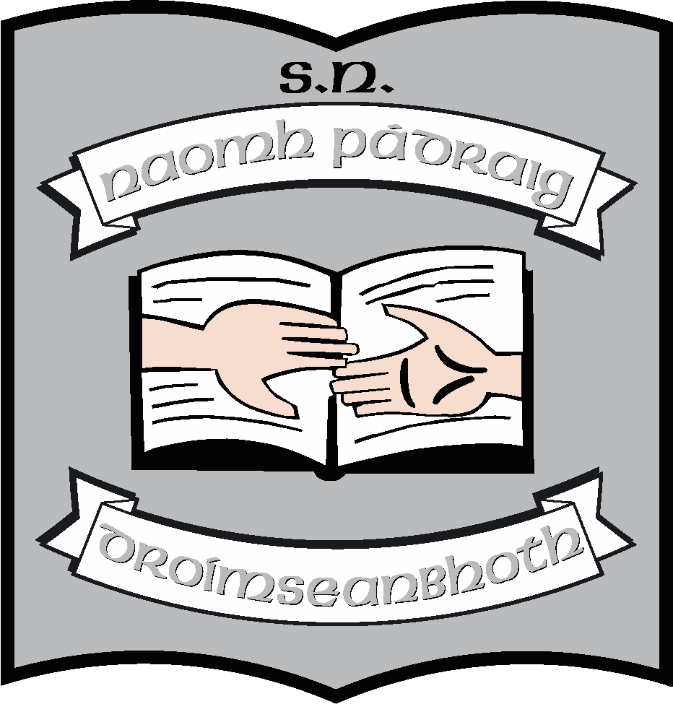
St. Patrick’s NS: Staffing: 2023 - 2024
Principal | Ruth McLoughlin
Deputy Principal | Orla Walsh
6th Class | Edel Lane
5th Class (A) | Clare McCabe (AP2)/Maria McGoldrick
5th Class (B) | Kathy Keegan
4th Class (A) | Ciara Tiernan
4th Class (B) | Jeannette Reynolds (AP2) & Emma Earley (Job-Share)
3rd Class | Áine Smith
2nd Class | Maureen McNamara
1st Class | Martina Duignan
Senior infants | Michelle Kelly
Junior Infants | Sinéad Rogers
Autism Class - Cairde | Rachel Noone
Autism Class - Laochra | Louise Brennan (AP2)
SNAs | Samantha Cullen / Caolann Scollan (Job-Share)  Sharon McGovern  Davinya Sheehan  Sinéad Dolan  Julie Durkin  Ann Flood  Donna Flynn  Deborah Kehoe  Olive Murphy
Support Teaching Team | Orla Walsh (DP)  Regina McLoughlin  John Molloy  Niall Craig (EAL)  Louise Henry (Visiting SET)
Secretary | Caroline Flynn
Cleaner | Raymond McGovern
Caretakers | Maurice & Andrew Cullen
Bus escorts | Caroline Flynn  Cerenna Reynolds  Zoe Gilhooly  Caolann Scollan  Donna Flynn / Davinya Sheehan (Job-Share)

